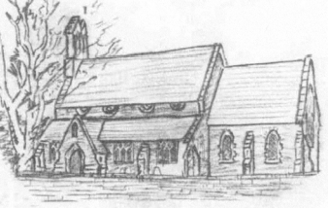
A letter from our Vicar
Greetings,
It has been a pleasure to meet many of you at different events, activities, services and the ‘school gate’. One of the delights of my role is the opportunity to share life with so many people. I hear amazing stories of adventures, challenges, joys and heartache. I get to support those in grief and hold the hands of those coming to the end of their lives. I have the delight of meeting new additions to our communities – mainly babies but I also enjoy meeting the puppies and other beloved animals of many varieties.
I get to celebrate marriages and share in the excitement of planning and preparation for not just a special day but of a new chapter in a couple’s life. I have the privilege of doing all of this because I am following the calling on my life to be a priest, to bring light into dark spaces, to share the good news of Jesus and most joyfully to love people.
I love this time of year, the smells, colours and change in light remind me of getting engaged and married. It reminds me of toffee apples and sparklers, of crisp walks and no matter what I plan I seem to always be caught of guard by the morning frost and each year vow to invest in a cool gadget to help de-ice the car or sort the garage out enough so a car can be parked in it….never happened!
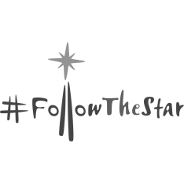
It also reminds me there is something very exciting around the corner: Advent! Which is a time of anticipation and preparation for a wondrous celebration!! As church communities we are going to journey through advent as we #FollowtheStar to Christmas. I look forward to sharing that exciting journey with you. I’ll share some resources at the time but if you have an Alexa device at home you can hear some of the Church of England Advent reflections from the 1st December in the comfort of your own home by asking Alexa to open the Church of England app and #FollowtheStar, or download the app onto your smart device…I know, how modern (continued overpage
Please do get in touch if you would like to talk about anything, would like more information about #FollowtheStar or the services and activities we run at All Saints Sawtry, St. Nicholas Glatton and St. Giles Holme.
Every blessing be with you and all those you love,
Reverend Becky Dyball
revdyball@gmail.com 01487 506217

Holme Youth Club
We are having a Halloween night on 1st November, the first day back after half term and fancy dress is invited but is optional and there will be lots of gruesome goings on!!
Would you believe we have only 6 sessions before we stop for Christmas. Where has this year gone – in fact where have the last 5 years gone since we started up again. Our membership continues to grow and I am really pleased to see that some of the older ones are interested enough to keep coming – hopefully they will become helpers as they get older.
We have some new equipment arriving imminently so please take care of it as it was expensive and we do like to keep you entertained for many years to come.
Holme Youth Club membership is open to school years 5-10 who live in Holme or attend or have attended Holme School. For further information about us email reneemitcham@btinternet.com or pop down to the village hall on a term time Friday between 6.30 and 8.30.

Holme Community Speedwatch
Another batch of intensive sessions still showed 25 per cent of drivers exceeding the speed limit along the B660 during the early morning rush hour so needless to say we will continue to try and educate drivers with the hope that eventually it will get through.
We did feel heartened when one lady commuter stopped on our second day to apologise for speeding the previous day and promised to stick to the limit in the future. She felt really guilty she said – what a shame more drivers dont feel that way.
Holme Community Speedwatch is run by volunteers who give up their time to try to make our village safer. If you feel you can spare anhour or o every now and again and would like to get involved please email reneemitcham@btinternet.com and we can arrange your training with Cambridgeshire Constabulary and add you to our team.

Bowls Club diary
Home Short mat Bowls club‘s season has started well and our recent recruitment campaign has resulted in five new members three from Ramsey area one from Folksworth and one from Peterborough at present with a possible five more ladies from home interested in coming along and trying Bowls The league team played its first match of the season and was victorious 11 points to 1 playing away to a team in March. A good start let’s hope it continues. anyone interested in playing bowls please come along Tuesday or Wednesday evenings we will be pleased to see you Viv Hempsell 01733 234089

Holme Parish Council News

Firstly I would like to welcome the new Priest, Becky Dyball. I was delighted to be invited to her licensing ceremony, it was a very happy occasion. We hope to see her at village events and wish her all the best as she takes on her new role in charge of the parishes of Sawtry, Glatton and Holme with Conington.

Bus: Update on the 415 bus – following intervention by your County Councillor Simon Bywater and myself, Dews have now agreed to reinstate the old bus stop in Holmewood. I’d call that a result. Thank you to Simon for getting the County Council to see sense.

Environment: I will repeat my request from last magazine - If you have road or footpath facing planting at your property, can you please ensure it is well trimmed – now is a good time to cut hedges, bushes and have a general tidy up.

HOWEVER….it is NOT acceptable to use the road verges for your grass cuttings, prunings and offcuts, something which has recently been brought to my attention. HDC can provide you a second green bin if you have too much for one bin (at a cost) and it is not very far to Alconbury tip/household waste recycling facility. Flytipping is illegal and will be reported.

Do I need to say anything about Dog Poo? It’s back. Let’s try and stop it.

Community Governance Review:

Holme Parish Council used to have 9 Councillors but numbers were reduced about 10 years ago to 7 after a national review was undertaken.

Holme Parish Council would like this number increased back to 9; there are increasing numbers of tasks the Council is supposed to do and we are finding that we have a manpower shortage at times. To add a couple more Councillors would really help the Council to run efficiently and reduce the burden on the existing Councillors - it would be good to be more diverse as well. There are many new homes in the village (and more planned) and the population is increasing all the time so we think we have good reasons for an increase.

To increase Councillor posts Huntingdonshire District Council has agreed to carry out a Community Governance Review which is basically a public consultation, they will then decide whether numbers may be increased or not.

If you agree with the suggestion, please can you make your comments to democratic.services@huntingdonshire.gov.uk - the review is open for consultation until 14 November. The full text of the notice (9 pages) is on display on the open noticeboard by the village hall, and on the Council website www.holmecambsparish.org. Or just ask me and I’ll send it to you.

Vacancy

We have a current vacancy for a new Parish Councillor. If anyone is interested in finding out more please contact me or any Councillor and we will let you know what is involved. It’s a voluntary role open to anyone over 18 who lives, works or owns property in the Parish. You need to be able to use email too. No experience is required, training is provided. Meetings are approx. 2 hours once every 2 months with extra meetings and tasks ad hoc.

Finally, I am sending our best wishes to our District Councillor, Tim Alban, who is undergoing hospital treatment. Marge Beutell, the other Councillor for our ward, will hold the reins until he is back on duty again. Get well soon, Tim.

Next full Council meeting: Tuesday 19 November 2019 at 7.00pm at the Village Hall. All welcome to listen, please let me know ahead if you wish to address the Council.

Holme Parish News can now be read online – on the Council website www.holmecambsparish.org
Mrs J Osborn - Parish Clerk. 01487 831559 holmeparishclerk@gmail.com

Admiral Wells Clay Pigeon Club
As the nights start to draw in it signals the start of the Admiral Wells clay pigeon shooting season. On average twenty people each month meet on a Sunday morning to compete in our annual competition which primarily takes place at High Harthy shooting ground near Brampton. New members of all abilities are welcome providing you have the necessary licence and insurance.
The season started on Sunday 20th October and the following dates are 17th November, 29th December, 12th January, 9th February, 8th March and the final on the 26th April. We meet at 9.15 for a 10am start.
For further info contact me, Ron Gilbert, at Ronnieg911@hotmail.com

Holme WI Summer Review
August and the warm summer now seems a fading memory, but we were visited by Kate Brewster and Dalton (the dog) from The Dogs Trust in Snetterton, Norfolk in August. The Trust was set up in 1891 with the mission to bring about the day when all dogs can enjoy a happy life. Now a nationwide charity with 20 units each containing its own vets and nurses, built to be eco-friendly using recycled water and heated by solar panels. We were informed about the illegal puppy smuggling trade, with puppies coming in mostly from Europe and often near death after the extensive travelling. Some of the dogs at the Trust are fostered instead of rehomed, and more sadly, sometimes when a person’s circumstances change, they help and advise on how to give up your dog, should this happen. A great charity doing some extremely hard work. Dalton also liked to join in the meeting with a bit of his own style of singing.
A small group recently went to Tolethorpe Open Air Theatre to see Blythe Spirit. The performance was wonderful, one of the best non-Shakespeare I personally have ever seen. Hilarious and dramatic with the final scene putting a chill down our spines. As we left the theatre in darkness it all felt very spooky!
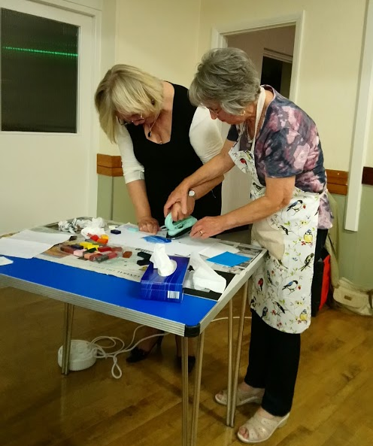
In September we got creative, with encaustic wax painting demonstrated by Anthea Moore. I use the term painter loosely because she creates pictures of landscapes, seascapes, flowers and leaves amongst just a few of her themes using encaustic wax and a small hot iron. The wax is melted on to the plate of the iron, several colours can be applied at the same time, and then the hot iron is applied to special card leaving an imprint. Manipulating the iron on the card and adding other colours she creates pictures. She made it look very easy. The card is then
polished as the wax has already dried and voila you have a picture. We had a great evening with Anthea, watching something that I had never seen demonstrated before
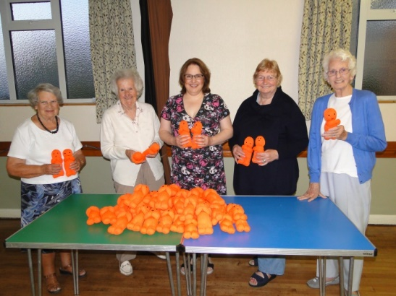
Our Knit and Knatter group has been really, really busy over the year. Six blankets were delivered to Olive Mead Care Home in Yaxley recently. Over 50 Myeloma Buddies have also been knitted. These are small orange toys that will be donated to the Myeloma Charity to raise funds to help the charity promote research into Myeloma and provide training to health workers to spot early signs of the cancer. It is one of the rarest forms of cancer and often the signs are missed or not noticed early enough.
September was also Blood Cancer Awareness month, so perfect timing for these little orange buddies. A huge round of applause to the ladies of the Knit and Knatter group for making these toys, which apparently were hard to knit on three needles and, according to one of our members, equally hard to stuff!
Now, as we leave the summer behind us and move into Autumn, October was our Members Night. This is when our members take over our meeting organising a guest speaker and refreshments. This year we had Will from Chicken Wired. Will makes sculptures from chicken wire including birds, bees, rabbits, ET and Olaf from Frozen. He travels the country teaching schools and groups how to make these sculptures. He insisted a simple bee or bird only takes 10 minutes, some of us were not quite so sure! A fabulous evening though, that kept us quiet and concentrating hard.
Anyone interested in joining, please do come along and see what we are all about and what we get up to. We meet on the first Thursday of every month at Holme Village Hall, Short Drove, Holme PE7 3PA at 7.30pm. Please contact holmewi2015@gmail.com for further details.
All ladies will receive a warm and friendly welcome.
Alison McGuinness President

The Story of Holmewood.
After Toby Simpson’s article in October’s parish magazine, on the present management of Holmewood, the history of the wood maybe of interest
Much of the west of the old county of Huntingdonshire was wooded as the heavy clays in this part of the county were not suitable for agricultural purposes. It is believed that the Holmewood, on the western boundary of the parish, (not to be confused with the woods in the nature reserve).are remnants of this woodland. After the Norman Conquest large parts of Huntingdonshire were subject to the very harsh forest laws when people could be put to death for breaking these.
The first written mention of the Holme wood is in 1248 when an inquisition was held, in Yaxley, when three unknown men chased a buck from Holme across the Fen to Yaxley. It was stopped by a page with a pickaxe but the men picked the dead animal up and returned to Holme. The entire population of Holme and the surrounding villages were questioned as to the identity of the men but no one could or would name them possibly as their punishment would have been death. The page was put in prison for the killing of the buck along with Richard of Stilton jailed for not raising the hue and cry after he had seen the men whilst standing on a pile of turf.
From the 1399 – 1611 Holme was part of the Duchy of Lancaster, the monarch’s private land with the Cecils, of Burghley near Stamford, appointed as baliff of Whittlesea Mere and keeper of the woods of Glatton and Holme.
In the 17th century there was a survey of the woods showing that there were a large number of oak trees. It appears to have been two woods one called Great Holme and Little Holme, a later 1770 map shows it as Great Wood and Little Wood.
The Wells, owners of Holme Hall from 1769 – 1889, seem to have increased the size of the wood as the first ordnance survey map, in the early 19th century shows trees across the field behind the church and covering much of this field.
Vice-Admiral Thomas Wells complained that the “rustics” had burnt his favourite trees before hanging an effigy of him in naval uniform from one. One of the corners of the old carriage road to Holmewood Hall was known as Hangman’s corner so possibly the site of this incident.
The woods were a valuable asset to the estate in the early 19th century earning as much income as the farm land for the Wells. By the end of the 19th century they were used more for pheasant shooting. A summer house stood in the middle of several rides and was used for luncheon parties and remains of this were still seen in the wood until relatively recently.
In 1944 the trees helped to screen the activities of the OSS with their packing station for equipment to be sent to the Resistance. The remains of the blast walls can still be seen in the woods.
In the 1950s, the Crown, the then owners, replanted the woods which until the early 1970s were maintained by the woodman living at number 43 Holmewood, Les Miles.

ST. GILES PARISH CHURCH
HOLME with CONINGTON

NOVEMBER 2019 CALENDAR

November 3rd | Fourth Sunday before Advent
9.00am |  | Holy Communion
Reader: |  | Mrs L Papworth
Flowers: |  | Mrs T Smith
Prayers for: |  | Brookside | Peterborough Business Airport
November 10th | Remembrance Sunday
3.00pm |  | Royal British Legion Service
Reader: |  | Mrs B Lawes
Flowers: |  | Mrs P Bliss
Prayers for: |  | Isolated Homes | The lonely and the afraid
November 17th | Second Sunday before Advent
9.00am |  | Holy Communion
Reader: |  | Mrs J Osborne
Flowers |  | Mrs A Madison
Prayers for: |  | St Giles Close | Mums & Toddlers Group
November 24th | Christ the King
NO SERVICE
Prayers for: |  | Spinney Fields | Our welcome to visitors

READINGS FOR NOVEMBER 2019

Date | Reading 1 | Reading 2 | Reading 3
03  November | Isaiah  1:10-18 | 2 Thessalonians  1:1-12 | Luke  19:1-10
10  November | Job  19:23-27a | 2 Thessalonians  2:1-5,13-17 | Luke  20:27-38
17  November | Malachi  4:1-2a | 2 Thessalonians  3:6-13 | Luke  21:5-19
24  November | Jeremiah  23:1-6 | Colossians  1:11-20 | Luke  23:33-43

