Coronavirus Response
supported by Holme Parish Council

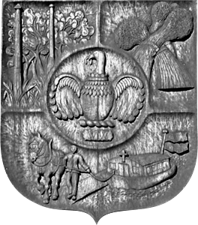

Dear fellow Holme resident,

If you are in need of help and are either currently self-isolating or end up self-isolating in the coming weeks due to Coronavirus (Covid-19) and need help with collection of essential items such as food or medicines or simply want a chat, we have a small team of volunteers who will do their best to help.

Please contact Parish Councillor Ed Whittaker on 07707468484 or cllrewhittaker@gmail.com.

Please note, we cannot guarantee all our volunteers are DBS checked.

If any villagers can help to volunteer, please get in touch with Ed.

