**Holme Parish Council News**

***The Case of the Missing Post Box.. continued..***

*Chapter 3.*

*Somehow the Local Radio Station heard about the theft of the Church Street Post Box. BBC Radio Cambridgeshire sent their roving reporter Johnny D to take a verbal statement from the Parish Clerk which was broadcast to the county the following day.*

*A few days later the matter escalated to BBC regional TV and this time the Chairman appeared on camera, along with Rev Becky (with her lipstick on!) to talk about the theft. Rev Becky delivered several sealed but (sadly) empty envelopes to the home of the Clerk, all in the pursuit of art. The piece was broadcast on the teatime BBC East news programme.*

*A week or so later we were national celebrities – our friends at the Admiral Wells and local broadcaster and resident Diane-Louise Jordan both spoke about the theft to Jeremy Vine live on BBC National Radio 2! Fame was bestowed upon Holme!*

*Not a peep was heard from Royal Mail.*

*Chapter 4.*

*One day in early December, completely out of the blue and with no word of warning, a van arrived and a hooded workman dug a big hole, filled it with quick setting cement and installed a shiny new postbox, disappearing as quickly as he came with no word of greeting, farewell or acknowledgement. Was this Santa Claus in disguise? We may never know.*

*Not a peep has ever been heard from Royal Mail. The end!*

**Planning**.

The main news is that the planning application to build 10 homes on Yaxley Road, adjacent to No 15, was approved by Huntingdonshire District Councils’ (HDC) Development Management Committee (DMC) on Monday 18 December. The Parish Council had recommended refusal and the application went before the DMC for determination as the Parish Council’s recommendation was different from the HDC Planning Officer’s opinion. The Committee decided on a majority vote that this “Rural Exception Site” should be permitted. 6 affordable homes (2 of them will be bungalows) are to be included and will be prioritised for applicants on the housing list who can demonstrate a strong connection to Holme.

The 30mph speed limit zone on Yaxley Road is to be extended to the limit of where they will build and the developer is to provide some additional open space for play which will be negotiated and agreed with HDC and the Parish Council in the next few months. We wait eagerly for the developer’s approach.

**Bushes**. Thank you to Councillors Jan Weatheritt and Wendy Aylesbury who tidied the footpath along Station Road recently. If you have bushes or trees near your property please trim them back where they overhang paths and pavements before spring arrives. Thank you.

**Holme Cemetery**

Whilst the grass in the cemetery is maintained by our contractors, the bins are emptied by your Councillors and Clerk as a voluntary job.

In recent years the number of Christmas wreaths laid on graves has increased and it is becoming a significant task to dispose of them - the regulations dictate they should be removed on or about 15 February. If you live locally enough to read this and could remove your own wreaths we would be very grateful.

Wreaths are made of mixed materials and are not recyclable as they are. It takes a long time and is a tiresome job to deconstruct them to separate into the green and black bins and we should also have a care for the amount of unnecessary material going to landfill.

Perhaps next year the wreath you lay could be more environmentally friendly?

Thank you

**Next Meeting**. The next planned full Parish Council meeting is on Tuesday 16 March 2021 at 7.00pm. It looks as though this will be another virtual meeting - if anyone wants to attend you are welcome (Zoom). Access details are published on the agenda. I can send you a digital link or phone no if you ask for it before 4pm on the day.

Janice Osborn Parish Clerk 01487 831451 [holmeparishclerk@gmail.com](mailto:holmeparishclerk@gmail.com)

Holme Parish News can now be read online – on the Council website [www.holmecambsparish.org](http://www.holmecambsparish.org) Find me *HolmeParish Clerk* on Facebook.

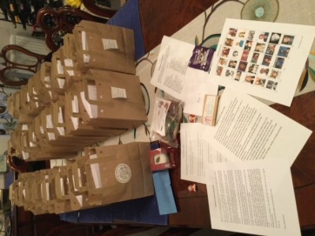**HOLME WI JANUARY 2021**

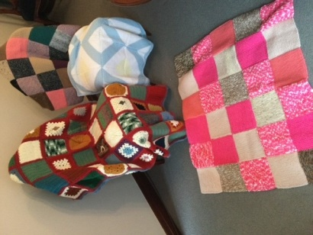Things have been quiet on the WI front after our Christmas themed educational bags were dropped in December which members thoroughly enjoyed. A lovely bag containing a small, iced fruit cake, chocolate buttons and Christmas themed chocolate shapes, friendship crocus bulbs, a small Christmas wreath kit to make and mulled wine sachet. The chocolates have long been consumed (mine did not last long), and the crocus bulbs planted, I am now waiting for them to appear in my pots, a good sign spring is on its way.

So, now we once again sit tight and wait for things to improve as we are now in Lockdown No.3. Members are still busy Zooming, knitting, and quizzing, and recently blankets have been made from knitted squares, these will be donated to Olive Mead Care Home, in a safe manner of course.

In the meantime, we wish everyone a peaceful New Year.

Anyone wishing to contact us please email [WIholmevillage@gmail.com](mailto:WIholmevillage@gmail.com)

Alison McGuinness President

**Census**

**Census 2021 will help shape your community for the next 10 years**

The census is coming. By taking part, you can help to inform decisions on services that shape your community, such as schools, doctors’ surgeries and bike lanes.

It’s important you fill in your census questionnaire because the information you share affects the life of every single person living in England and Wales.

Because these things matter to us all, everyone needs to complete the census. Do not worry, your information is protected by law. That means government officials dealing with payments or services you receive cannot see it.

The ONS have reviewed the digital-first Census plans in light of COVID19 and they are confident that everyone will be able to provide their information safely and securely.

Census Day is Sunday 21 March. You can fill yours in online as soon as you get your access code in the post. If your household circumstances change on Census Day, you can let The Office for National Statistics (ONS) know.

How you can get involved:

* Work on the Census, there is more information about the roles at www.censusjobs.co.uk

If you need help, you can visit [www.census.gov.uk](http://www.census.gov.uk) where there’s a wide range of support services available.

**Holme Church of England Primary Academy**

As we step into 2021 we welcome seven new children and their families to our school community.

Despite most of our children working from home, we continue to strive to deliver a full education to all of our pupils. The first week back in January we focussed on physical activity and mindfulness exercises. The Mental Health of adults and children is a priority for us at Holme and we teach children strategies for coping with worries and relaxing.

Our fantastic staff are working extremely hard to deliver live teaching sessions to the children working at home. The children are coping brilliantly with this new way of learning and are becoming quite skilled at video calls and uploading work! Some of our pupils are receiving additional teaching sessions to make sure they don’t fall behind. The children are especially enjoying the end of day story times.

The parents have been incredibly complimentary of our remote learning offer.

We have around 20% of our children working in school. These pupils are well supported by their class teacher and those in Key Stage 2 have access to their own Chromebook.

In January we had new playground markings as well as new break time equipment. This has been very exciting and the children have enjoyed utilising these. Around school we have been busy enhancing the learning environment using our artistic skills.

We have limited places across the school, Please call the school office for details.

School office : 01487 830342

[www.holme.cambs.sch.uk](http://www.holme.cambs.sch.uk/)

**From Becky**

Hello Everyone,

As many of you will have already heard public worship across Sawtry, Glatton and Holme has been suspended until further notice. We continue to have online services (including the opportunity to call in from a phone), coffee times, dial a sermon, listen again and a phone care tree.

For the latest information about our services please look at your local notice board or visit [www.allsaintssawtry.org.uk](http://www.allsaintssawtry.org.uk) You are also always welcome to be in touch with me directly: [revdyball@gmail.com](mailto:revdyball@gmail.com), 01487506217.

Our offline provision includes:

**Dial-a-Sermon:** **01487 800141**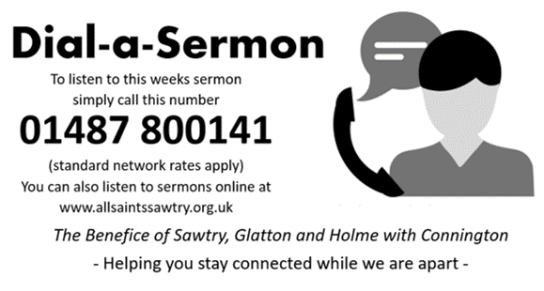

**Daily Hope -** **0800 8048044 (free)** 

Available 24 hours a day. An opportunity to listen to hymns, prayers, bible readings and short messages sharing the meaning of the gospel.

**Fancy a Pancake?**

February and March see some key dates in the Christian Calendar and we are creatively coming up with ways to celebrate and mark these occasions.

Pancake Day (16th Feb), Ash Wednesday (17th ~~Feb~~), Mother’s Day (14th March) Lent and Holy Week are all part of the journey to Easter Day (4th April), the biggest Christian celebration of the year. It is a time when lots of people make time to think carefully about their life. For Christians, this means trying to live God’s way and remembering all that Jesus did. We are following a series of teaching and exploration looking at how to #LiveLent.

Pancake Day is also called Shrove Tuesday and is one last chance for a big party before Lent begins with Ash Wednesday the next day.

Long ago, Christians traditionally used up all the eggs and fat they had in store by making pancakes and feasting on them. This was because when Lent came, they would eat less food, or even fast (do without food sometimes) to help them focus on God and not on the things they wanted. This tradition has been passed down the generations.

Shrove Tuesday always falls 47 days before Easter, a date which changes every year. This year, we’ll be eating our pancakes on **17th Feb and are excited to invite everyone to our Zoom Pancake Party taking place 5:30 -6:30pm**. Suitable for all ages, we will have a chance for a natter, a fun quiz, some activities and a live pancake cook off. You don’t have to have a pancake, just yourself. We would love to see you there.

With every blessing,

Reverend Becky

Dates for your diary – All dates are subject to change and take place online at present.

Weekly Sundays 10:30am – Online Sunday Service

Weekly Mondays 9:30am – Online Morning Prayer

.**The Admiral Wells**

We have opened up our community shop again to try and ease the pressure of lockdown.

We would like to thank the village for continuing to support us. If you know anybody shielding or isolating that may need a doorstep delivery please ask them to get in touch with us on 01487831214 we do have an answer machine if anybody wished to leave a message.

We are open Tuesday to Sunday 10 until 2.

Many thanks

The Admiral Wells Family.



**Your Care**

Due to the ever increasing demand within the NHS there has been a national drive to ensure patients are seen and assessed by the most suitable allied healthcare professional, thus allowing Doctors to see the most clinically vulnerable and complex.

Nurse Practitioners, Emergency Nurse Practitioners and Clinical Pharmacist, all hold extensive qualifications to allow them to triage, diagnose and treat and prescribe for the patients accessing the service.

An important point to remember is that they are always supervised by a GP and they can ask for help, advice and even transfer the patient for a further call if the issue could not be resolved.

In these uncertain times, currently dominated by dealing with the Coronavirus Pandemic, it is important to be aware of any unexplained changes to your body which signal the onset of other potentially serious illnesses.

Examples include blood in your urine, a change to your usual bowel habits such as:

* Blood in your poo or diarrhoea
* Constipation no apparent reason
* Pain in your stomach or back passage
* Persistent bloating

or

* Unexplained or unintentional weight loss
* Post- menopausal bleeding or bleeding between periods
* A lump in a breast or a lump that is rapidly increasing in size elsewhere on your body

This is not an exhaustive list and further information can be found online at <https://www.nhs.uk/conditions/cancer/symptoms/>

Please get in touch with the practice via Engage Consult <https://wsp.psf-live.co.uk/1082/#/portal> if you are at all worried about your health.

**Building Extension**

Good news – we are very pleased to announce that our building extension and refurbishment will begin on Monday 4th January 2021.

Whilst our team will experience some interim building work disruption, our service to our patients will not change.

This will be a fantastic project for our patients and staff once completed.

Please visit our website for regular updates:

[www.yaxleygp.nhs.uk/health-centre-extension-buildings-update](http://www.yaxleygp.nhs.uk/health-centre-extension-buildings-update)

**Monthly Closure Dates**

The Practice will be closed on Wednesday

**17th February 2021**

Between **12.30pm** and **4.00pm** for staff training.

Emergency Telephone 01733 240478.

