**Holme Parish Council News**

I am writing this looking out at the snow and ice, and I am not on a mountain holiday, more’s the pity!

However I am optimistic that you will be reading it in brilliant spring sunshine and we all look forward to the daffodils appearing which announce the end of winter.

There have been a few weather related problems recently – mainly flooding and the appearance of potholes. I haven’t heard that anyone’s home was flooded –we seem to have fared better than other villages. The County Council is aware of potholes appearing and the Highways officer is also aware of the new duck pond in the layby! Anglian Water came straight out (within hours) to see to the overflowing sewerage pumping station at the bottom of Short Drove and I cannot fault their response.

By the time you read this the roadworks to Holme Lane/Glatton Lane will have been completed and there have been some more works commissioned for Yaxley Road/Hod Fen Drove and also along the road to Ramsey St Mary’s where the surface has sunk badly.

Hopefully things are moving in the right direction regarding the Covid-19 Virus. Both Yaxley and Sawtry Doctors’ surgeries are running very efficient vaccination centres in Stanground and Alconbury respectively and there are also hubs in Huntingdon and Peterborough. You can choose where to go, including out of the local area if you work further away from home.

Can I draw your attention to the Census – it’s on 21 March. The census is taken every 10 years and is to put it simply, a count of who lives in the UK and where, and people’s circumstances. The individual responses are not passed on to any other government department however the numbers will inform the government about all sorts of trends – if they know household sizes, for example, it will inform housing policies and direct what sort of/size of houses need to be built and where; modes of transport used will help allocate funds for buses, trains and car parks, cycle ways and footpaths.

You will be sent or delivered a letter and instructions and you complete the survey, online if you can, if not then a paper form will be provided. If you find it difficult for any reason they have recruited a small army of census officers who can help you, either over the phone or in person, or you can ask a friend of course.

The census is an important social and historical resource and is kept out of the public domain for 100 years. The 1921 one is to be published this year and I am excited to see where my ancestors lived and worked then. You can have a look at pre- 1911 census results on the internet.

**Next Council Meeting**. The next full Parish Council meeting is on Tuesday 16 March 2021 at 7.00pm. If anyone wants to attend you are welcome (Zoom). Access details are published on the agenda. I can send you a digital link or phone no if you ask for it before 4pm on the day.

Janice Osborn Parish Clerk 01487 831451 [holmeparishclerk@gmail.com](mailto:holmeparishclerk@gmail.com)

Holme Parish News can now be read online – on the Council website [www.holmecambsparish.org](http://www.holmecambsparish.org)

Find me *HolmeParish Clerk* on Facebook.

Our fantastic School Family

 We pride ourselves on working in partnership with families and the local community.

I thought this month I’d take the time to share with you our fantastic school family.

Our staff continue to work tirelessly to provide a quality education for both the children in school and the pupils at home. As well as daily live sessions for Maths and English , we are still teaching Art, History, Geography, Religious Education and Personal Social and Health Education remotely.

We are so grateful to our families who are working alongside us to ‘teach’ their children. Last month the families treated the whole staff to an afternoon tea and two hampers of chocolate treats. The staff were thrilled!

Over the past month we have:

*Held our PTA meeting remotely and welcomed lots of new members

*Spent some of the PTA’s donated ‘Covid Fund’ on technology to support remote learning and picture books to support mental health.

*Handed out devices and resources to support home learning

*Ran an online workshop for families on developing resilience in young people

*Set up an online forum for parents to chat with one another

This month we are all learning to skip! We have purchased a skipping rope for each child and asked our friends at Youth Dreams Project to prepare 10 videos to support the children learning to skip.

Our Vicar the Rev. Dyball has also been supporting us by creating some imaginative Collective Worship sessions in the world of Minecraft. The children at home are enjoying these.

We continue to be small but mighty!

We do have spaces in a few of our year groups. If you are interested in joining this community do contact the school office for details.

School office : 01487 830342

[www.holme.cambs.sch.uk](http://www.holme.cambs.sch.uk)

Mrs Thomas (Head of School)

**MARIE CURIE DAFODIL APPEAL 1ST – 31ST MARCH 2021**

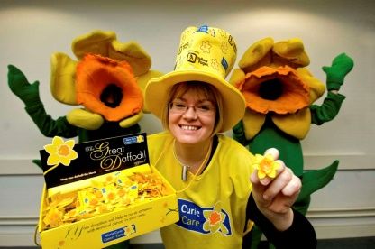Marie Curie’s Great Daffodil Appeal has been raising awareness and funds since 1986.  
Every March, millions of people across the UK show their support for our work, simply by giving a donation to wear a daffodil pin.

Without this generosity, thousands of families across the UK wouldn’t be able to make the most of the precious time they have left together.

Visit <https://www.mariecurie.org.uk/daffodil> for more information

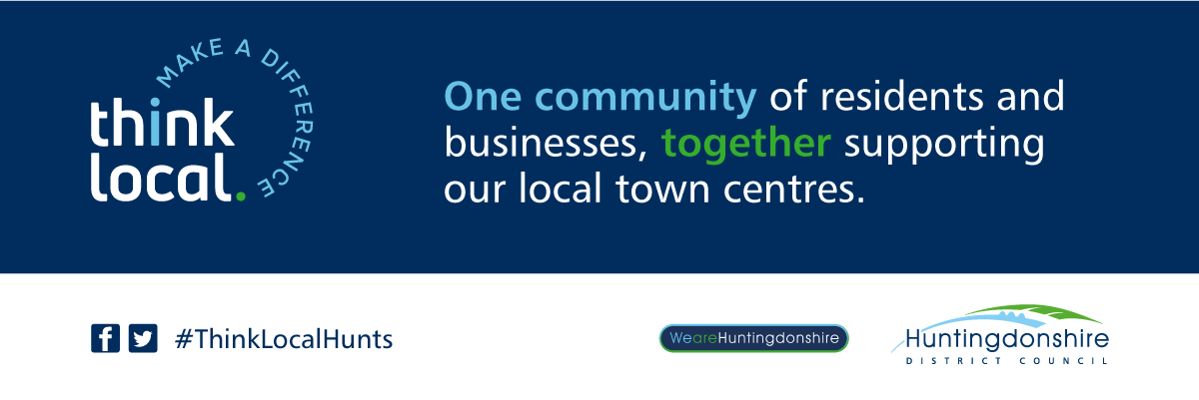

**We all want to recycle, but could you be recycling more?**

Huntingdonshire residents can recycle a wide range of materials via the kerbside collections including the most common items; glass, paper/cardboard, cans/tins and plastic bottles. But did you know we can also recycle:

♻ Aerosols

♻ Plastic pots tubs and trays, including black trays

♻ Clean foil

♻ Drink cartons

♻ Stretchy, flexible plastics, like bread bags

Do not forget, it needs to be clean, so as not to contaminate other materials when being collected. This can be done at the end of the washing up; it does not need to be sparking.

If you create more recycling than your bin can hold, we do take excess recycling as long as placed out in clear or transparent sacks, so our crew can see that it is recycling.

We also provide an organic collection, where you can dispose of food waste (including cooked food and bones/shells), shredded paper and untreated wood, as well as garden waste. This can all be added loose into the bin or wrapped in paper.

Shredded paper needs to go in the green garden collection as the paper is too small and degrades the quality of the paper recycling. It can also get caught up in the machinery at the materials recovery facility.

**Holme Cricket Club**

Holme Cricket Club has had quite the year already, despite not playing any games yet!

We have successfully thrown virtual fundraisers, released Holme CC official playing shirts and other kit, and also brought the community together.

We would like to thank our sponsor Vyper Cricket for working with us to create our team kit, and also for setting up our new club shop where we have plenty of Holme CC kit available.

We also have an official website “Holmecricket.club” where our fixtures and match results will be located too, thanks to Social Echo.

We are so excited for our first season as Holme CC and hope that we can get a few games played!

**Holme Cricket Club Fixtures 2021**

|  |  |
| --- | --- |
| **May** |  |
| Sunday 23rd May | Wakerley & Barrowden |
|  |  |
| **June** |  |
| Friday 11th June | Hampton |
| Tuesday 15th June | Wansford |
| Sunday 20th June | Wansford |
| Sunday 27th June | Howizaters (Conington) |
|  |  |
| **July** |  |
| Friday 16th July | Hampton |
| Tuesday 20th July | Wansford |
| Sunday 25th July | Wakerley & Barrowden |
| Friday 30th July | Stilton |
|  |  |
| **August** |  |
| Tuesday 3rd August | Wansford |
| Sunday 29th August | 100 Ball Blast Tournament |

**A villagers view of local life under lockdown – The Good, The Bad and The Ugly.**

The pandemic has impacted on everyone’s life for nearly 12 months. In a small rural village, in many respects we are shielded from the worst of its impact. We still wake up every day and look out over fields, open spaces, grateful for an environment that minimises our risk of catching Covid19.

Isolation, particularly for those living on their own does however exist and it is hard. Thankfully our community has demonstrated a togetherness that has worked hard to keep everyone’s spirits up. Whilst missing out on physical contact and interaction with loved ones, family and friends remains difficult and cannot be replaced, the efforts of many in the village to keep an eye on the more vulnerable in our community has been uplifting and very much appreciated.

The local pub has again shown how it is the heartbeat of the village. Creating the community shop, providing Christmas lunches to those in need, keeping up a stream of wonderful home-made pies and cakes. Taking a walk around the village for daily exercise has been made all the more enjoyable for the knowledge that a tasty treat awaits at the pub even if it cannot be shared with others in the ambiance of the pub itself.

To all those who have used their initiative to bring help and happiness to the community I say thank you. The Sunflowers, children’s pictures in the windows, Christmas decorations in the woods, the WI members “treats” along with many other tokens of goodwill have all helped us get through. So much good in deeds and actions.

So why, in a community that I feel so lucky to be part of, that has each others well being at heart do we still have irresponsible selfish behaviour with dog fouling and speeding drivers? What possesses any dog owner to think it is ok to let their dog foul pavements or private verges and not clear up after it? It is your dog, don’t be selfish, be responsible for it. Is it really too much to ask?

To the minority of villagers who still feel that they are ok to speed in and out of the village I ask the same question? The speed limit is there for a reason, it is to keep us all safe. Our village is small, when driving into or out of the village, if you drove at the speed limit instead of exceeding it, might add 30 seconds to your journey. It only takes a second to take or ruin a persons life by driving irresponsibly. Think! Don’t be selfish, nothing you are doing is so time critical you cannot take another 30 seconds to safely complete your journey.

We are very lucky to live in Holme, it a very pleasant environment, where people care for each other and in times of difficulty we rally round and help each other. Small acts of kindness and taking responsibility for our actions often have the biggest impact. At a time when so many are selflessly trying to help others around them perhaps it is an opportunity for all of us to think about how our individual actions are contributing to the local community. *Submitted to be published anonymously*

**HOLME WI** **FEBRUARY 2021**

Hopefully the Covid-19 vaccination is progressing, and we can see a way forward out of the current Lockdown, albeit slowly. WI news is a little quiet at the moment, members are still Zooming, knitting and sewing, and our monthly e-cards are being well received by our members as a timely reminder we are still here and still thriving. Our knitted squares collection was recently put together and made into lovely blankets for residents of Olivemede Care Home in Yaxley. These have been delivered safely and I am sure residents will find them very useful during our currentvery cold weather.Once again, as before, we now just wait for the Covid situation to improve, so stay safe everyone.

Anyone wishing to contact us please email [WIholmevillage@gmail.com](mailto:WIholmevillage@gmail.com)

Alison McGuinness President

**LAKESIDE COVID-19 National Vaccination Programme**

This is the biggest vaccination programme the NHS has ever undertaken.

The NHS is well-used to delivering millions of vaccines a year, and is moving quickly to roll out this vaccine to those who need it, but it’s important that we remember this will be a marathon, not a sprint.

The large increase in cases hospitals are seeing and the emergence of a new variant of the virus shows that we cannot let our guard down now.

NHS staff are doing an incredible job to deliver what it is the largest vaccination programme in our history, at the same time as continuing to be there for everyone who needs care.

The public have an important part to play to help them do this:

* Please don’t contact the NHS to seek a vaccine, we will contact you;
* When we do contact you, please attend your booked appointments;
* And please continue to follow all the guidance to control the virus and save lives.

The new medical advice is the second dose of the vaccine remains effective when given up to 12 weeks after the first dose, and should be given towards the end of this 12 week period.

We will contact you to arrange your first and or second vaccination if eligible. Please continue to wear face coverings where required and adhere to social distancing guidelines even **after** you have received your vaccine. This is very important.

**Visit our website for the most up to date information** [**https://www.yaxleygp.nhs.uk/**](https://www.yaxleygp.nhs.uk/) **ttps://www.yaxleygp.nhs.uk/**

**Monthly Closure Dates**

The Practice will be closed on Wednesday March 17th 2021Between **12.30pm** and **4.00pm** for staff training.

Emergency Telephone 01733 240478