All together April 2021

Holme Parish Council News

**Annual Parish Meeting**

**You are warmly invited to attend the Annual Parish Meeting!** This will take place using Zoom and I will publicise the access codes a bit nearer the time on the village noticeboards and on Facebook. The date for your diary is THURSDAY 29 APRIL at 7PM. If you have anything you want to say, comments to make or suggestions regarding the village, here is your opportunity!

The Annual Parish Meeting is a legal requirement for all civil parishes and is generally facilitated by the Clerk to the Parish Council for ease, (do step forward if you would like this job!) but it is not a Parish Council meeting as such, although the Chairman will report on Council activities.

You will be able to join by phone or perhaps by 29 April it will be possible to sit in your friend’s garden and join on their device if you don’t have one. I am also happy to take questions and comments for discussion by email, post or phone before the day.

If you are involved in a village organisation, please watch your inboxes for my request for your report and these will be printed here in the Holme Parish News next month. Most of them will be rather short, I fear.

**Census**

How was it for you? I hope you have all completed your online or paper form. If not please ring 0800 141 2021 and get some help. There are people specially trained to assist you. Please don’t get fined! It takes just a few minutes.

**Covid-19**

Both Yaxley and Sawtry Doctors’ surgeries are running very efficient vaccination centres in Stanground and Alconbury respectively and there are also hubs in Huntingdon and Peterborough. You can choose where to go, including out of the local area if you work further away from home. At the time of writing they are starting the over 50s group so if you are over 50 and haven’t been called yet, do go online and book a slot.

**Next Council Meeting**. The next full Parish Council meeting is on Tuesday 4 May 2021 at 7.00pm. If anyone wants to attend you are welcome (Zoom). Access details are published on the agenda. I can send you a digital link or phone no if you ask for it before 4pm on the day. Unless regulations change this may well be the last zoom meeting. We shall see!

Janice Osborn Parish Clerk 01487 831451 [holmeparishclerk@gmail.com](mailto:holmeparishclerk@gmail.com)

Holme Parish News can now be read online – on the Council website [www.holmecambsparish.org](http://www.holmecambsparish.org)

Find me *HolmeParish Clerk* on Facebook.

**From Tim Alban**

**Planning** continues to take up a lot of my time,  where along with my  fellow ward District Councillor, Marge Beutell, County Councillor Simon Bywater and Holme Parish Council, I am continuing to try and achieve the best possible outcome for the community from allowed and ongoing planning applications.

**Floods**  Although not primarily a District Council matter, I have again worked with Councillor Simon Bywater, to try and tackle the immediate and medium term issues which were experienced in the ward - especially around Christmas.

I am grateful for all the feedback and photos I received from Holme Parish Council and Connington Parish Council, which I used as part of my report to the District Council's Flooding Task & Finish Group.  Whilst our villages might not have been hit as badly as the towns and villages in Huntingdonshire which are adjacent to the River Ouse, I am determined to let the council know that the north of the distict also has flooding issues which continue to need attention.

**Potholes**Again not a District Council issue but one I am contacted about and one where I do lobby the County Council.  Whilst potholes and other highways faults should always be reported via the County Council website, Simon Bywater and I have worked together to try and get some of the worst potholes priotised ahead of those which aren't as bad.

**Parking**  I am a member of the Panel which scrutinised the District Council's proposed application to take over some elements of parking enforcement in Huntingdonshire.  Along with all the other councillors on the panel I voted in favour of this measure which, if approved will allow the District Council to issue Civil Enforcement Notices to drivers who park their vehicles on double yellow lines.

**Council Tax**  This year, although the overall Council Tax we pay will go up, following a cross party (and nearly unanimous) vote for a 0% increase, the amount levied by the District Council won't.

**And finally...**Spring is my favourite time of year - the lighter and warmer days (well sometimes) and the hope of the brighter times to come.  This year it with the impressive vacination programme, the road map to the end of lock down and the continued contribution made by local support groups, local councils, as well as individual residents, those hoped for brighter times seem that much closer.

With best wishes for a Happy Easter.

Councillor Tim Alban

Stilton, Folksworth & Washingley Ward

tim.alban@huntingdonshire.gov.uk  07913 101145

From Becky

Hello Everyone,

What a Year! Wow! I write this reflecting on a year like no other. As I write I am aware the days are gradually getting longer bringing with them signs of brighter times ahead, what a relief! I have loved watching bulbs in the garden grow, seeing glimpses of blossom on the trees, and noting the volume of birdsong increasing. As a Benefice we are preparing to slowly return to in person worship and have made the decision that Zoom will be a forever feature in our worship, we valued joining people in their homes through this technology on Sundays as we worship and learn together and want this to continue. In the Bible Jesus uses stories to share Good News and help explain his teaching. Jesus uses the image of a seed to help us understand a journey of change and transformation, and it seems rather apt as the bulbs continue to emerge around us and we navigate the roadmap out of lockdown to reflect on that helpful imagery.

**Seeds Need a Healthy Environment** to grow otherwise they sprout, but quickly wither and this applies to the environment in which we grow too. We need comfort and security, challenge and inspiration, learning and service otherwise our growth is reduced or worse halted. Over this last year that environment has been really challenging and it is my prayer that as a community across Sawtry, Glatton, Holme and Conington we can support each other as we enrich that environment and encourage the growth of one another.

**Seeds Can't Be Rushed**. Seeds require the amount of time to grow that they need. In God's plan, the time things take is the right time. We, however, get impatient. There is pressure on us to rush through everything. We live in an ‘instant’ age...come on who doesn’t love an amazon prime delivery!! I certainly do, but Seeds teach us that we need to learn to wait, to develop patience. As we move out of lockdown, we are all going to respond at different paces, with different levels of uncertainty and anxiety. Let kindness and generosity in spirit be our first response, being patient with those around us, enriching the space together for people to grow and regain their strength.

**Seeds Contain the Past and the Future**. Each seed is the result of previous generations and contains within it all the genetic code for the future. Seeds are filled with the information that yields transformation. Each generation builds upon the last and lays the foundation for the next. The experience of the last year will change us as individuals and as a collective, may we not forget what we have learnt in this unusual time and always remember the power of kindness, grace, love and hope.

The church calendar also offers signs of new life, with many baptisms and weddings booked for later this year and next. We are your parish church, if you would like to have a special celebration with us; baptism, baby dedication, marriage service, marriage blessing, renewal of vows etc. Please be in touch. It is always a joy and delight to share these life events and God’s blessing with you.

Email: [revdyball@gmail.com](mailto:revdyball@gmail.com)

Mobile: 07444 574039

Office: 01487506217

Address: The Rectory, Church Causeway, Sawtry, PE28 5TD

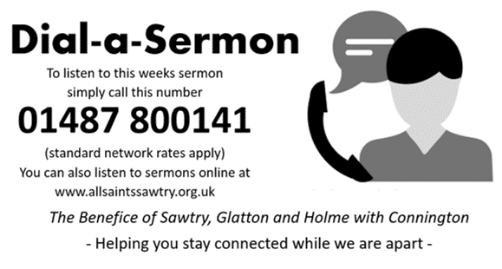

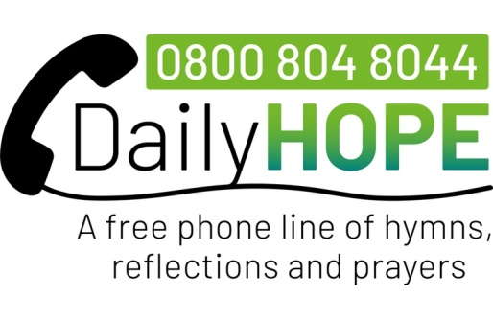

Holme Church of England Primary Academy

The children have returned to school brilliantly. Naturally, there were nerves, but once in the classroom all the children have settled back into a bit of normal. Most children are seated with their friends.  
  
We thought very carefully about the first few weeks back and as well as phonics, reading, writing and maths the teachers have planned lots of active sessions to get the children moving and to get them outside. The children are enjoying our new ‘Active Maths’ sessions.

All classes held regular circle time sessions to talk about feelings and to remind the children of how to access support in school.  
  
Teachers have been planning a range of activities to allow the children to reconnect with each other. Taking turns, sharing views, working as a team and learning to compromise has been a huge focus. We have additional members of staff on duty at break times to support with this. The new playground markings are a hit with the whole school community. It is great to hear the sounds of children laughing and enjoying being with their friends.

Over the past few weeks we have continued to reach out to the parent community via our virtual Mother’s Day and Easter Services. These are special moments in our calendar and we are keen that these still go ahead.

We are proud to be small but mighty!

We do have spaces in a few of our year groups. If you are interested in joining this community do contact the school office for details.

School office : 01487 830342

[www.holme.cambs.sch.uk](http://www.holme.cambs.sch.uk/)

Mrs Thomas

**HOLME WI**

**MARCH 2021**

Now we are into March and hopefully Spring is well on its way, the mornings and evenings are at last getting lighter

. We are obviously still a little quiet on WI news, but members are still busy behind closed doors knitting, sewing, and now a little gardening, and each month an e-card is sent to all our members as a reminder we are still here. The vaccination program is going well and many of our members have received theirs so hopefully we are heading towards a little more freedom in the not, too distant future.

Once again, as before, we now just wait for the Covid situation to improve, so stay safe everyone.

Anyone wishing to contact us please email [WIholmevillage@gmail.com](mailto:WIholmevillage@gmail.com)

Alison McGuinness President

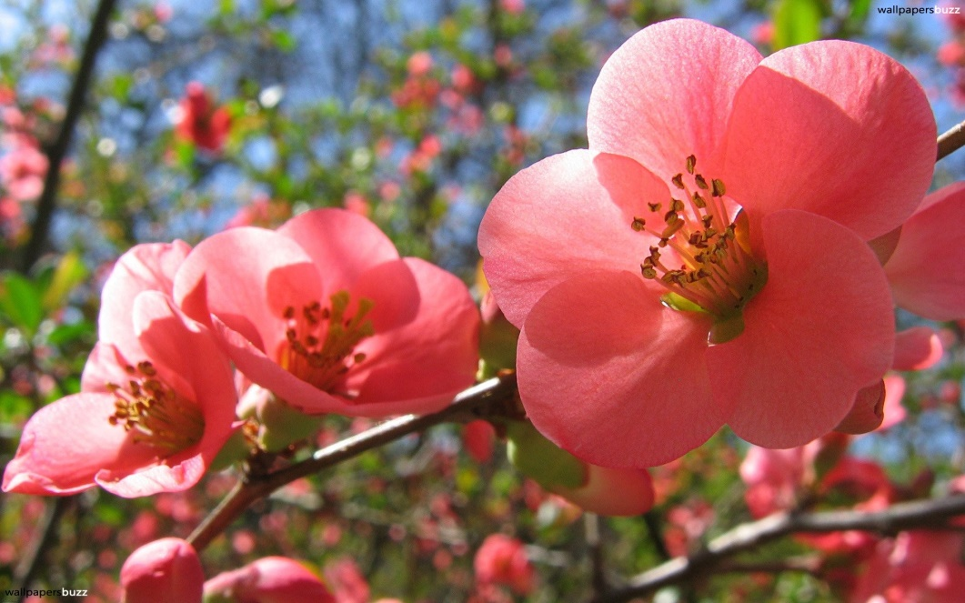

**Lakeside HealthcLakeside Healthcare at Yaxley**

**Covid Vaccination Clinics**

We would like to thank those patients who continue to treat our staff and volunteers with patience, kindness, and respect at a time when our teams are working under increased pressure to keep you safe and well. It is very much appreciated.

**Social Prescribing Link Worker**

The social prescribing service has adapted in order to continue to offer a listening ear and a helping hand. We have helped connect you to your statutory and community services, also community volunteers who have delivered food, prescriptions and befriending services, helping make our lives a little easier and to pass those long- isolated days.

But spring is now here and with it the hope for rebuilding / opening up of our community. So please get in touch with Your Social Prescriber who would like to offer a helping hand to re-establish old and establish new social groups and community activities.

I am hopeful that shortly our service will be once again able to meet you in person, helping you explore options and connect you to appropriate services.

Your Social Prescriber offers free confidential advice and support around:

***Social activities, Emotional wellbeing, Lifestyle changes, Education skills and training, Debt, Benefits and Housing***

To arrange an appointment please contact your GP practice reception team

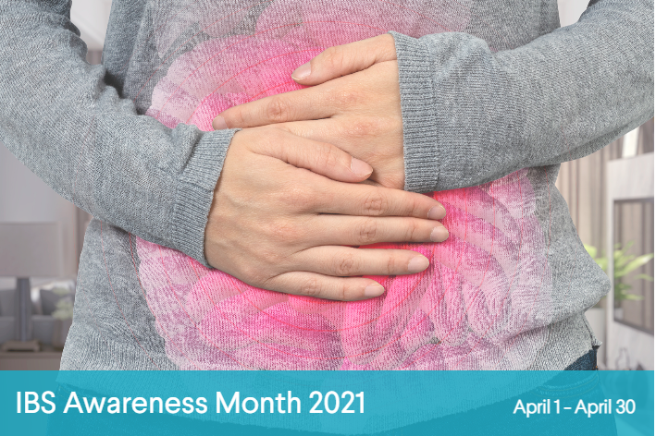Do you have IBS?

What you need to know.  
Irritable Bowel Syndrome (IBS)is a fairly common disease that strikes anywhere between 10 – 15% of the general population so feel like you’re suffering alone. The month of April is recognised as IBS awareness month.   
IBS is a condition that effects the digestive system. The disease generally causes stomach cramps, bloating, diarrhoea and constipation and can be ongoing for weeks, months or longer at a time. The exact cause for this condition is unknown but research is ongoing.

Visit <https://aboutibs.org/living-with-ibs-main/ibs-awareness-month.html> for more information

**Monthly Closure Dates**

The Practice will be closed on Wednesday 21st April 2021

Between **12.30pm** and **4.00pm** for staff training.

Emergency Telephone 01733 240478.

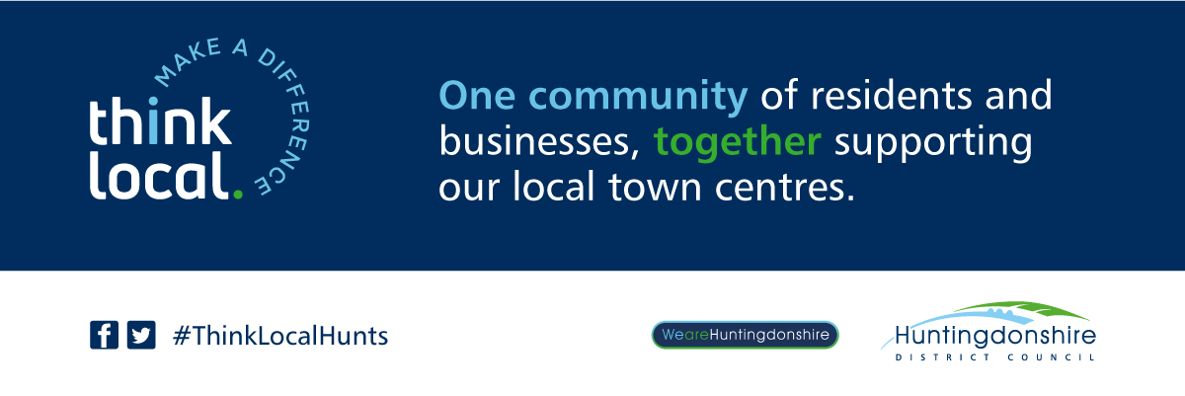

We can all make a difference – It is about changing our mindset and planning ahead.

There are many areas of our life where we produce waste and don’t even think about it. From using disposable wipes rather than a flannel to using a disposable cup rather than a reusable. One of the #HuntsWasteBusters explores this in a bit more detail.

"Pick up a drink on your way past" Why do we need to do this? It is probably becoming the "norm" as we find ourselves outside going for a walk in this pandemic. We may still need to queue and possibly identify with that person next to you who just needs a coffee ‘right now!’ We continually find people walking around holding a cup of coffee - its like a comforter, especially in these colder months. There is also an element of needing to "treat ourselves" with this thing we do when we go outside to play. But the disposable cup, like many disposable items, are just due to ‘convenience’. But when you are planning to go for a long walk, why not plan to have a hot drink treat and take the reusable cup with you?

Coffee cups are the second biggest contributor to litter after plastic bottles. Takeaway cups are usually lined with a polyethylene membrane to make them waterproof. This is very thin. They are not recyclable through conventional methods or biodegradable, meaning we have to take care to dispose of them, but usually they will end up as general waste. In addition, 25.000-micron sized particles are released into 100mls of hot liquid if left in a "paper" cup for 15 minutes - which you drink.  The ocean is packed with micro particles which accumulate in places of outstanding beauty.

It can take 90 years for a takeaway cup to biodegrade - depending on the type of plastic used.

So why not see this as ‘your personal non-contribution to waste’, rather than seeing the problem as too big to care or tackle.

💚 DON"T USE A TAKEAWAY CUP

💚 CONSIDER A FLASK

💚 USE YOUR OWN REUSABLE CUP

💚 REFUSE A LID

