Holme Community Speedwatch
Our campaign grew teeth during “Action Week” when we had police officers supporting one of our sessions and issuing speeding tickets and severe warnings to those with excessive speeds – most disapointing that some of the recipients of each were residents of the village as with all our efforts we would like to think they at least would acknowledge the speed limit.

Sadly the session we held after that still showed 8% of the traffic exceeding the 30 mph, one at 50 mph and one 54 mph. Much better than our usual 25-30% but the fixed sign advising them of their speed was only 20 yards in front of our equipment. Consequently we will continue our campaign to educate drivers with the hope that we are reaching some of the regulars who pass along the B660 and will eventually get our percentage to an acceptable level to make life safer for the residents of our little village.

As always we welcome anyone who feels they have an hour or so to spare now and again and would like to support our volunteers to send an email to reneemitcham@btinternet.com and training with Cambridgeshire Constabulary will be arranged and we can add you onto our list at a time and date that is appropriate for your circumstances. I must stress our volunteers are from all walks of life - students and full time workers as well as part time workers and retirees - everyone is welcomed.

Holme Youth Club
Another year draws to a close as our final session before the summer break is on 5th July. With a membership in excess of 50 and an average attendance of 25 each week we have a very good year and are all set for welcoming the new Year 5s in September. Our first session will be 6th September and the AGM will be on 27th September. The committee of the Youth Club is made up of 3/4 adults and a minimum of 5 members who help run the club and make decisions about visits, equipment purchase, membership management, etc so that they effectively run the club.

We have at times struggled with numbers as volunteer helpers are like gold dust - much valued and difficult to find - and without them of course we cannot run our sessions. Never the less we have not yet had to cancel a session though we have had to turn members away because we have reached the maximum we can take. My grateful thanks go to all those parents/carers/friends who have assisted as supervisors and the three young ladies who as part of their Duke of Edinburgh Award volunteer to run our tuck shop.

The annual day out was on 23rd June so the report could not make this issue but it will be in the August one hopefully with pictures.

Membership of Holme Youth Club is open to members of school years 5-10 who live in Holme or attend or have attended Holme School. We also offer a guest membership to anyone invited by a bona fide member but I am afraid we cannot extend it beyond that because of the restriction on numbers. If you meet this criteria and would like to find out more please pop along to Holme Village Hall on a term time Friday evening between 6.30 and 8.30 pm and see what goes on or email reneemitcham@btinternet.com for further details.

Holme Parish Council News

I am writing this in the middle of June with several layers of clothing on and the rain beating down outside, the 4th day of such horrible weather in a row. So much for the summer. I hope by the time you read this we will have some sunshine and warmth!

The Huntingdonshire Local Plan to 2036 has now been adopted. You can read it (283 pages) on the HDC planning portal. http://www.huntingdonshire.gov.uk/media/3872/final-adopted-local-plan-to-2036.pdf

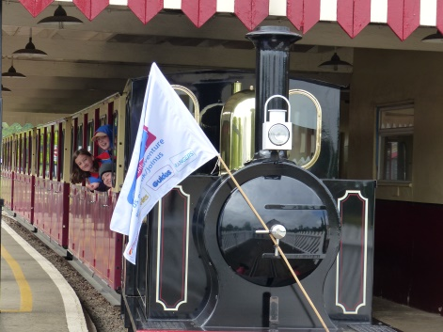
Holme is designated as a small settlement and the important information is in chapter 4. Hopefully the rush of applications is now over. I am informed that the applicant for the Pingle Bank development has up to 2 years to come up with plans for the footpath and pedestrian crossing which are pre-requisites for the development to happen. The Planning office is still overwhelmed with work so there is nothing new to report on the 4 current applications.

Holmewood Hall/Country House Weddings has been granted their entertainment and alcohol licence. If late night traffic movements or noise cause you any problems once events start please can you keep a note of the date and time.

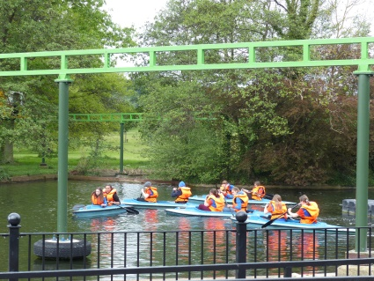
The Parish Council met on 21 May and is pursuing Network Rail about the footpath project, the Forestry Commission and HDC Tree Officer about trees and has asked HDC to consider increasing the number of Parish Councillors – to allow some more of you to become involved whilst retaining the experience of the current elected Councillors. Currently there are no vacancies but we need to plan for the future.

Drains. At the Annual Parish Meeting we heard complaints about the drains being blocked but only one person came up with dates. If your drains have been blocked and needed to be cleared please let me know so that I can compile some statistics.

Dog Poo. This has started again. Please do not allow your dog to foul the pavements. Anyone seen will be reported.

Next full Council meeting: Tuesday 16 July 2019 at 7.00pm at the Village Hall. All welcome to listen, please let me know ahead if you wish to address the Council. Holme Parish News can now be read online – on the Council website www.holmecambsparish.org

Mrs J Osborn - Parish Clerk. 01487 831559 holmeparishclerk@gmail.com
1st Holme Guides have been very busy since returning after Easter. Girlguiding Cambs West arranged a sleepover at Wicksteed Park. The 6 girls from the unit and myself went along on a Friday night. A wide game was played with all 193 girls present and then we slept in the ballroom overnight.
Saturday was spent in the park where the girls were able to enjoy all of the rides and activities. It was an amazing time and everyone was exhausted at the end of our adventure.

In order to complete her Leadership Qualification Kathryn had to arrange an activity with another unit. She arranged for us to visit Yaxley 1st Brownies where everyone worked in small groups to create a catwalk creation from black bin bags and newspaper. They were very creative and the designs were amazing and all unique.

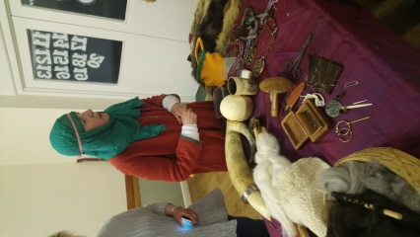
Having visited the Brownies some of the older girls decided they would like to come and try an evening of Guides. We had arranged a fire lighting activity, damper cooking and filtering water with a selection of different materials. However, the British weather being what it is we had to improvise. Janice came to the rescue and the activities were completed in her house in her open fire place. This was a great evening for firsts, girls never having struck a match, lit a candle, built a fire or made dampers – I admit dampers were a first for me!

We are working hard on the new programme Unit Meeting Activities and Skills Builders during our Monday meetings. The Guides are encouraged to work independently at home on the Interest Badges and then present what they have been doing to the rest of the unit. Everyone is getting the hang of how this is going to be working and I hope you can see how much fun we are having.
If anyone is interested in joining our unit please get in contact, Linda Browning 01733 247147 ljbing.girlguiding@gmail.com
We would love to welcome some new friends .

Holme WI A Different Language & Viking Invasion (Not at the Same Time Though!)

Holme WI recently hosted the Annual Group Meeting, when the four WI’s in our group area, ourselves, Ramsey, Ramsey Abbey and Ramsey St. Marys all meet up. This year we were invaded by a group of Vikings, or more specifically Vikings from the Russian regions. We enjoyed a talk about Viking life in East Anglia including the very basic but sometimes necessary surgery needed and the occasional tooth pulling, with some rather crude surgical instruments. Then a Saxon Lady told us all about the clothing, how they spun and dyed their wool to make garments, and displayed examples of the type of tapestries and garments they made, along with amber and bead jewellery. Viking women would always be busy, as bread was made each day along with many pints of beer, as there wasn’t any clean drinking water, so beer was drunk instead.

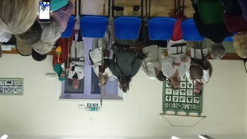
We also had a boisterous weapons demonstration with axes, swords and shields, with the demonstration coming to a close with a charge and a shield wall, look out the front row of ladies.

A group of our ladies also drove to Chatteris on a lovely day in May for a fabulous morning watching Steve and his team at the London Glass Blowing Company. They were thoroughly looked after from a very informative talk and demonstration to coffee and homemade cake afterwards. There were some amazing pieces of his craft on display to purchase and we will definitely be going back during his open weekends to show family and other friends and make some more purchases!

Our June guest speaker was Jane Kennedy, a British Sign Language Tutor. Jane taught us how to sign our own name, we learnt the alphabet and we also sang along and signed at the same time to The Rainbow Song. As we became more adventurous with our signing Jane also taught us some of the finer nuances of words, so that we wouldn’t sign a rude word by mistake, phew! By the end of the evening we were signing (and um sort of singing) to Louis Armstrong’s Wonderful World and Hello by Adele. I was so pleased she didn’t pick a faster song, keeping up with Jane was a challenge. A fantastic evening, Jane is a brilliant guest speaker and we all had a really good time.

Anyone interested in joining, please do come along and see what we are all about and what we get up to. We meet on the first Thursday of every month at Holme Village Hall, Short Drove, Holme PE7 3PA at 7.30pm. Please contact holmewi2015@gmail.com for further details.

All ladies will receive a warm and friendly welcome.

Alison McGuinness President

Clay Shooting Club
The next meeting will be in August and anyone wishing to join should contact Ron Gilbert, email: ronnieg911@hotmail.com

ST. GILES PARISH CHURCH
HOLME with CONINGTON

JULY 2019 CALENDAR

July 7th | Third Sunday after Trinity
9.00am |  | Holy Communion
Reader: |  | Mrs L Papworth
Flowers: |  | Mrs T Forster
Prayers for: |  | Holme Lane | Holme Guides
July 13th | Fourth Sunday after Trinity
4.30pm (Saturday) |  | Family Service
Reader: |  | Mrs L Papworth
Flowers: |  | Mrs C Bergh
Prayers for: |  | Holme Road | Local Delivery Services
July 21st | Fifth Sunday after Trinity
9.00am |  | Holy Communion
Reader: |  | Mrs J Osborne
Flowers: |  | Mrs B Lawes
Prayers for: |  | Holmewood | The Village Hall Committee
July 28th | Sixth Sunday after Trinity
NO SERVICE
Prayers for: |  | Holmewood Crescent | The Womens' Institute

READINGS FOR JULY 2019

Date | Reading 1 | Reading 2 | Reading 3
07  July | 2 Kings  5:1-14 | Galatians  6:7-16 | Luke  10:1-11,16-20
14  July | Amos  7:7-17 | Colossians  1:1-14 | Luke  10:25-37
21  July | Amos  8:1-12 | Colossians  1:15-28 | Luke  10:38-42
28  July | Hosea  1:2-10 | Colossians  2:6-15 | Luke  11:1-13

