Holme Parish Council News
IMPORTANT!! Mobile Post Office – time change! The powers that be have decided to change and reduce our mobile post office service. Please note that FROM NOW the new time is 9.30am to 10.30am on a Friday. This service is at an absolute minimum now, and it must be used to keep it.
Oh no, not again – DOG POO is causing trouble. Please pick it up. It is the law. The Parish Council has debated this subject again in November and decided to continue with the strategy of spray painting the poo. This is intended to mark the spot so pedestrians can avoid it more easily and also to remind the perpetrator to remove it next time they pass. The paint is specially made for this purpose and is biodegradable. Alternative ideas will be considered.
The Council is aware that some of you pick up poo that other people’s dogs have left. A huge THANK YOU. It’s a shame you need to.
Fly tipping is continuing to be a problem and should be reported on the HDC website please.
Gritting: I know it may not be needed, with global warming and climate change, but Highways are still looking for a new volunteer to carry out footpath gritting in the winter time. Please contact me if you could help.
The bus! We have one regular weekly service which may be much easier than parking in town if you are off to do Christmas shopping! Please USE it or we will LOSE it! There is a new “Ring and ride” type bus service called TING now operating along, and on the other (west) side of, the A1 corridor- if it’s successful it may well eventually reach us!
Air Pollution - School and Level Crossing. In the interests of children’s and residents’ health can you please switch off your car engine and not sit idling – at the railway crossing you could be there a while! Also if you have a bonfire please consider your neighbours and the wind direction.
Speeding – I am sure Renee will have written elsewhere, but the speeds through the village are still higher than anyone would like. Regular speeds of 65-66mph are recorded along Station Road in the middle of the 30 zone, not always late at night either – and the jackpot speed recorded by the Holmewood SID was a massive 91mph last month!
Speed Indicators - I have been asked to clarify how these are used. The Parish Council owns 2. They are both mobile units and are moved about – this is a condition of their use imposed by Cambs County Council (CCC). The indicators are designed to inform the driver of their speed, remind them of the speed limit and encourage compliance and the data from the devices is advised to Councillors and sent to CCC for their records. The data is not used by Speedwatch, Police or any other outside body.
CARESCO, the Community resource in Sawtry, is looking for a new delivery person for the Sawtry Eye in Holme. Please contact Liz Coates direct at Caresco. There is a small payment for this work which is suitable for anyone who likes a little walk around the village.
The next Parish Council meeting is scheduled for Thursday 20 January at Holme Village Hall. On behalf of the Chairman and Councillors as well as myself, I wish you all a peaceful Christmas time and a very happy 2022.
Janice Parish Clerk www.holmecambsparish.org email: holmeparishclerk@gmail.com
From the Vicar
Countdown to Christmas
“It’s beginning to look a lot like Christmas” is one of those ear worms that stick in your head this time of year and has been covered by heaps of artists due to its popularity….Bing Crosby is probably my favourite one. Yet this brilliant time called Advent precedes Christmas but sometimes it is easily overlooked. Advent is ‘the final countdown’ to Christmas day and many people will have an Advent calendar to help them count the days. It’s also a really special time for the church.
The words Advent simply means ‘coming’ – it’s the season when Christians remember that God came to earth to be born as the Christ child, Jesus. God also promised that Jesus will come again at the end of time to heal all the world’s hurts and divisions. Advent remembers this amazing promise, so it’s a time of hope, of getting ready, and expectation.
Waiting is hard, but Christmas is worth waiting for – it’s a special time, and at its heart is a gift of love from God to the world. An AWESOME gift in Jesus and this gift is for everyone. I am one of “those” people that really struggle to keep a surprise a surprise….If I have brought someone a present I cannot wait to give it to them, or if I’ve arranged a special outing I am rubbish at not blurting it out (to the annoyance of my family) and that is because I am so excited about what is to come and the anticipation is too much to contain. It’s also fair to say I love giving a gift and give time, thought and energy into the gifts I give and because of that get as much out of giving it as I hope the recipient does in receiving it. Yet the countdown, the wait, the getting ready is so worth it and we mark it in different ways as a church, in advent you will see an advent wreath with candles on it. One candle is lit each week (usually at the start of the service) – often with a special prayer.
This year you will also see large Christmas Trees in or outside each of our churches, these trees have been sponsored by two local business Addison Arms and Outside Structure Solutions. The trees, simply decorated with lights and a star, represent hope and faith during times of sadness and challenge, acknowledging the difficulties of the pandemic and offer thanks for light in darkness.
There are services taking place across the villages and I encourage you to take a look at all that is on offer from the different churches and join in as you feel able. You will receive a warm welcome and even the odd mince pie.
May the joy of the angels, The gladness of the shepherds, The worship of the wisemen and the peace of the Christ child be yours this Christmas and all through 2022.
Reverend Becky
Services in December & January @ St. Giles Holme

Sunday 5th December
9am Holy Communion
Saturday 11th December
2:30-4:30pm Festival Coffee and Cake with 30@4:30 (short service)
Sunday 19th December
Holy Communion
Christmas Eve
6pm – Candlelit Carol Service*
11:30pm ‘Midnight’ Holy Communion
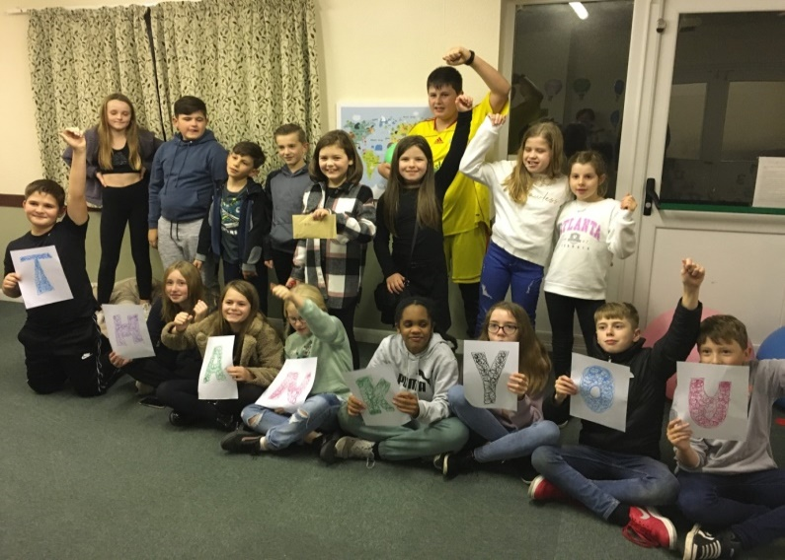
*Although we are not limiting numbers, we ask everyone to come with a mask to be used as needed and to follow the guidance given on the day.
January @ St. Giles Holme
Sunday 2nd Jan No Service at St. Giles 10:30am at All Saints’
Saturday 8th
2:30-4:30pm Coffee and Cake with 30@4:30 (short service)
Sunday 16th Jan Holy Communion
Please Note: If there is no service at St Giles there are alternatives to chose from on WWW.allsaints sawtry.org.uk.
HOLME YOUTH CLUB
The members of Holme Youth Club were delighted to have a visit from the organisers of the Sunflower, scarecrow and pumpkin competitions as they hand us £130 as our share of the proceeds. The photograph shows members saying a big thank you and I would like to emphasise that Thankyou in this publication. It is wonderful to receive such kind hearted support from people who live in the village and dont even have children.
We now have 50 members on role and are teetering on the edge of turning members away on club nights as 40 is our maximum. Its lovely to see it so popular and the members letting their hair down and having a great time. Thank you to all those who have volunteered to supervise and help keep us going.
Our visit to Laserforce on 26th November was fully subscribed so the older members who help out in the tuck shop opted to go ice skating instead. It was lovely to know that 38 of our members could have a really enjoyable night out – thanks to those people who provided transport to help us cut down on the number of cars making the journey. A great time was had by all!

Our final session before Christmas is 10th December and we will be back on 7th January so we would like to take this opportunity to wish all our members and their families (and all the you readers) a very Happy Christmas and a healthy and prosperous New Year.
Holme Youth Club membership is open to school years 5-10 who live in Holme village or attended or have attended Holme School. Unfortunately we are unable to accept guests as we are at capacity.
HOLME COMMUNITY SPEEDWATCH
Holme Community Speedwatch volunteers are trained and supported by Cambridgeshire Police to try to educate drivers to consider and respect our residents and visitors by adhering to the speed limit within our village and hopefully everywhere else with a speed limit. We are a dedicated group who are trying to make our village safer and pleasanter for all those who live or visit Holme.
It has been requested we refrain from using the fixed sign and just use the mobile unit at the Holme Lane entrance to the village. We will comply with this request but whatever sign we use we always have a member of the team calling out when the vehicle passes the 30 mph limit sign and the reading is taken from the sign at that point. With a flashing red light to warn you you were going too fast for quite some distance you would really think drivers would take the hint and get down to at least 30 before passing the 30 mph limit sign but sadly 20-30% of drivers passing through the village do not do that, coming past our speedwatch sign at speeds of up to 50 mph. There is a serious need for our services as we try to protect our village residents.
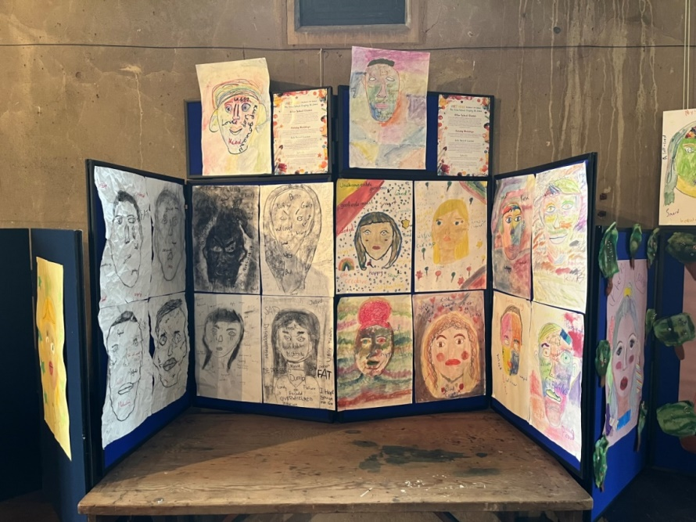
We have been asked on several occasions to do sessions in certain places and at certain times because a pedestrian has felt their life was threatened by excess speed and inconsiderate driving and we are always ready and willing to step in and do this. If you have any concerns about “danger areas and times” please let us know and we will do our best to arrange a session.
If you have an hour or so a month to spare and would like to join our team please contact csw.holme@btinternet.com and we will sort out your training and add you to our team
Holme School
We can already hear the sleigh bells and carols as we make our way to the end of a very busy term and prepare for Christmas. It has certainly been a very busy half term with the children taking part in many exciting learning projects across the school.
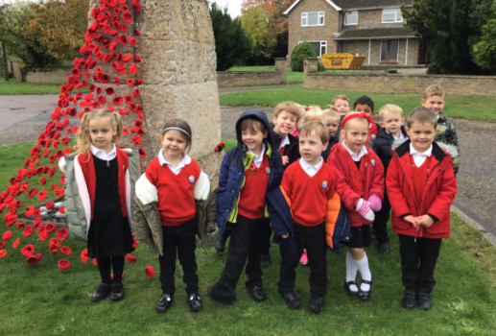
In November, we also took part in Remembrance Day with a trip to see the monument outside the church and completing our 2-minute silence. The children spent time reflecting on the importance of remembering those who died for our tomorrow and we talked about all of those who continue to do so.

The Key Stage 2 children took part in a body positivity project and we exhibited a selection of the art work at St Giles, on the 13th November.
A big thank you to Reverend Becky Dyball for supporting us with the exhibition and we hope many of you were able to pop along to see the hard work the children had completed. The children absolutely loved the project and it has really made them think carefully about the words in which they use and having confidence in themselves.
Towards the end of November, we began practicing our special Christmas carols and nativity. Unfortunately, due to being in an Enhanced Response Area, we have made the decision to continue these events virtually so as to minimise transmission in our school community. The children are all very excited to share their songs and story with all of the families very soon.
This month, we wanted to make sure the children had an extra special Christmas, so we have planned lots of additional Christmassy treats to get us all into the Christmas spirit including a whole school visit to the pantomime. All of the children have made their own decorations and the wonderful PTA have supported the school once again with fantastic activities for the children to all get involved in (big thank you to all of the PTA for their unwavering support). We look forward to our Christmas party in our last week of term too.
As we make our way to the end of term, with the Christmas break and New Years celebrations shortly after, we will be spending time reflecting on the past 12 months and considering what we would like to achieve in the new year. It has been a challenging year for all, once again, and so we hope that we will be able to provide some extra opportunities for our children as we continue to get back to some form of normality...watch this space!
We would like to wish you all a very Merry Christmas and a happy New Year. Please take care and we look forward to seeing all of the children back to school on Wednesday 5th January 2022!
Kind regards, Mrs King and the small but mighty Holme team
From Tim Alban Our Local Councillor
PLANNING – LOCAL
Ironically enough for a councillor who isn't a member of the District Council's Development Management Committee, I continue to spend a significant amount of time dealing with planning issues; to one degree or another, over the last year I have been involved with planning related issues in Holme and Conington as other villages in my ward.
At the time of writing I have no further news on the sites on Pingle Bank or Yaxley Road.
PLANNING - NOT QUITE SO LOCAL
I am concerned about the proposals for a distribution park on a green field site to the north west of Junction 17 of the A1M (on the opposite side of the A605 to the Extra Services) not least because this would be outside of the local plan.
As the site is in the northern part of our district council ward, my fellow ward councillor, Marge Beuttell, is taking the lead for the two of us on this matter; at the time of writing, a planning application hasn't been published but Marge, County Councillor Simon Bywater and I have already been contacted by a number of local residents.
FLY TIPPING
There seems to have been another spike in Fly Tipping recently and I am grateful to the prompt actions of the Huntingdonshire District Council Enforcement team, who work to identify those responsible and the Operations team, who clear away what has been tipped. Reports of tipping and littering can be made via www.huntingdonshire.gov.uk I use the What3Words app to help identify the location, which I find especially useful in representing a rural ward, which one of the largest in the district.
THE ENVIRONMENT
Huntingdonshire is one of the largest districts in the country and the district council has a longstanding commitment to tackle environmental challenges.
The Local Plan sets out green infrastructure priorities and key policies which better shape our future environment for the benefit of nature and the reduction of carbon emissions.
The environment is one of my key areas of interest and I look forward to continuing to try and reduce my own carbon footprint as well as working with the council to benefit of the whole community.
COVID-19 AND RECOVERY
Huntingdonshire District Council's officers and councillors continue to work hard to deal with the ongoing issues around COVID-19 and the ongoing recovery. Further information on what has been achieved can be found at https://www.huntingdonshire.gov.uk/people-communities/recovering-from-covid/
A WIDER PERSPECTIVE
The last 18 months have been some of the busiest in my time as a District Councillor; I am approached about a wide variety of issues, not all of which are the direct responsibility of the District Council. Sometimes I am able to help directly and other times my role is to point people towards other councillors, councils or organisations but I will always try and help.
I am fortunate to have a good working relationship with my fellow ward District Councillor Marge Beuttell, our County Councillor Simon Bywater and the Councillors and Clerk at Holme and Conington Parish Councils and enjoy working with them for the benefit of the community.
CONTACT INFORMATION
Contact details for Huntingdonshire District Council, including the Out of Hours Emergency Telephone Number, are available via https://www.huntingdonshire.gov.uk/contact-us there is also information available via https://www.wearehuntingdonshire.org/
My contact details are:
tim.alban@huntingdonshire.gov.uk 07913 101145
With best wishes for a Happy Christmas and New Year.
Tim Alban District Councillor

