Church & Parish Directory

St Giles Church Website: www.holme-parish.org
Rector Revd Becky Dyball, The Rectory, Church Causeway, Sawtry
PE28 5TD. T: 01487 506217 revdyball@gmail.com
Churchwarden Mrs Judith Osborne, 27 St Giles Close, Holme 01487 832023
Secretary Mrs Rachael Downer, 11 Station Road, Holme PE7 3PH 07939 049759
Treasurer David Perry astreasurer1880@gmail.com
County Councillors Cllr. Simon Bywater email: simon.bywater@cambridgeshire.gov.uk
District Councillor Cllr Tim Alban email: tim.alban@huntingdonshire.gov.uk
Parish Council Website: www.holmecambsparish.org
Clerk 07548441977 email: holmeparishclerk@gmail.com
Chairman Mr John Griffin, 11 Vicarage Close, Holme,PE7 3PQ 01487 831245
Parish Councillors Cllr. W Aylesbury, Cllr D Neal, Cllr. P Sargent, Cllr H Watson,
Cllr. E Whittaker Cllr C Reed, Cllr L Roderick Smith, Cllr J Edwards. Contact via email as above
Bowls Club Mr P Dickman email: holmesmbc.secretary@gmail.com
Rainbows/Brownies/Guides/Rangers contact Val Aldridge District Commissioner
valaldridge@btinternet.com or wwwgirlguiding.org.uk
Holme Youth Club holmeyouthclub@outlook.com
Holme Cricket Club Ian Kendall email: holmecrickeclub@gmail.com 07437425107
Holme Reading Room Trust email: holmereadingroomtrust@hotmail.co.uk
Holme School Website: www.holme.cambs.sch.uk
Executive Head (Holme & Stilton) Mrs Clara King 01487 830342
Head of School Mrs Charlene Ferrara
cferrera@holme.cambs.sch.uk
Friends of Holme School Nuala Clements friendsofholmeschool.hotmail.com Or Amanda Rose Amanda.rose8 @btinternet.com
Neighbourhood Watch David Neal email: davidneal994@gmail.com
Speedwatch email csw.holme@btinternet.com
Sir John Cotton Educational Trust email: SJCEFI@outlook.com
Holme WI Pres: Mrs Alison McGuinness email: alimcg10@googlemail.com
Holme Pre-School email: holmepreschool@yahoo.co.uk
Holme Village Hall Victoria Lunan Website: www.holmecambsvillagehall.org.uk
bookings@holmecambsvillagehall.org.uk 01487 830146
Articles for December & January Holme Parish News to the editor by 13th of January
Editor Mrs Barbara Lawes : barbaralawes@hotmail.co.uk 01487 832332

Also available : Holme Village Facebook Page

HOLME

Parish News

Also available : Holme Village Facebook Page

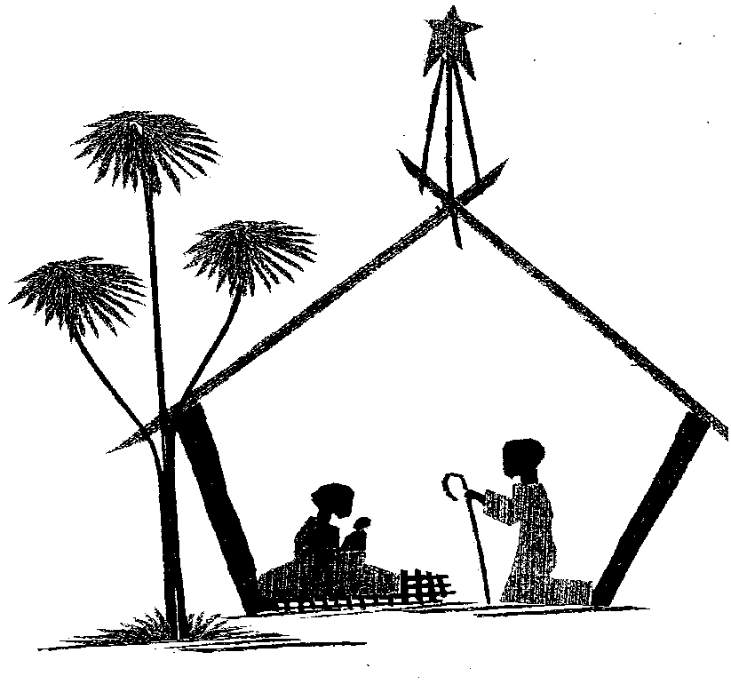

St Giles Candlelit Carol Service
Saturday 24th December at 6.00pm

December 2022 & January 2023

Free to Holme residents
(thanks to the Reading Room Trust)

