Holme Parish Council News

Happy New Year!
Well, here I am again! Some would say turning up again like a bad penny! Unfortunately Kiri was unable to continue with the role of Clerk to the Parish Council due to overwhelming personal circumstances. She resigned in November so at the request of the Chairman I am back holding the reins at the Council until further recruitment has taken place. I really do want to retire and travel so hopefully it won’t be for long!
If you would like to apply please do not hesitate – the (paid!) job is for 20 hours a month and requires administrative skills with good attention to detail, basic computer literacy, eagerness to learn, an interest in village matters, adaptability and a good command of English. Experience as a Clerk is not required as full training is available (and I will help you!). For a full job description please email me.
A little bird has also told me that Barbara is hoping to retire from the Editor role of the Holme Parish News soon. Another wonderful opportunity, this time a voluntary one, to play a part in our community. I am sure there is someone, or maybe a team of people, out there who could continue to do a great job with this magazine. Why not give her a call?
Our quiet and peaceful cemetery on Station Road is the responsibility of the Parish Council and this includes maintenance and tidying and all the Councillors take turns emptying the bins. There is a green bin there and a grey dustbin but no recycling bin so please take all your recyclables home. Please do not put anything which is not green waste in the green bin as it will be rejected, this includes wires, bases, vases etc. Conversely please do not put dead flowers in the grey bin.
If you have laid a wreath at the cemetery over Christmas, could you remove it by 1 March please? In the past it has taken us several afternoons in March to take all the wreaths to bits for proper disposal in the green/grey bins and if you have ever tried to do this you will know it’s not an easy task when there are so many. Thank you!
Janice Osborn
Clerk to Holme Parish Council email: holmeparishclerk@gmail.com tel: 07548441977

HOLME WI December 2022

Our December meeting started with a glass of alcoholic or non-alcoholic fizz and a Christmas toast with some of our members wearing their special Christmas jumpers. Then one of our members, Norma, gave us a demonstration how to ice a Christmas cake with fondant icing, using lots of gadgets and tools to get a smooth surface. She then showed us how to make holly and ivy leaves, holly berries and snowflakes. We were then each given a cupcake to decorate ourselves. The fondant icing was rolled out by Norma and then we used cutters to cut out the leaves and snowflakes. The very special bit was the glitter spray which made the cakes look all sparkly and pretty for Christmas. Norma gave us a lovely demonstration and lots of hints and tips on decorating cakes using fondant icing.
We then tucked into some lovely Christmas treats and a cup of tea.
Merry Christmas to everyone.
Anyone wishing to contact us please email WIholmevillage@gmail.com

Alison McGuinness
President

Holme C of E Primary Academy

Happy New Year from all of us at Holme, we hope January has started well for you all!
The children came back after the Christmas break all ready to go again and they had looked like they had grown so much in just those 2 weeks! We have spent a bit of time in school talking about New Year and what this means to us and how it is a great opportunity to have a fresh start, make choices and changes in our everyday lives and be the start of our journey for 2023.
In Hedgehogs class, the children have been excitedly exploring all things Space, from planets, to stars and astronauts to rockets. They are really enjoying their learning. Hedgehogs have also been developing their multi-skills in PE, practicing throwing and catching and hand to eye co-ordination.
In Owls class, the children have been learning all about Electricity in Science and learning all about the British Isles in Geography. The children have located where they live and where the capital cities are within the British Isles. The children have also been excited to get to their new teacher and are looking forward to the rest of the year.
In Squirrels class, the children are expanding on their prior learning and are exploring what life was like in Ancient Rome. The children have remembered about the British Empire from their Key Stage One learning and have used this to help them. The children have also been developing their passing, dribbling and shooting skills in their hockey lessons too.
In Foxes class, the children have been developing a greater understanding of friendships, resolution and conflict. They have also begun their learning on World War Two and have learnt when and where it took place and who was involved as well as more details about The Blitz.
We continue to look forward to our connections with St Giles and of course Reverend Becky and Reverend Diane. We couldn’t resist included a few pictures from our Christingle service at the end of 2022. It was hands down one of the funniest and best Christingle services the staff have witnessed.
We look forward to what the rest of the year brings our way.
Mrs King, Mrs Ferrara and the small but mighty team.

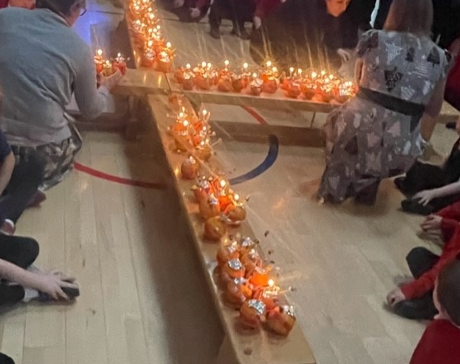
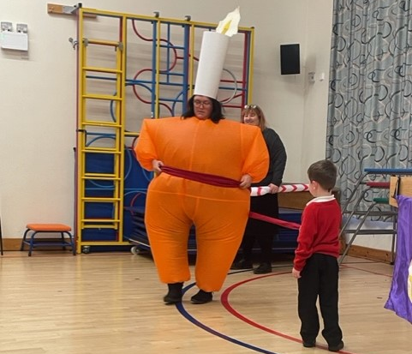

HOLME YOUTH CLUB

Youth Club is in full swing again now after the Christmas break. Unfortunately, we have had to turn some members away as we were oversubscribed for the evening. Its nice to know we are so popular and we will do our best to increase the supervisors so we can take them. We look forward to a happy and exciting year for our members.
Membership of Holme Youth Club is open to school years 5-10 who live in Holme village, or attend or have attended Holme School. If you meet this criteria and would like further information please go to our Facebook page, web site or email holmeyouthclub@outlook.com We meet from 6.30 to 8.30 on a term time Friday in Holme Village Hall and a warm welcome will be given to all new members and any adults who would like to come along and offer their assistance as supervisors who would done duty every half term.

HOLME COMMUNITY SPEEDWATCH

It was a cold and frosty morning as the speedwatch team set up their equipment thinking it would be a bit of a waste of time as surely no one would be speeding in these conditions. How wrong they were! The first car past was going at 50 mph and the next one at 46 mph followed by 25% of the remaining through traffic exceeding the 30mph limit.
Sessions during December were hit by road works and bad weather but now we are starting the new year with a continuing determination to stamp out the speeding through our village.
We would respectfully ask everyone who drives through our village to observe our speed limits and try and make 2023 a safe and happy year for all our residents.
If you would like to join our team please email csw.holme@btinternet.com and we can arrange your training with Cambridgeshire police and get you out their to join our campaign.
Time to get walking again!
With Spring on its way we start to think about getting out to walk in the beautiful English countryside again, but where to find new and interesting walks?
Walking in Cambridgeshire https://www.walkinginengland.co.uk/cambridge has loads of walks to download and print, free, it also has books of walks, details of all the walking groups in the county and much more. Whether you want to walk on your own or with a group all the information is there in one place.
John Harris (who maintains the website) said ‘There is so much walking information on the web but it is difficult to find. Walking in Cambridgeshire (part of the Walking in England website) has brought it together in one place so whether you are walking from home, or away on holiday, you will be able to find a walk suitable for you’.
With walks from half a mile to twelve miles plus long, and a note of suitability for pushchairs and wheelchairs, everyone can find a walk to enjoy.
So home or away, check out the websites and get walking!
John Harris
www.walkinginengland.co.uk
john@walkinginengland.co.uk

St Giles Church
Who have you made an appointment with?
If I haven't seen you to say it already - Happy new year!
One of the things I love about the start of a new year is a new diary. Even the way a brand-new diary smells and feels is filled with potential. Considering the blank pages - full of yet unwritten possibilities. What exciting things will be written on those pages in the next 12 months? Now of course, in the era of electronic diaries, the anticipation is maybe not quite the same but one of the lectionary readings this week made me think again about my diary.
The reading was Amos 3 and specifically verse 3:
"Do two walk together unless they have made an appointment?"
Now I don't know about you but I haven't spent a lot of time reading Amos, usually just when it comes up in the lectionary but this verse made me pause for thought.
The thing about diaries is that they have a habit of filling up - fast - with all kinds of things. Our diaries reflect both who we have to spend time with, especially if they are our work diaries, and who we choose to spend our time with. And those are the people and maybe the agendas that we will walk with throughout the year because that is who we have made appointments with. Those appointments will impact our lives and our feelings about the year, for good or ill.
So ... a big question here ... have you made any appointments with God yet? Amos asks us the question, "Do two walk together unless they have made an appointment?" Now we all know that God will never leave us and is always with us BUT are we always really aware He is there? If we want to walk together with God then maybe we should make an appointment with God. Write it in our diaries. Book it in, now before the pages fill up and set our priorities for us, make God that first entry in that new diary. Book an appointment to walk together with God, and discover what His agenda is for you this year.
And a final thought ... that electronic diary makes it really easy to enter repeat appointments at the touch of a button!
Every blessing,
Diane

Holme Parish Council
Vacancy for Parish Clerk and Responsible Financial Officer
Our recently appointed Clerk is now unable to continue working with us and we are looking for someone to take on the role of Clerk and Responsible Financial Officer.

The position is for 20 hours per month, a laptop, tablet computer and printer are supplied. Applicants should have experience in administration, good IT skills, basic bookkeeping and comfortable with managing a budget of £25,000.

Our meetings are held six times a year, in the evening in the Village Hall.
The salary will be subject to negotiation based on experience and qualifications and in the range of NALC LC2.

If you would like to join our friendly group of councillors, please email holmeparishclerk@gmail.com for a job description or if you would like to chat about what’s involved.

