Holme Parish News needs a new Editor please
Holme Parish News has been published in the village for a very long time. Published ten times a year, double issues cover December and January and August and September, it now contains articles from many, if not most, of the various organisations in Holme. Many will say that the most useful part is the central Village Diary which contains, among other things, the days on which the dustbins are collected.
When I arrived in Holme it was edited by Pat Thomas and I took it over when she retired around 20 years ago. Subscriptions were required then for it to be delivered to homes. More recently the Reading Room Trust generously agreed to fund it so that it could come to every house in the village.
Always produced by volunteers it has been a delight to get to know the contributers and all the people involved in the production and distribution of our Village magazine.
My health and circumstances mean that the time has now come for me to hand on the task to others. Please consider taking on this as a service to your fellow Holme dwellers. It needs to be taken on by somebody younger and fitter than me. It is not a big task, if needed I will help as much as I can while a new Editor gets used the task, but I am keen to give up as soon as possible.
If you feel that this is something you would be able to do, on the first instance get in touch with me and we will arrange to have a chat about it. I look forward to hearing from you.
Barbara Lawes. Editor 1487 832332

Holme Parish Council News
Save the date! Annual Parish Meeting, Thursday 27th April at 7pm. It’s your meeting – do come along!
I am very pleased to say that the Council has recruited a new Clerk from a strong field of 6 applicants. Her name is Sarah Abbott and she lives in Folksworth where she is an active village member. She is new to clerking but is keen to learn and has a wealth of relevant experience. The handover is going well and she will be here with you next month. The email stays the same holmeparishclerk@gmail.com and the phone no is now 07548 441977.
The Council met on 19 January and topics under discussion included the Speed Indicators (possible conversion to solar power), play space and the layby. The Council has been in regular contact with Highways about the latter which has recently suffered quite bad flooding. The road drain has now been cleared out and we hope this will have done the job. The Council has in mind to try to improve the appearance of this area. We are also in contact with Highways about the state of the B660 – some new bollards are promised.
As we move into spring our gardens get tidied – please think about looking after hedges near you and keeping the pavements clear. Please also remove wreaths and dead flowers from the cemetery.
Finally, a parishioner has let me know about this website which shows how long the level crossing gates will be down www.opentraintimes.com
As the song goes…So long, farewell, Auf Wiedersehen, Adieu!
Janice
Parish Clerk
HOLME YOUTH CLUB
Membership of Holme Youth Club is open to school years 5-10 who live in Holme or attend or have attended Holme School. This gives all those young people the opportunity to get to know other youngsters from the village, keep in touch with old friends or socialise with their school friends in a safe, friendly environment away from their homes.
When we recently did a check on our membership we found we had 63 members on role who currently attend about 12 different schools so we really feel we are achieving our aim of helping young people develop a social life within our very isolated and socially restricted community.
In our run up to Easter we will have another “night out” but where to?? It is up to the members to make that decision so come on guys lets have some ideas but remember parents have to be good enough to ferry you to the location so dont lets have daft ideas – Dubai is not an option!
If you meet our membership criteria and would like to see what we are all up to pop round to the village hall between 6.30 and 8.30 pm on a term time Friday and check us out. You can also find us on Facebook Holmeyouthclub or email us on
holmeyouthclub@outlook.com or seek out our web page.

HOLME COMMUNITY SPEEDWATCH
With various roadworks around the area we have found a lot of extra traffic coming through the village so our campaign has been very busy. It is heartening to see we have dropped from the 30% of traffic speeding to 15% but that is still too high for our liking so we will continue with our efforts to reduce it even further.
We still find some drivers are amazed they are considered to be speeding, and stop to tell us so, as, although they are doing 45 mph in a 30 mph zone, they are “slowing down” so are not speeding – maybe we should be called the “Holme Community exceeding the speed limit watch”
If you feel you have an hour or so to spare each month and would like to support our campaign please contact us on csw.holme@btinternet.com and have a chat about how you can join us.

HOLME WI
February 2023
At our February meeting our guest speaker was Jane Sills from the Ramsey Walled Garden. Jane gave us a lovely talk about the garden, how it dates back as far as the 1540’s when the site of the now Ramsey Abbey was acquired by Sir Richard Cromwell.
The estate has gone through several changes of ownership through the centuries with the Abbey College, formerly Ramsey Grammar School moving to the site in the 1930’s, where it remains today. During the 1950’s the garden was used as a market garden growing flowers for markets. Sadly, it fell into decline where it remained until a group of volunteers rescued it and after many years of hard work the garden was opened for public viewing in 2010. The garden was officially opened by Lord Fairhaven, the son of Diana Broughton who owned the estate in the 1930’s and upon her death in 1937 requested the estate was to be used for educational purposes.
The garden thrives today with an army of volunteers and funding, the new glasshouse was built with the legacy left by one of the founding members.
The garden has a very old mulberry tree which is thought to have been planted in the 1700’s, and a tunnel of apple trees has been planted. Gateways and pathways have been restored and although there are a lot of flower beds there are also vegetable beds and a herb garden, which is based on the design the monks may have had originally used.
There were lots of pictures to look at and a lot of hard work has gone into restoring the garden. It looks like a visit needs to be made. Jane gave us lovely talk and is a highly recommended guest speaker.
Very sadly Holme WI will be closing at our March meeting. I decided last summer it was time for me to stand down as president and let someone else take the reins, unfortunately no one has volunteered and without a president we cannot continue. So, we will end with a social gathering of our ladies and Holme WI will be suspended.
Anyone wishing to contact us please email WIholmevillage@gmail.com
Alison McGuinness President

Holme School CoE Primary Academy
Exciting News if you are starting school in September 2023 – we still have some spaces available for our much sought after Reception class. If you forgot to apply or have since moved to the area, then please get in touch and we can advise you on how to apply for your place!
We have been working so hard that we can’t believe how far into the year we are already!
Hedgehogs have enjoyed exploring their Space themed work by becoming astronauts in their Space Station role play area. They have been telling all the grown-ups in school interesting facts they have learnt. It always amazes us how much they can remember! The children have also been learning about how to help others through their RE and PSHE work.
The Owls class have been learning all about The British Isles and have become super geographers and can name the countries that make up The British Isles. They have been able to discuss where each country is using their knowledge of compass directions too. The children have been enjoying their music lessons, where they have been singing and exploring pitch through the use of hand bells. We definitely have some aspiring musicians in Owls class.
The Squirrels class have been learning all about working together in their PSHE lessons and have been exploring good communication, listening skills and what makes effective group work. During their PE lessons, Squirrels children have been exploring rotation through gymnastics and are becoming experts in their hockey lessons too.
The Foxes class recently had a wonderful trip to Duxford Imperial War Museum and were lucky enough to have an online meeting with a lady who lived during the Holocaust. These first hand experiences have really inspired our Foxes children to find out more and have compassion and empathy for people who lived during the times of the War.
We would like to take this opportunity to thank our supportive parents, FoHS team and community for everything they do and continue to do for us as a school.
Mrs King, Mrs Ferrara and The Small but Mighty Team.
Feel Brighter
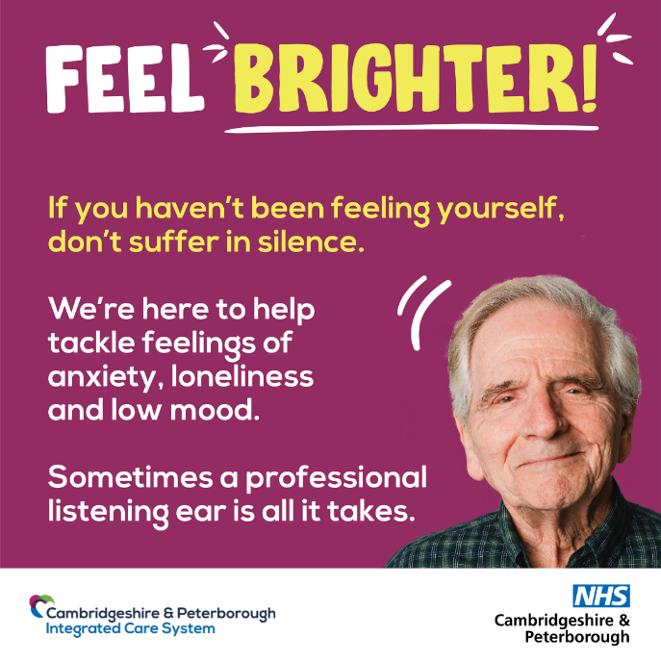
Helping older people ‘Feel Brighter’ again with NHS Talking Therapies
Are you 65 or older and feel like life is less colourful than it used to be? If you haven’t been feeling yourself, don’t suffer in silence.
‘Feel Brighter’ is a new NHS campaign that aims to reach out to older people aged 65 and over, who may be struggling with their mental health but don’t know where to turn for advice, support and to find out what services are available locally.
The new campaign aims to encourage older people who have symptoms such as anxiety, loneliness, or low mood to reach out and access free NHS Talking Therapies and other support to help them feel brighter again.
NHS Talking Therapies are effective treatments that involve speaking with an experienced mental health professional to understand feelings and learn ways to manage them. Sessions are totally confidential and can be one-to-one, in a group, online, or over the phone.
To find out more, simply visit the Feel Brighter webpage at www.cpics.org.uk/feel-brighter for more information about NHS Talking Therapies, other support available, and how to refer yourself. Alternatively you can call this number to make an initial referral: Tel 0300 300 0055. Phone lines are available 9am-4pm, Monday to Friday (closed on Bank Holidays).
Holme Pre School
We have had a busy start to the new term at Holme Village Pre-School. We have welcomed lots of new friends to the pre-school over the past few weeks and the setting has had a revamp with new resources and a fresh lick of paint.
Despite the cold weather, the children have still been able to spend time outside playing in the garden area and have enjoyed playing with the new toys and activities, in particular learning skills in the new dedicated maths area. The pre-school team provide a welcoming and creative environment for children to develop and learn through play. Information and photos are regularly shared on the pre-school Facebook page, follow us for updates @Holmevillagepreschool.
If you would like to arrange a visit to the pre-school or further information about enrolling your child, please contact managerholmepreschool@yahoo.com.

From St Giles
Moments of joy ....
This morning it was my privilege and joy to visit the residents of Hillview Nursing Home. We have been visiting once a month since restrictions were lifted and it has been great to start to get to know some of the residents a little better.
This morning I was accompanied by Pam who played the keyboard and we decided we would do a medley of hymns - focussing on the first verses and choruses so that these could be from memory as many of the residents find reading words difficult. As anyone who has stood next to me in the church when singing will know I can't carry a tune in a bucket so leading a small group of people singing would normally be my last choice of things to do! And so I was especially blessed this morning when, as we began to sing the familiar hymns more and more of the small group joined in. The sound of the worship was truly beautiful. There was something about the familiarity of the words that made them accessible and the singing of them over many years writes them in the memory.
Every Blessing Diane

