#### **Holme**

#### **Parish News**

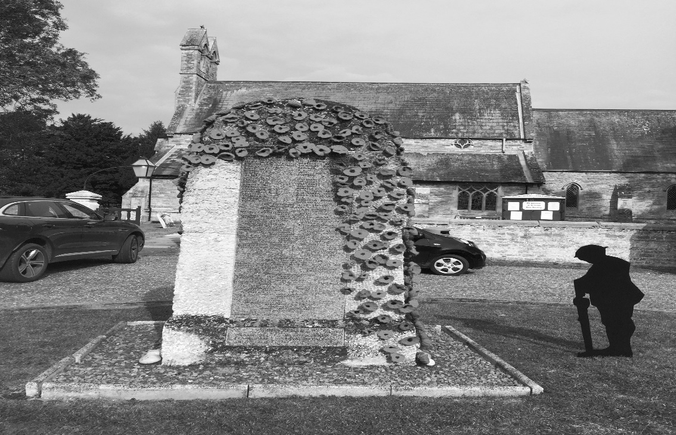

November 2023

Free to Holme residents

(thanks to the Reading Room Trust)

**HOLME PARISH COUNCIL**

The **September meeting of the Parish Council** had a full agenda. Minutes are available via the Parish Council website or by emailing me. Here are the highlights.

Council’s vision for the village is to have a **play area**. A sub-committee has been formed who will be carrying out research into what ages of children would benefit from a play area; what we can learn from nearby villages who have installed play areas; and, what potential design options are available for the budget allocated. No decisions will be made without residents having the opportunity to provide their input – the subcommittee are just exploring what might be possible at this stage.

A discussion was also held as to whether there is a need to provide **allotments**. If you are interested in having an allotment please email or write to me to express your interest.

Village maintenance is a hot topic and by the time you read this Council will have responded to a survey that Cambridgeshire County Council have organised asking for feedback on the impact of their change in **road side weed management**. The worry is that drains will block resulting in (dangerous) surface water on the roads and that over time tarmac will deteriorate making road surfaces even worse.

On a positive note, you may have noticed that the **Speed Indicator Devices** have been converted to be powered via **solar panels** rather than batteries.

Looking ahead to **November’s meeting** topics on the agenda include:

* The results of the **biodiversity survey** on the green space at Holmewood which includes a variety of recommendations on action that could be taken to increase levels of wildflowers and wildlife
* Selecting contractor(s) to carry out **grass cutting, verge cutting, hedge trimming** for the year that starts on 1st April 2024. It’s good practice for councils to obtain 3 quotes as well as reviewing what’s needed.
* 2024/25 **budget** including agreeing the request we will be making to Cambridgeshire County Council for the **precept** i.e. the amount of money that Parish Council need to cover expenses. You see this as a separate line on your council tax bill.

**Date of next Parish Council meeting**

The next meeting is scheduled for Thursday 16th November at 7pm in the Village Hall. Members of the public are very welcome to attend.

**Can I help?**

If I can be of any help with Parish related matters please call or email me (or you can write to me too)

Sarah Abbott, Parish Clerk and Responsible Financial Officer

[holmeparishclerk@gmail.com](mailto:holmeparishclerk@gmail.com)

07548 441977

38 Townsend Way, Folksworth, Peterborough, PE7 3TU

**Christmas Bin schedule**



**HOLME C OF E PRIMARY ACADEMY**

We have had a busy first half of the year at Holme. We have had our Year 5’s head out on the roads for bike-ability and have learnt how to become safe cyclists. The instructors said they were sad to leave such a delightful group of children at the end of the course – so well done Year 5! A selection of Year 1 and 2 children have taken part in a multi-skills competition too and enjoyed taking part in so many different activities! Our Year 5 and 6 girls have participated in a girl’s football tournament too and demonstrated great team work and fantastic core values – well done!

In school our Foxes have been busily learning about ‘wisdom’, how we use it in our everyday life and what the bible teaches us about It too. In addition, they have thoroughly enjoyed their unit on coding, whereby the children have coded a traffic light simulation and have written code to make a football game work.

In Squirrels, the children have been learning how to round numbers to the nearest 10, 100 and 1000 and have been using these to solve problems. They have also been continuing their learning of Stone Age through to The Iron Age and have been so immersed in this across the curriculum.

In Owls, the children have had great fun learning all about their bodies and how out senses work, how skeletons protect and support and how Scientists such as Louis Pasteur changed the world of medicine. In addition, the children have really enjoyed their multi-skills lessons.

Our Hedgehogs have been exploring the wonderful world of Autumn. They have been exploring the outdoor area, painting leaves in Autumnal colours and enjoyed stories together. In addition to this, the hedgehogs really enjoyed taking part in our whole school Harvest assembly and we so brave standing in front of the rest of the school to sing ‘I’m a dingle dangle scarecrow’.

**SIR JOHN COTTON EDUCATION FOUNDATION**

Are you going to university or starting an apprenticeship? Sir John Cotton Charities could give you a little financial assistance if you are a bona fide resident of the Parish of Holme.

The Sir John Cotton Charities offer Grants to

1. young persons, aged between 18 and 25, who proceed into further education establishments for the duration of their original course
2. Towards apprenticeships or self-funded, recognised re-training courses for young persons (no age limit) who are bona fide residents of the Parish of Holme, to some useful trade or occupation to improve their employability, for a maximum of 3 payments
3. One off payment to those young persons aged between 16-18 who undertake short term educational activities such as camps or conferences.

GET YOUR APPLICATION IN NOW as the Trustees meet in November. If you think you might be eligible to receive one please send in a letter of application for consideration, as soon as possible, to [SJCEF1@outlook.com](mailto:SJCEF1@outlook.com) submitting your name, age, address in Holme and details of the course you are taking, apprenticeship or retraining you are undertaking or the activity or event you are attending. All emails will be acknowledged so if you don’t get a reply check the address you sent it to and resend. Please reapply every year giving us an update on your progress.

All awards are made at the discretion of the Trustees.

**THIS IS THE FINAL NOTIFICATION THIS YEAR SO GET YOUR APPLICATION IN NOW**

**HOLME YOUTH CLUB**  
As the nights grow shorter and Youth Club is held in the dark our numbers are once again swelling.  This does cause us a problem as we do not have enough helpers to take more than 24 unless we can commandeer someone when they come to drop off their child and we are full - their option is to stay and help of take their child home.  You dont have to have a child who is a member you can come and give a hand once every six weeks just for the love of it!  No DBS is required if you do it on that level.  
  
It looks like our night out will be to Flip Out on 8th December and once again you will have to attend for 6 weeks to get it for the usual weekly admission of £2 - the cost gradually increases as attendance numbers decrease.  We had to introduce this method as we had members with full attendance subsidising those who came once and then wanted to go on the night out.  We like to support our regular members.  
  
Membership of Holme Youth Club is open to school years 5-10 who live in Holme or attend or have attended Holme CofE Primary Academy.  If you meet this criteria and would like further information please look on HolmeYouthClub web site or Facebook pages or email [holmeyouthclub@outlook.com](mailto:holmeyouthclub@outlook.com) or just pop down one term time Friday between 6.30 and 8.30 and check us out.

**HOLME COMMUNITY SPEEDWATCH**  
Holme Community Speedwatch is a group of volunteers, trained and supported by Cambridgeshire Police, who undertake sessions on the village roads to monitor the speed of through traffic.  Those exceeding the speed limit are noted and contacted by the police by letter asking them to please observe the speed limits.  Initially the percentage of speeding vehicles was a regular 50% on the B660 which is a busy road - now we regularly get 15% with the occasional 20% so we feel we are doing a worthwhile job.  
  
Sometimes we are specifically requested, by residents of the village, to set up a session at a particular point as they have concerns about speeding vehicles and the safety of others.  One particular request was recently passed to us to cover "danger corner" in Church Street near the village sign.  Two sessions were held covering traffic travelling both ways and I am pleased to report that of the 38 vehicles one way and 28 the other none of them were exceeding the 30 mph limit.  
  
If you have any concerns about a particular site in the village please email [csw.holme@btinternet.com](mailto:csw.holme@btinternet.com) and let us know so we can set up a session and monitor it for you.  
  
If you can spare an hour or so each month and would like to join our team please contact  us on [csw.holme@btinternet.com](mailto:csw.holme@btinternet.com) and we will send you further details of how it works and if your still interested arrange your training and get you on the rota.

**SIR JOHN COTTON CHARITY - HOLME CHARITY LANDS**

The above charity was set up in 1869 to support “the most deserving and necessitous bona fide inhabitants of the Parish of Holme, with a preference to those with disabilities”.

Originally this was easy to administer as everyone in the Parish and their circumstances, was known to the Trustees but now it is difficult to obtain the names of residents never mind their circumstances.

The Trustees meet in earlyNovember to select recipients for the small amount of funding that we distribute every year just before Christmas, mainly to help with heating, to those they feel need a little support.

If you think you might qualify for this grant, i.e. you meet any of the following criteria

* bona fide residents of Holme Parish
* receiving free school meals
* qualify for food bank support
* on pension/universal credits
* anyone struggling to deal with impairments, or disabilities

**PLEASE APPLY STRAIGHT AWAY**– giving your reasons for why you feel you qualify – in one of the following ways

* Send or drop off a letter to Holme Charity Lands c/o Holme Village Hall, Short Drove, Holme PE7 3PA
* email [holmecharitylands@gmail.com](mailto:holmecharitylands@outlook.com)
* call 07989554268 to either give your reasons or request a confidential visit from one of our representatives

The Trustees can then consider your application to ensure funding goes to the most deserving cases.

**THOSE WHO RECEIVED IT LAST YEAR WILL AUTOMATICALLY BE CONSIDERED SO NEED NOT APPLY**

APPLY NOW THIS IS THE FINAL NOTIFICATION THIS YEAR

**HOLME VILLAGE PRE-SCHOOL**

At Holme Village Pre-School we pride ourselves in offering a small and personal setting for children aged 2, 3 and 4 years old. The Pre-School is based in the Village Hall. We have two large rooms and a dedicated outside garden area, where the children enjoy learning through play and exploration. The children this term have been learning about themselves and their friends and families, taking part in making family trees.

We still have some spaces available for an immediate start and a waiting list for 2-year-olds from April 2024 when the funding rules change.

The Pre-School team is supported by a voluntary committee, we held our AGM on Tuesday 10th October 2023 and had the biggest turn out we have ever had, filling all roles easily with a Vice Chair also now in place and some extra general members. Thank you to everyone for coming!

This term we have also had a change in website, with a brand new design now live for everyone to look at. It has loads more information on it and up to date photos. Look out for a logo change coming soon too!!

For further information or to arrange a visit, please contact our manager Kelly at [managerholmepreschool@yahoo.com](mailto:managerholmepreschool@yahoo.com) or call 07842 192052

Visit our shiny new website:

[www.holmevillagepre-school.co.uk](http://www.holmevillagepre-school.co.uk)

**ST GILES CHURCH**

**Remembrance reflection**

November is the traditional season for reflection and remembering. We look to Remembrance Sunday as a time when we reflect on the great conflicts of the 20th Century, and we vow never to forget. As a curate, I have enjoyed the privilege of leading these services on crisp November days, inviting others to lay wreaths and join in this collective act. In some church traditions, the month of November is set aside for the purpose of reflecting on those who have died in the previous year.  We should also not forget, however, that the purpose of reflecting is to help us look forward with a new perspective. We reflect so that we learn and can move forward. Hard on the heels of November comes December, with its lights and lots of activity and celebration. We cannot reach the lights and gaiety of December without passing first through the reflection and remembrance of November. We reflect on some of the darker things in the world to then be better equipped to step into the light.

**Update re: heating project at St Giles Holme:**

The start of this project has been delayed somewhat by the need to coordinate multiple contractors. We are still very hopeful that the project will be completed before Christmas. Please do keep an eye on the church noticeboard for amended service times or on our weekly electronic notices (which can be subscribed to by emailing [curatedianekutar@gmail.com](mailto:curatedianekutar@gmail.com)).

**HOLME KNIT & NATTER**

We are a small friendly group who meet roughly once a month during the afternoon to knit and do plenty of nattering! We knit **Only** for charity, having knitted for various care homes in our area, the local YMCA, Peterborough and Huntingdon premature baby units to name a few. Our latest efforts have been solely for Ukrainian mothers and babies who have managed to get to a maternity unit across the border in Poland to give birth but who often arrive with nothing.

Our Admiral Wells pub kindly allows us to host these sessions each time.

If you would like to join us we do have a couple of spaces. You definitely don’t have to be an experienced knitter, we have beginners right through to amazing knitters who are always willing to help out. Alternatively we are always looking for donations of double knit wool.

Please contact me if you are interested or have any spare wool.

Alison

[ali.jane@btopenworld.com](mailto:ali.jane@btopenworld.com)

**IN FLANDERS FIELDS**

In Flanders Fields, the poppies blow

Between the crosses, row on row,

That mark our place; and in the sky

The larks, still bravely singing, fly

Scare heard amid the guns below.

We are the dead. Short days ago

We lived, felt dawn, saw sunset glow,

Loved and were loved, and now we lie,

In Flanders fields

Take up our quarrel with the foe:

To you from failing hands we throw

The torch; be yours to hold it high.

If ye break faith with us who die

We shall not sleep, though poppies grow

In Flanders fields

**Diary Dates for November 2023**

|  |  |
| --- | --- |
| **Wednesday 1** | **415 Bus to Peterborough**  **Wet Fish van –** Station Rd, St Giles, Church St, Vicarage Cl.  T: 07894 495544 |
| **Thursday 2** | **Zumba 6.30pm; Yoga 7.30pm**  Becky T:07951 785668 |
| **Friday 3** | **Mobile Post Office –** 9.30-10.30am  **Youth Club –**Village Hall, 6.30pm-8.30pm |
| **Saturday 4** | **Yaxley Fireworks @ Three Horseshoes 7pm** online booking only via Ticket Source.  **Fish’n’Chip van –** various stops in the village from 7pm.  T: 07717 747772 for details or Howe Chippy on facebook. |
| **Sunday 5** | **Holy Communion at St Giles Church, 9am** |
| **Monday 6** | **Blue bin collection** |
| **Tuesday 7** | **Short Mat Bowls –** Village Hall 7.30pm  **Quiz Night -** 8pm Admiral Wells |
| **Wednesday 8** | **415 Bus to Peterborough**  **Wet Fish van –** Station Rd, St Giles, Church St, Vicarage Cl.  T: 07894 495544  **Short Mat Bowls –** Village Hall 7.30pm |
| **Thursday 9** | **Zumba 6.30pm; Yoga 7.30pm**  Becky T:07951 785668 |
| **Friday 10** | **Green bin collection**  **Mobile Post Office** – 9.30-10.30am  **Mobile Library** – 12.05–12.30pm Holmewood  **Youth Club –**Village Hall, 6.30pm-8.30pm |
| **Saturday 11** | **Armistice Day**  **Fish’n’Chip van –** various stops in the village from 7pm |
| **Sunday 12** | **Remembrance Sunday**  **2.45pm Act of Remembrance** followed by service in St Giles |
| **Monday 13** | **Grey bin collection** |
| **Tuesday 14** | **Short Mat Bowls –** Village Hall 7.30pm  **Quiz Night -** 8pm Admiral Wells |
| **Wednesday 15** | **415 Bus to Peterborough**  **Wet Fish van –** Station Rd, St Giles, Church St, Vicarage Cl.  T: 07894 495544  **Short Mat Bowls –** Village Hall 7.30pm |
| **Thursday 16** | **Parish Council mtg, Village Hall 7pm**  **Zumba 6.30pm; Yoga 7.30pm**  Becky T:07951 785668 |
| **Friday 17** | **Mobile Post Office –** 9.30-10.30am  **Youth Club –**Village Hall, 6.30pm-8.30pm |
| **Saturday 18** | **Fish’n’Chip van –** various stops in the village from 7pm |
| **Monday 20** | **Blue bin collection** |
| **Tuesday 21** | **Short Mat Bowls –** Village Hall 7.30pm  **Quiz Night -** 8pm Admiral Wells |
| **Wednesday 22** | **415 Bus to Peterborough**  **Wet Fish van –** Station Rd, St Giles, Church St, Vicarage Cl.  T: 07894 495544  **Short Mat Bowls –** Village Hall 7.30pm |
| **Thursday 23** | **Zumba 6.30pm; Yoga 7.30pm**  Becky T:07951 785668 |
| **Friday 24** | **Green bin collection**  **Mobile Post Office –** 9.30-10.30am  **Youth Club –**Village Hall, 6.30pm-8.30pm  **Bingo at Yaxley Public Hall –** doors open 6.30pm, eyes down 7pm, £8 pp. Everyone welcome |
| **Saturday 25** | **Fish’n’Chip van –** various stops in the village from 7pm |
| **Monday 27** | **Grey bin collection** |
| **Tuesday 28** | **Short Mat Bowls –** Village Hall 7.30pm  **Quiz Night -** 8pm Admiral Wells |
| **Wednesday 29** | **415 Bus to Peterborough**  **Wet Fish van –** Station Rd, St Giles, Church St, Vicarage Cl.  T: 07894 495544  **Short Mat Bowls –** Village Hall 7.30pm |
| **Thursday 30** | **St Andrew’s Day**  **Zumba 6.30pm; Yoga 7.30pm** Becky T: 07951 785668 |

**\*415 Bus to Peterborough** pick up from 10.15 am Pingle Bank then Station Road & Holmewood. Return at 1.30pm

**HACT Ring and Ride Tel: 01480 411114** – membership £15 per annum. http://www.hact-cambs.co.uk/home

**Community Car Scheme** **Tel:** **07795542084** between 9am -12noon to book.

*If you have an event you would like included please let us know by the 17th November, email: wendyaylesbury@hotmail.com*