#### **Holme**

#### **Parish News**

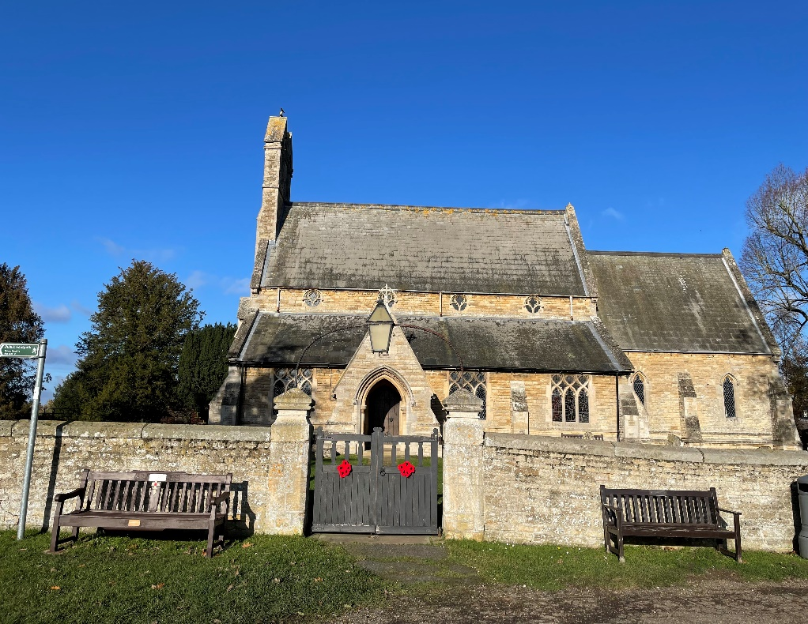

December 2023 and January 2024

Free to Holme residents

(thanks to the Reading Room Trust)

If you would like to advertise your business in the Holme Parish News please email [louisersmith@hotmail.com](mailto:louisersmith@hotmail.com)

A full page advert is £30 for the year and a half page advert is £15 for the year.

**HOLME PARISH COUNCIL**

**2024/25 Budget and the precept**

During November council spent time reviewing and discussing budgets and the precept for the next financial year. The cost of living crisis has seen many costs increase but we are very conscious that any increase in the Precept we request from Huntingdon County Council increases your Council Tax payment. We are therefore pleased to report that we will be requesting the same Precept as last year.

**Play area subcommittee**

The subcommittee’s first step was to understand how many children and of what age would benefit from a play area. Thank you to Holme School and Holme Preschool for providing useful insight. Advice from nearby Parishes that have a Play area is also being sought. Taking into account feedback received, the committee’s next step is to create a high level design.

**Green spaces in Holme**

In October, councillors walked along the green areas in the village that Parish Council are responsible for maintaining. The weather this spring resulted in rapid growth of verges which in turn resulted in an increase in the risk of accidents as drivers’ visibility was blocked when pulling out of junctions. Council have therefore decided that **“one mow” will take place** **in May** rather than “no mow”. Contractors appointed will take care not to mow over flowers or disturb nesting birds. Council are also looking at how best to maintain the **Spinney** footpath as fallen leaves are a slip hazard.

Seven people have expressed an interest in having an **allotment.** The challenge now is to find a suitable piece of land which has access. Please let me know if you have any ideas.

Councillor Tim Alban tells us he has spoken to the developers of **Pingle Bank** and **Yaxley road** sites. They told him work is due to start next year.

Council will be erecting a **Christmas tree** on the green area behind the war memorial near the church. Weather allowing this will be put up the second weekend in December.

**Prisoner of Wars remembered**

Six international war graves markers were recently found following the clearance of a property in Holme, which previously belonged to Holme Cemetery. Research identified that Holme Cemetery originally held fifteen International War Graves, for Prisoners of War who died while being housed and working in the surrounding area. The six original grave markers that were recently found have been restored and nine new grave markers have also been made to represent all fifteen prisoners of war that were once buried in Holme Cemetery.

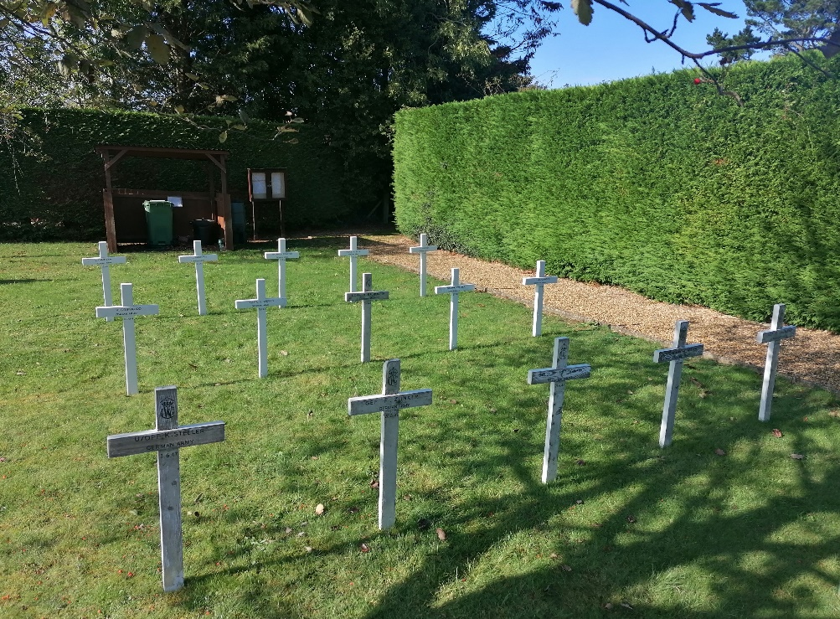

**Date of next Parish Council meeting**

The next meeting is scheduled for Thursday 18th January at 7pm in the Village Hall. Members of the public are very welcome to attend.

**Can I help?**

If I can be of any help with Parish related matters please call or email me

Sarah Abbott, Parish Clerk and Responsible Financial Officer

[holmeparishclerk@gmail.com](mailto:holmeparishclerk@gmail.com)

07548 441977

**HOLME YOUTH CLUB**

At the moment Youth Club attendance has to be restricted to 24 each week as we just cannot get enough volunteer helpers to allow any more.  We very much appreciate the half dozen wonderful helpers and the committee members who keep everything going but would love to add more names to the list.  If you would like to join us for a somewhat noisy couple of hours on a term time Friday email us on [holmeyouthclub@outlook.com](mailto:holmeyouthclub@outlook.com) and we will add you to our list.  It really is a rewarding experience to see these young people having fun in a safe and friendly space they can call their own.

With Christmas and the end of term looming we have plans for our termly night out – 8th December should see a party of youngsters have a fun filled night out at Flip Out.  Once again we thank the volunteer drivers very much for ferrying them down there.

Our last session before Christmas will be 15th December and the first one in 2024 will be 12 January.

Membership of Holme Youth Club is open to school years 5-10 who live in Holme or attend or have attended Holme CofE Primary Academy.  If you meet this criteria and would like to find out more check out our Facebook page, Web Page or email [holmeyouthclub@outlook.com](mailto:holmeyouthclub@outlook.com) or just pop down to the Village Hall one term time Friday between 6.30pm and 8.30pm and see what’s going on.

We would like to take this opportunity to wish everyone, especially members, committee members, volunteer helpers and all the parents a very Merry Christmas and a Happy and prosperous New Year.

**ST GILES CHURCH**

How did it get to be December again already? This year, more than any other, seems to have flown by. And, of course, Christmas celebrations seem to start earlier every year. And sometimes we can be critical of those who start very early, with trees and lights appearing before the fireworks have finished on Bonfire Night. But I wonder why we want to start early? These last few years have been difficult with the pandemic and the cost of living crisis, and I wonder whether there isn't just this longing for a little more light in the world? Something to counter the darkness. To have something to celebrate.

I am looking forward to the many opportunities to gather and celebrate this Christmas, do look at the schedule of events we have planned as a group of churches through December, and we would love to see you at any of them. One event becoming a tradition is the pop-up cinemas on Christmas Eve at All Saints Sawtry, with films, breakfast rolls, and refreshments - all free of charge. Another tradition is the Candlelit Service at 6 pm at St Giles, Holme on Christmas Eve, where we will contribute to shining a light into the darkness.  And more than anything, we have a chance to celebrate the one who came to bring the light that can never be extinguished, the light the darkness can never overcome, the infant Jesus.

Rev Diane Kutar

Curate

**Update on the Heating at St Giles, Holme**

Coordinating dates for all the resources and contractors for the work required has proved more challenging than we anticipated. Still, we are pleased to report that work has commenced, although it is unlikely that the installation will be completed until the New Year.

We intend to go ahead with the 6pm Carol Service on Christmas Eve but would ask that you dress warmly and offering you a warm welcome even if we can not promise a warm building. The collection from this service will go towards Thorpe Hall Hospice and the heating project.

We will look to keep you regularly updated, so do keep an eye on the local social media for any updates, including when the normal service pattern will be able to resume.

We remain committed to providing you with a warm welcome at St Giles and look forward to when this can be reflected in our building!

**HOLME COMMUNITY SPEEDWATCH**

Although the cold weather and short days have curtailed our activities somewhat our Speedwatch volunteers are still managing to fit in 4 or 5 sessions per month.  Obviously we cannot cover the rush hour times when we have most offenders but even at quieter times of the day we still get a disturbing percentage of drivers ignoring the 30 mph speed limit.  Please slow down through our village.

If you can spare an hour or so a month and would like to get involved with our speedwatch campaign please email [csw.holme@btinternet.com](mailto:csw.holme@btinternet.com) to let us know of your interest and we can send you the full guidance notes then, if you are still interested, put you in touch with Cambridgeshire Police to arrange your training.

We wish you all a very Merry Christmas and a Happy New Year and hope safe driving speeds are everyones new years resolution.   Many thanks and very best wishes to all our dedicated helpers who give up their time to try and make our little village with a busy through road, much safer.

**HOLME VILLAGE PRE-SCHOOL**

At Holme Village Pre-School we pride ourselves in offering a small and personal setting for children aged 2, 3 and 4 years old. We have two large rooms and a dedicated outside garden area, where the children enjoy learning through play and exploration.

The children this term have been learning about colours as this is a very colourful term, with the leaves changing, fireworks, poppies and leading into Christmas of course. There is a lot of glitter already in use!

This term is a busy one and also a very exciting one, with lots of lovely activities planned, including a Christmas party!

**Sunday 3rd December** is our first Christmas Fayre as a Pre-School, so please come along and support us. The fayre will be in The Village Hall and is a £1 entrance fee with a home made mince pie included. We will be opening 12pm-4pm with lots of lovely stalls to look at.

 We still have some spaces available for an immediate start and a waiting list for 2-year-olds from April 2024 when the funding rules change.

The Pre-School team is supported by a voluntary committee but any donations or help is gratefully received.

For further information or to arrange a visit, please contact our manager Kelly at [managerholmepreschool@yahoo.com](mailto:managerholmepreschool@yahoo.com) or call 07842 192052

Visit our shiny new website:

[www.holmevillagepre-school.co.uk](http://www.holmevillagepre-school.co.uk)

**Diary Dates for December 2023**

|  |  |
| --- | --- |
| **Friday 1** | **Mobile Post Office –** 9.30-10.30am  **Youth Club –**Village Hall, 6.30pm-8.30pm |
| **Saturday 2** | **Fish’n’Chip van –** various stops in the village from 7pm.  T: 07717 747772 for details or Howe Chippy on facebook. |
| **Sunday 3** | **Holme Pre-School Christmas Fayre,** Village Hall 12pm-4pm |
| **Monday 4** | **Blue bin collection** |
| **Tuesday 5** | **Short Mat Bowls –** Village Hall 7.30pm  **Quiz Night -** 8pm Admiral Wells |
| **Wednesday 6** | **415 Bus to Peterborough**  **Wet Fish van –** Station Rd, St Giles, Church St, Vicarage Cl.  T: 07894 495544  **Short Mat Bowls –** Village Hall 7.30pm  **FOHS Wreath Making Evening 7pm** T: 07739 378510 |
| **Thursday 7** | **Zumba 6.30pm; Yoga 7.30pm**  Becky T:07951 785668 |
| **Friday 8** | **Green bin collection**  **Mobile Post Office** – 9.30-10.30am  **Mobile Library** – 12.05–12.30pm Holmewood  **Youth Club –** Night out 6.30pm-8.30pm |
| **Saturday 9** | **Grey Bin collection**  **Fish’n’Chip van –** various stops in the village from 7pm |
| **Tuesday 12** | **Short Mat Bowls –** Village Hall 7.30pm  **Quiz Night -** 8pm Admiral Wells |
| **Wednesday 13** | **415 Bus to Peterborough**  **Wet Fish van –** Station Rd, St Giles, Church St, Vicarage Cl.  T: 07894 495544  **Short Mat Bowls –** Village Hall 7.30pm |
| **Thursday 14** | **Zumba 6.30pm; Yoga 7.30pm**  Becky T:07951 785668 |
| **Friday 15** | **Blue bin collection**  **Mobile Post Office –** 9.30-10.30am  **Bingo at Yaxley Public Hall –** doors open 6.30pm, eyes down 7pm, £8 pp. Everyone welcome  **Youth Club –** Village Hall, 6.30pm-8.30pm |
| **Saturday 16** | **Christmas Concert, Stilton @ 7.30pm.**T:01733 243056  **Fish’n’Chip van –** various stops in the village from 7pm |
| **Monday 18** | **‘Father Christmas by the Fire”, Admiral** **Wells 5.30pm**  Donations to Sue Ryder Hospice |
| **Tuesday 19** | **Quiz Night -** 8pm Admiral Wells |
| **Wednesday 20** | **Green bin collection**  **End of Autumn term Holme School and Pre-school**  **415 Bus to Peterborough**  **Wet Fish van –** Station Rd, St Giles, Church St, Vicarage Cl.  T: 07894 495544 |
| **Thursday 21** | **Grey bin collection**  **Zumba 6.30pm; Yoga 7.30pm** Becky T:07951 785668  **Quiz and Hog Roast, Holmewood Hall,** T: 01487829555 for Tickets |
| **Friday 22** | **Mobile Post Office –** 9.30-10.30am |
| **Saturday 23** | **Fish’n’Chip van –** various stops in the village from 7pm |
| **Sunday 24** | **Christmas Eve**  **6pm Candlelit Carol Service in St Giles Church** |
| **Monday 25** | **Christmas Day**  **Admiral Wells open 12-2pm for drinks only** |
| **Tuesday 26** | **Boxing Day Bank Holiday**  **Admiral Wells closed** |
| **Wednesday 27** | **415 Bus to Peterborough**  **Wet Fish van –** Station Rd, St Giles, Church St, Vicarage Cl.  T: 07894 495544 |
| **Friday 29** | **Mobile Post Office –** 9.30-10.30am |
| **Saturday 30** | **Fish’n’Chip van –** various stops in the village from 7pm |
| **Sunday 31** | **New Year’s Eve**  **Admiral Wells open 12-3pm, then 8pm ‘till late** |

**Diary Dates for January 2024**

|  |  |
| --- | --- |
| **Monday 1** | **New Year’s Day bank holiday**  **Admiral Wells closed until 10th January, reopen on 11th** |
| **Tuesday 2** | **Blue bin collection**  **Short Mat Bowls –** Village Hall 7.30pm |
| **Wednesday 3** | **415 Bus to Peterborough**  **Wet Fish van –** Station Rd, St Giles, Church St, Vicarage Cl.  T: 07894 495544  **Short Mat Bowls –** Village Hall 7.30pm |
| **Thursday 4** | **Holme School and Pre-school start of Spring Term**  **Zumba 6.30pm; Yoga 7.30pm**  Becky T:07951 785668 |
| **Friday 5** | **Mobile Post Office** – 9.30-10.30am |
| **Saturday 6** | **Green bin collection**  **Fish’n’Chip van –** various stops in the village from 7pm  T: 07717 747772 for details or Howe Chippy on facebook. |
| **Monday 8** | **Grey bin collection** |
| **Tuesday 9** | **Short Mat Bowls –** Village Hall 7.30pm |
| **Wednesday 10** | **415 Bus to Peterborough**  **Wet Fish van –** Station Rd, St Giles, Church St, Vicarage Cl.  T: 07894 495544  **Short Mat Bowls –** Village Hall 7.30pm |
| **Thursday 11** | **Zumba 6.30pm; Yoga 7.30pm**  Becky T:07951 785668 |
| **Friday 12** | **Mobile Post Office –** 9.30-10.30am  **Mobile Library** – 12.05–12.30pm Holmewood  **Youth Club –**Village Hall, 6.30pm-8.30pm |
| **Saturday 13** | **Fish’n’Chip van –** various stops in the village from 7pm |
| **Monday 15** | **Blue bin collection** |
| **Tuesday 16** | **Short Mat Bowls –** Village Hall 7.30pm  **Quiz Night -** 8pm Admiral Wells |
| **Wednesday 17** | **415 Bus to Peterborough**  **Wet Fish van –** Station Rd, St Giles, Church St, Vicarage Cl.  T: 07894 495544  **Short Mat Bowls –** Village Hall 7.30pm |
| **Thursday 18** | **Parish Council mtg, Village Hall 7pm**  **Zumba 6.30pm; Yoga 7.30pm**  Becky T:07951 785668 |
| **Friday 19** | **Green bin collection**  **Mobile Post Office –** 9.30-10.30am  **Youth Club –**Village Hall, 6.30pm-8.30pm  **Bingo at Yaxley Public Hall –** doors open 6.30pm, eyes down 7pm, £8 pp. Everyone welcome |
| **Saturday 20** | **Fish’n’Chip van –** various stops in the village from 7pm |
| **Monday 22** | **Grey bin collection** |
| **Tuesday 23** | **Short Mat Bowls –** Village Hall 7.30pm  **Quiz Night -** 8pm Admiral Wells |
| **Wednesday 24** | **415 Bus to Peterborough**  **Wet Fish van –** Station Rd, St Giles, Church St, Vicarage Cl.  T: 07894 495544  **Short Mat Bowls –** Village Hall 7.30pm |
| **Thursday 25** | **Zumba 6.30pm; Yoga 7.30pm** Becky T: 07951 785668 |
| **Friday 26** | **Mobile Post Office –** 9.30-10.30am  **Youth Club –**Village Hall, 6.30pm-8.30pm |
| **Saturday 27** | **Fish’n’Chip van –** various stops in the village from 7pm.  T: 07717 747772 for details or Howe Chippy on facebook. |
| **Monday 29** | **Blue bin collection** |
| **Tuesday 30** | **Short Mat Bowls –** Village Hall 7.30pm  **Quiz Night -** 8pm Admiral Wells |
| **Wednesday 31** | **415 Bus to Peterborough**  **Wet Fish van –** Station Rd, St Giles, Church St, Vicarage Cl.  T: 07894 495544  **Short Mat Bowls –** Village Hall 7.30pm |

**\*415 Bus to Peterborough** pick up from 10.15 am Pingle Bank then Station Road & Holmewood. Return at 1.30pm

**HACT Ring and Ride Tel: 01480 411114** – membership £15 per annum. http://www.hact-cambs.co.uk/home

**Community Car Scheme** **Tel:** **07795542084** between 9am -12noon to book

If you have an event you would like included please let us know by 19th January, email wendyaylesbury@hotmail.com

**HOLME CRICKET CLUB**

A great season comes to a close! 44 games completed for Holme Cricket Club throughout a season that despite has been challenged by weather, it has been a brilliant season.

This season, Holme CC introduced a Saturday team and placed in the Hunts League Division 3 one above the usual starting point. Despite a tough start to the season, everyone stuck together and it ended with great success, beating the drop and remaining in Division 3 for 2024.

Bijoy Joseph and Andy King lead the way with the ball, Bijoy taking 30 wickets and Andy King taking 26 in a season full of inspired bowling performances notably by Kelsey Brace’s 7 wickets for 23 runs against top of the league, as we defended just 75.

The runs were shared across everyone throughout the season, Johnly John scoring 453 and passing 1,000 runs for the club, Sai Jammy scoring 500 and Ian Kendall reaching 907 for the season.

We have had excellent support at both our midweek home of Port Lane, Castor and our Saturday home, The Manor Leisure in Whittlesey. Thank you for your support in person and on social media, it means a lot to everyone involved in the club. We are always looking for people to welcome aboard, be it as players, supporters for the 2024 season and beyond!

**HOLME C of E PRIMARY ACADEMDY**

We are so pleased that we can finally share with everyone that we officially continue to be good in all areas in our recent Ofsted inspection as a school!

And with that amazing news, we are very excited to be getting our Christmas preparations well underway.  
  
The first of our Christmas events is on the 30th November which all are welcome, and this sees the second year of our very own Christmas Fayre. Local stall holders will be set up, children’s creative Christmas gifts for sale, Christmas games, Arts and Crafts and you may be lucky to see the big man yourself in his Grotto. To come along, please call the office for more information and secure your tickets on 01487 830342!  
  
In addition to this, we will be holding our annual nativities, Christmas dinner day, Christmas jumper day, our Christingle service with our lovely Reverend and not one, but to Christmas carol concerts as well as a panto in to school too - oh yes we are!  
  
During November, we’ve had some great learning going on in school including reception leaning all about Transport, year 1 and 2 have performed firework poetry and have been learning about animals including humans. We are very excited to enhance the learning experience of this Science visit by visiting Hunstanton Sea Life Centre. The children are so excited!  
  
In Key Stage Two, all year groups have been studying my emotions and anti-bullying during PSHE lessons and the whole school joined in with anti-bullying week and wore odd socks to school to kick it off. Year three and four have been developing the dance techniques linked to the solar system during PE lessons and have begun swimming lessons, which is very exciting. Year five and six have been building on their knowledge of databases during computing and have blown us away with the narrative poetry writing based on the story of ‘Moth’ by Isabel Thomas.

We would like to take this opportunity to wish all our children, families and the community a Merry Christmas and a prosperous new year.

Mrs King, Mrs Ferrara and the Small but Mighty Team.

**HOLME READING ROOM TRUST**

The Holme Reading Room Trust is a charity which has been established to provide funds which are to be used exclusively for the benefit of the village. The trustees wish to maximise the benefit from the fund and welcome applications from those with ideas for new ventures, as well as from existing organisations. The trustees will encourage applicants to make a contribution towards funding ideally on a £ for £ basis according to individual circumstances. If you are interested in submitting an application please drop an email to [holmereadingroomtrust@gmail.com](mailto:holmereadingroomtrust@gmail.com). The next meeting to review applications will be held in March.

**DISTRICT COUNCIL REPORT**

Being a District Councillor is rarely dull and since my last report, there has been plenty to keep me busy on behalf of local residents and the wider district; these are just some of the issues I have been working on.

**FLY TIPPING**

Tackling tipping is not unusual but the most recent example I came across was braze, to say the least, with a mixed load dumped in the bus stop on the B1043 (old A1) just north of the flyover.  Thanks, as ever, to the District Council's Operations Team, who tackled it so promptly.

With a view to prosecution, the District Council Enforcement Team look for evidence when they receive reports of fly tips, which can be logged via [https://www.huntingdonshire.gov.uk/streets-parking/report-a-street-issue/](https://eur01.safelinks.protection.outlook.com/?url=https%3A%2F%2Fwww.huntingdonshire.gov.uk%2Fstreets-parking%2Freport-a-street-issue%2F&data=05%7C01%7Cjon.collins%40mitie.com%7C13d7be173b4942c14c9908dbe861e072%7C9e66e0b4768c4506a1b67e44c80595f2%7C0%7C0%7C638359279300705708%7CUnknown%7CTWFpbGZsb3d8eyJWIjoiMC4wLjAwMDAiLCJQIjoiV2luMzIiLCJBTiI6Ik1haWwiLCJXVCI6Mn0%3D%7C3000%7C%7C%7C&sdata=ocdfID7MIkIEmBOeANMAxiEDMBB%2B3zT9xli4TlbtoPs%3D&reserved=0)

**DEVELOPMENT NEWS**

I approached the agent dealing with the development sites on Pingle Bank and Yaxley Road and have been informed that work is due to start on both in the new year.

**GREEN BIN CHARGE**

As a member of the District Council Panel, which is scrutinising the plans to introduce a separate charge for collecting garden waste bins, I will continue to monitor the implantation and results of this policy.

For anyone who wants to continue to have their garden bins emptied after 1st April 2024, the charge will be payable in addition to council tax bills.  I didn't vote to implement this scheme; I remain unconvinced it will bring the financial benefits predicted and concerned about possible negative environmental implications.

Initial details about the scheme should be included in the bin hanger, which gives details of the Christmas Refuse Collection changes.

**WORKING TOGETHER**

A few weeks ago, Councillor Marge Beuttell and I arranged a liaison meeting for the Chairs and Clerks of the various Parish Councils and Parish Meetings in our district council ward.

The meeting took place at the recently re-opened hotel at Norman Cross, was well attended and included representatives from Holme, Conington and Glatton.

As well as a chance to share best practice and issues the villages have in common, there was an opportunity to discuss the revision of the Huntingdonshire Local Plan and the implementation of Neighbourhood Plans, with the District Council's Chief Planning Officer.

**COURTS 4 KIDS @ CHRISTMAS**

The District Council's One Leisure Centres are again set to operate "Courts 4 Kids" during the Christmas school holiday.  Details of scheme, which offers discounted rates on hire of courts and 3G pitches for Under 18s are available via [https://www.oneleisure.net/](https://eur01.safelinks.protection.outlook.com/?url=https%3A%2F%2Fwww.oneleisure.net%2F&data=05%7C01%7Cjon.collins%40mitie.com%7C13d7be173b4942c14c9908dbe861e072%7C9e66e0b4768c4506a1b67e44c80595f2%7C0%7C0%7C638359279300705708%7CUnknown%7CTWFpbGZsb3d8eyJWIjoiMC4wLjAwMDAiLCJQIjoiV2luMzIiLCJBTiI6Ik1haWwiLCJXVCI6Mn0%3D%7C3000%7C%7C%7C&sdata=TUoMF9pYT3eLFevnNVY1BS1WpSSGAfkY8nMeDk0w%2Fu8%3D&reserved=0)

**EMERGENCY HELP OVER CHRISTMAS**

Huntingdonshire District Council offices will be closed over Christmas but the Out Of Hours team will still be working and can be contacted on 01480 434167.

With best wishes for a Happy Christmas & New Year.

Tim Alban

District Councillor for Stilton, Folksworth & Washingley Ward

[tim.alban@huntingdonshire.gov.uk](mailto:tim.alban@huntingdonshire.gov.uk)

07903 518967

**FLYING CLUB CONINGTON**

We will not be taking Afternoon Tea bookings between 22nd December to 3rd January. We will be open on days between Christmas and New Year (these are to be confirmed) and refreshments can still be obtained. Please call for further details on 01487 834161.



*Yaxley Amateur Players*

*Present*

**ALI BABA**

**COMING IN 2024**

**SATURDY 3RD FEBRUARY 2.30PM & 7PM**

**SUNDAY 4TH FEBRUARY 2.30PM**

**SATURSDAY 10TH FEBRUARY 2.30PM & 7PM**

See our website, yap.org.uk for details of our forthcoming shows for 2023 & 2024



**Church & Parish Directory**

|  |  |  |
| --- | --- | --- |
| **St Giles Church** | **Name** | **Contact Details** |
| **Priest in charge** | Revd Becky Dyball | The Rectory, Church Causeway, Sawtry, PE28 5TD  T: 01487 506217  [revdyball@gmail.com](mailto:revdyball@gmail.com) |
| **Churchwarden** | Mrs Judith Osborne | 27 St Giles Close, Holme  01487 832023 |
| **Treasurer** | David Perry | astreasurer1880@gmail.com |
| **Website** |  | [www.holme-parish.org](http://www.holme-parish.org) |

|  |  |  |  |  |
| --- | --- | --- | --- | --- |
| **Parish Council** | **Name** | | **Contact Details** | |
| Chairman | Mr John Griffin, | | 11 Vicarage Close, Holme, PE7 3PQ  01487 831245 | |
| Clerk | Sarah Abbott | | [holmeparishclerk@gmail.com](mailto:holmeparishclerk@gmail.com)  07548 441977 | |
| **Parish Councillors – can be contacted via Clerk** | | | | |
| Cllr. W Aylesbury | | Cllr J Edwards | | Cllr D Neal, |
| Cllr C Reed | | Cllr L Roderick-Smith | | Cllr. P Sargent |
| Cllr H Watson | | Cllr E Whittaker | |  |

|  |  |  |
| --- | --- | --- |
|  | **Name** | **Contact Details** |
| **County Councillors** | Cllr. Simon Bywater | simon.bywater@cambridgeshire.gov.uk |
| **District Councillor** | Cllr Tim Alban | tim.alban@huntingdonshire.gov.uk |

|  |  |  |
| --- | --- | --- |
| **Village organisations** | **Name/website** | **Contact Details** |
| **Bowls Club** | Mr P Dickman | holmesmbc@gmail.com |
| **Holme Charity Lands** |  | holmecharitylands@gmail.com |
| **Holme Cricket Club** | Ian Kendall | [holmecricketclub@gmail.com](mailto:holmecricketclub@gmail.com)  07437 425107 |
| **Holme Reading Room Trust** |  | [holmereadingroomtrust@gmail.com](mailto:holmereadingroomtrust@gmail.com) |
| **Holme School** | Exec Head (Holme & Stilton)  Mrs C King  Head of School  Mrs C Ferrara |  |
| **www.holme.cambs.sch.uk** | [admin@holme.cambs.sch.uk](mailto:admin@holme.cambs.sch.uk) |
| **Friends of Holme School** | Amanda Rose | [Amanda.rose8@btinternet.com](mailto:Amanda.rose8@btinternet.com) |
| **Holme Pre-School** |  | manager[holmepreschool@yahoo.co.uk](mailto:holmepreschool@yahoo.co.uk) |
| **Holme Village Hall** | **www.holmecambsvillagehall.org.uk** | [bookings@holmecambsvillagehall.org.uk](mailto:bookings@holmecambsvillagehall.org.uk)  07714088691 |
| **Holme Youth Club** |  | holmeyouthclub@outlook.com |
| **Neighbourhood Watch** | David Neal | [davidneal994@gmail.com](mailto:davidneal994@gmail.com) |
| **Rainbows/Guides/Guides/ Rangers** | Val Aldridge, District Commissioner www.girlguiding.org.uk | [valaldridge@btinternet.com](mailto:valaldridge@btinternet.com) |
| **Sir John Cotton Educational Trust** |  | SJCEF1@outlook.com |
| **Speedwatch** |  | csw.holme@btinternet.com |

**HOLME PARISH NEWS EDITOR**

|  |  |
| --- | --- |
| **Name** | **Contact Details** |
| Louise Roderick-Smith | [Louisersmith@hotmail.com](mailto:Louisersmith@hotmail.com) 07971 955940 |

Please send articles to the editor by the 19th January 2024.