#### **Holme**

#### **Parish News**

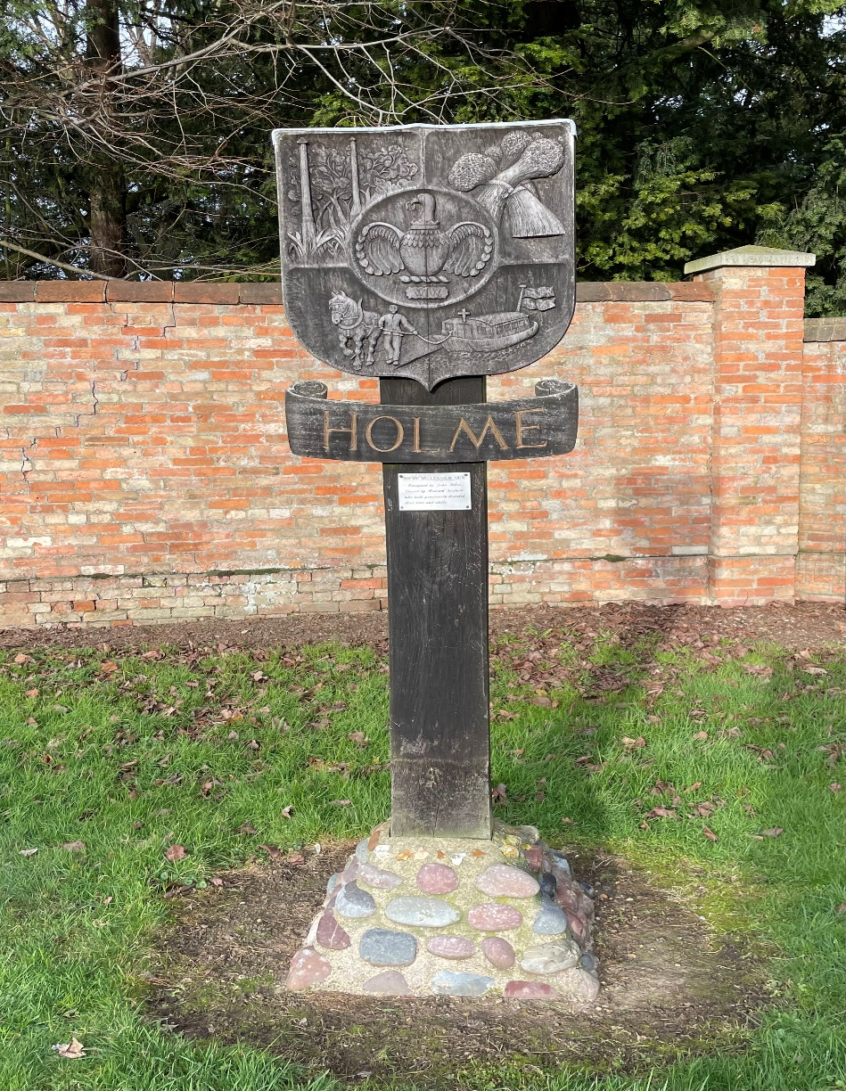

February 2024

Free to Holme residents

(thanks to the Reading Room Trust)

If you would like to advertise your business in the Holme Parish News please email [louisersmith@hotmail.com](mailto:louisersmith@hotmail.com)

A full page advert is £30 for the year and a half page advert is £15 for the year.

**HOLME PARISH COUNCIL**

**Garden Waste**

Your council (and District Councillor) did not support the decision to introduce a charge for green (garden waste) bins and use every opportunity to share your feedback with Huntingdon District Council. There is a lot of information available on this topic and highlights have been shared on the Village Facebook Page and in this edition of Holme Parish News. Alternatively, search the internet for Huntingdon District Council Garden Waste Initiatives.

**Green Spaces in Holme**

Work was undertaken in December to prune and tidy the Spinney. Council encourage people dropping off/picking up children from the School to park in the village hall and walk to the School as this is safer than parking in the road outside the School. Going forward, work will take place on the Spinney every year once nearly all leaves have come off the trees. Council would be very grateful for any support that residents backing onto the Spinney can give in keeping the path safe for people to use.

At the January meeting, council discussed ideas for “the beautification of the village”. Quotes will be obtained to replace/overhaul two of the notice boards. A “walk of the village” will be carried out (when temperatures are back to double figures!) to check status of any issues that have already been reported to Cambridgeshire County Council as well as identifying new issues that need to be reported. I will then chase, chase and chase again to get as much progress made as possible.

**Play area subcommittee**

Helpful advice has been gained from Folksworth Parish Council on what equipment is recommended for a play area and things to be considered such as parking and inspections. The play area subcommittee are now contacting providers of play equipment to understand potential designs and costs. Before making any decisions on a play area in Holme, Council will hold a public meeting to share ideas and get your input. Decisions of this nature will always be made at a full meeting of the Council to which all members of the public are welcome to attend.

**Railway crossing emergency contact number**

Thank you to the resident who highlighted the emergency contact number on the sign next to the crossing was not being answered. A complaint was registered with Network Rail as this issue was discussed with them last spring. The number (01733 346710) has now been diverted to the Operating Centre in York. I tested a call to this number and it was answered promptly.

**Planning**

The decision maker on planning applications is Huntingdon District Council and your council always respond to requests received from them for recommendations. There were two requests received in December. One related to a minor change in the boundary for the Pingle Bank Development (still no news on when work will start). The second related to an appeal received by HDC challenging their decision to refuse planning permission for conversion of a barn to dwellings. Details of all applications and council’s response can be found on HDC’s planning portal.

**Date of next Parish Council meeting**

The next meeting is scheduled for Thursday 21st March at 7pm in the Village Hall. Members of the public are very welcome to attend. Looking ahead, the Annual Parish Meeting with be on Thursday 2nd May. All village organisations are encouraged to attend and share their updates.

**Can I help?**

If I can be of any help with Parish related matters please call or email me

Sarah Abbott, Parish Clerk and Responsible Financial Officer

[holmeparishclerk@gmail.com](mailto:holmeparishclerk@gmail.com)

07548 441977

**EXTRACT FROM HUNTINGDON DISTRICT COUNCIL WEBSITE**

**How to deal with Food Waste**

By law, we cannot charge for the collection of food waste. As there is a charge for the new garden waste service, this means we cannot accept food waste as part of these collections.

If the waste is from a vegetable patch or windfall fruit, it is classed as garden waste and you can put it in your garden bin. If the waste comes from your kitchen, it is classed as food waste and you cannot put it in your garden bin.

We are fully committed to continuing to providing residents with advice to help them minimise the amount of food waste they generate. To learn more visit [Pledge to Fight Food Waste on the Recap website](https://www.recap.co.uk/pledge-to-fight-food-waste)

Approximately 70% of the food waste from UK households that is thrown away is edible. By cutting food waste the average UK household can save £500 each year.

We want to encourage residents to reduce the amount of food waste that they are generating which not only helps the environment but saves you money too.

[Love food Hate Waste](https://www.lovefoodhatewaste.com/) provides tips to assist householders to reduce their food waste, from how to store your food to make it last longer, portion planning to some great recipes to use up your leftovers.

There will always be some food waste and if you have or are thinking about [home composting](https://www.recyclenow.com/how-to-recycle/home-composting) or a [wormery](https://www.rhs.org.uk/soil-composts-mulches/worm-composting), these are an ideal way to create soil conditioner for your garden.

You can also put food waste in your grey refuse bin. The contents of these bins are treated via a [Mechanical Biological Treatment plant](https://thalia.co.uk/where-we-work/cambridgeshire/cambridgeshire/our-waste-technologies/) (MBT).

Currently 37% of grey bin waste is food waste. We do not expect a significant increase in this percentage based on the analysis of other councils that charge for garden waste collections.

**Garden Waste Initiatives: Current and Proposed Offers**

**1. Free Loose Compost**

Free loose compost is available for all Huntingdonshire residents at Waterbeach, Alconbury and March transfer stations. Simply visit with a spade and a bag and you can help yourself. You can collect your own soil improver from:

* Waterbeach Waste Management Park, Ely Road, Waterbeach, CB25 9PG

Open Monday to Friday from 8am to 4pm and weekends from 8am to 1pm

* Alconbury Waste Transfer Station, Stangate Business Park, Alconbury Hill, PE28 4JH

Open Monday to Friday from 8am to 4pm

* March Waste Transfer Station, Melbourne Avenue, Hundred Road, March, PE15 0EN

Open Monday to Friday from 8am to 4pm

If you cannot make it to any of the transfer station sites to load your own soil conditioner, then you can buy it for £3 a bag at the [household recycling centres](https://thalia.co.uk/where-we-work/cambridgeshire/cambridgeshire/composting/).

**2. Community Compost Schemes**

Advice on composting can be found on the [Recycle Now website](https://www.recyclenow.com/how-to-recycle/home-composting).

We will continue to update and enhance these pages with details and case studies about Community Compost Schemes, so you can learn more about how it works and how to set one up.

**3. Subsidised Home Composters**

Residents in Huntingdonshire are eligible to buy 1 compost bin and get a second bin half price.  
For more information go to the [Additional Garden Waste Bin and Composting page](https://www.huntingdonshire.gov.uk/bins-waste/manage-your-bin-collections/additional-garden-waste-bin-and-composting/) or [visit the Get Composting website](https://getcomposting.com/collections/bestselling-composters/filtered?filter_pf_opt_admin_area_code=DEFAULT_VAR&page=1).

We are working with Straight, for an HDC subsidy. Please keep an eye on our website for further information.

**4. Parish Council Allocation for Land Management**

A form is currently being created where parish councils can request bins, which they can allocate to residents to support them maintaining local green spaces. Once HDC receives a request there will need to be a site visit to agree whether this is a suitable area for a resident to manage.

**5. Shared Bins**

Households will be able to make a personal arrangement with a neighbour to share the cost of a garden bin. If people share their garden waste bin with a neighbour, the householder who pays the annual charge will have overall responsibility for the bin as a bin can only be allocated to one address. It would be the responsibility of the named householder if the bin is contaminated, misused, or needs replacing.

The agreement to share bins is between the payer and their neighbour only. If circumstances change, then the payer remains the primary contact.

**6. Assisted Collections**

Residents who cannot take their bins out themselves and there is no other person living at the household who is able to help can apply to have assisted bin collections. This service is provided for all bin collections, not just garden waste collections.

**7. Free Saturday Freighter Service**

Every Saturday from 6.30am to 1pm, between April and September (6 months), we will arrange for 26 tonne waste collection vehicles to be situated at pre-designated areas in the district (up to a maximum of 5), where residents can visit and deposit garden waste. The vehicle will be staffed with one driver to facilitate the loading. Areas have been identified based on geographical spread, along with availability of parking for HGVs. Keep an eye on the website for further updates.

**8. For Parishes Not Eligible for Saturday Freighter Service**

HDC will contact the outlying parish councils, not included on the Saturday Freighter Schedule, to ask if they want up to 10 community bins for a community location. These bins will be accessible for local residents to use to deposit their garden waste and will be collected as part of the normal route scheduling for fortnightly garden bin collections. It will be the responsibility of the parish council to manage these bins, the same as a household, i.e. no contamination, out for collection on the collection day.

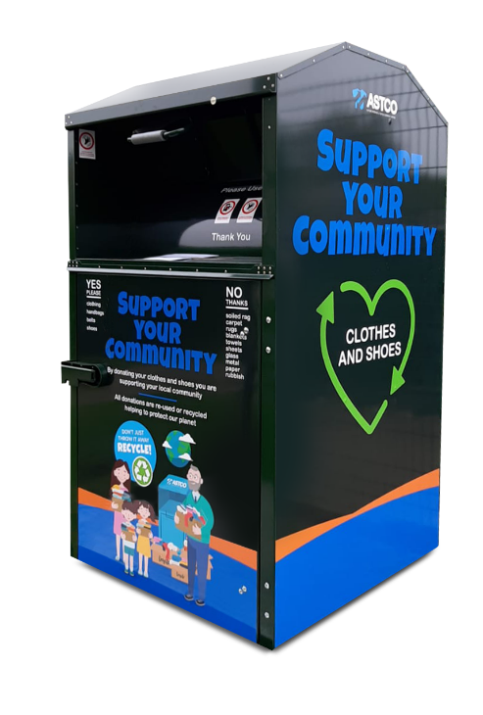

**Clothing and textile recycling banks**

Huntingdonshire County Council work with a company called ASTCO to provide textile recycling banks in Huntingdonshire. All materials collected from the clothing banks are re-used, with textiles providing reusable clothing for the UK and developing countries. This helps reduce waste from going into landfill. The recycling banks can accept clothing and textiles such as sheets, pillowcases and blankets.

These banks are currently located Huntingdon and there is one in Wansford. We will be contacting local Council’s to see if together we can influence having a recycling bank put some-where nearer.

**COMMUNITY CAR SCHEME - VOLUNTEERS NEEDED**

The local community car scheme operates in conjunction with the Cambridgeshire & Peterborough Combined Authority and serves residents in Holme and the surrounding areas.

The car scheme offers a personalised service and takes passengers who have difficulty using public transport. Usually this is to and from hospitals, doctors, care homes, social events, shopping, hairdressers and other appropriate journeys. Destinations covered include Stamford, Peterborough, Huntingdon and Cambridge and further afield if appropriate. Passengers would often be taken to their relevant clinic if needed and not just the main hospital entrance or car park and wait for them before returning. People that require wheelchairs and those that may have other mobility or health related issues can usually be accommodated.

The subsidised cost to the passenger is only 30p per mile with a £5.00 min charge per journey. Registration is free. The scheme is run entirely by volunteers. With approximately 200 registered passengers they urgently need more volunteer drivers to maintain this essential service to local people. Hours can be arranged to suit from just a few hours a week.

Drivers receive a tax free mileage allowance.

For more details please call 07795 542084

**HOLME YOUTH CLUB**

Youth Club started back on 12th January and despite starting the year in September with an attendance of up to 24 we now find it has dwindled to single figures.

Last year we had 42 members going on our subsidised night out and this year we only had 5.

I know we are constantly appealing for volunteers to supervise the sessions and we are struggling to get them, but we can currently accommodate up to 24 so do come along and see what it’s all about – if you don’t like what we are offering then let us know what you would like and we will see if we can change things – it is a club for school years 5-10 to do what they would like so please let us know what you would like so we can increase our membership again.

We currently offer table tennis, pool, air hockey, table football, PS4, craft corner, large connect 4 and Jenga, bowling alley, hair styling and table top board games not forgetting a football to kick around.

We are open on term time Friday evening in Holme village hall from 6.30pm to 8.30pm so come on down and see what we are all about or check out our Facebook or Web page for further details.

Admission is £2 a week and there is no membership fee but we do ask for membership forms to be filled in so that we have contact details in case of emergency.

Holme Youth Club membership is open to school years 5-10 who live in Holme or who attend or have attended Holme (CofE) Primary Academy.

**ST GILES CHURCH**

As this is our first opportunity, we wish you a Happy New Year!

We were delighted that so many of you joined us for the Christmas Eve service. The completion of the first stage of the heating project meant that we were temporarily without power. Despite this it was wonderful to see so many people there, proving that the church is definitely the people not the buildings. It was a truly beautiful evening as the church was genuinely candlelit! Maybe no lighting at all will become a new tradition.

Also, a huge thank you for your generosity at that Christmas Eve service – we are grateful for your support that is helping us complete the improvements to the church building. The heating project, after some initial delays, is now pressing ahead. The electrical supply has been upgraded and the main work is scheduled to begin in February. We are confident we will be recommencing services on Easter Sunday but hopeful of being able to start earlier. We look forward to seeing you all in a brighter, warmer church building in 2024.

Every blessing,

Rev Becky & Rev Diane

**Service Rota February 2024**

For latest service information and online service links please visit www.allsaintssawtry.org.uk

|  |  |  |  |
| --- | --- | --- | --- |
|  | **All Saints’, Sawtry** | **St. Nicholas, Glatton** | **St. Giles, Holme\*\*** |
| Sunday 4th February | 10.30am Holy Communion | 9.00am Morning Prayer | -- |
| Sunday 11th | 10.30am Service of the Word | 9.00am Holy Communion | -- |
| Wednesday 14th | 6pm Ash Wednesday Service | -- | -- |
| Sunday 18th | 10.30am Reflective Service | 9.00am Holy Communion |  |
| Sunday 25th | 8.00am BCP* Holy Communion  10.30am Holy Communion | 9.00am Holy Communion | -- |

*BCP A much loved traditional service using the 1662 prayer book

** St Giles, Holme remains closed for the completion of a new heating system. We are expecting to return no later than Easter Sunday but hopefully earlier in March. Do watch out for notices on social media and the noticeboard outside St Giles.

**HOLME COMMUNITY SPEEDWATCH**

The new year started with a few days of winter weather resulting in cars having to be pulled out of ditches as the black ice caught them unaware.  Sadly, that has not deterred the speeders through our village and our percentage has gone back up to 25% on our last session.   Maybe that is because we haven’t been doing many sessions lately because of illness, bad weather and Christmas.  Consequently, we feel we must carry on the battle and continue with as many sessions as we can possibly fit in to try and get that rate back down – oh wouldn’t it be wonderful if we could fill in NIL returns after a few sessions!

Please – whatever the weather – slow down through Holme village and give consideration to the people who live here and walk along our roads.  As the majority of these roads do not have pavements for them to walk along please slow down and give them space as they are trying to go about their business or enjoying a leisurely walk and don’t really want to be worrying about being knocked down by a speeding motorist.

We are always ready to welcome new members to our team of volunteers so if you feel you can spare and hour or so a month and would like to support our scheme please contact [csw.holme@btinternet.com](mailto:csw.holme@btinternet.com) and we can arrange your training with Cambridgeshire Police and get you out there supporting our efforts to make our village safer.

**PARKING AT THE VILLAGE HALL**

The village hall car park is for users only and for primary school and pre-school drop off and pick up.

Please do not park there for any other reason as parking is limited and unauthorised parking causes problems. Any questions please email the village hall info@holmevillagehall.org.uk

**HOLME VILLAGE PRE-SCHOOL**

The children were welcomed back after the Christmas break to a new layout of the preschool and new furniture and toys too which has been lovely to see them interacting with.

The cold weather hasn’t stopped us going outside in the garden, we have been wrapping up warm to play with the sports equipment and ride the bikes.

Our theme has been ‘people that help us’ and we have recently focused on firefighters and are hoping for a visit from the local fire brigade soon.

We are welcoming some new staff to the team soon, both ladies with a wealth of knowledge in childcare, so we look forward to them starting with us.

We still have some spaces available for an immediate start on a Tuesday and a Thursday and a waiting list for 2-year-olds from April 2024 when the funding rules change.

The Pre-School team is supported by a voluntary committee, but any donations or help is gratefully received.

For further information or to arrange a visit, please contact our manager Kelly at [managerholmepreschool@yahoo.com](mailto:managerholmepreschool@yahoo.com) or call 07842 192052

[www.holmevillagepre-school.co.uk](https://eur01.safelinks.protection.outlook.com/?url=http%3A%2F%2Fwww.holmevillagepre-school.co.uk%2F&data=05%7C02%7Cjon.collins%40mitie.com%7C8e7e94df72fb44e1d9c808dc19f2a1c9%7C9e66e0b4768c4506a1b67e44c80595f2%7C0%7C0%7C638413777080824093%7CUnknown%7CTWFpbGZsb3d8eyJWIjoiMC4wLjAwMDAiLCJQIjoiV2luMzIiLCJBTiI6Ik1haWwiLCJXVCI6Mn0%3D%7C3000%7C%7C%7C&sdata=HH4jJpLYIaRojPi9X8J42oqmtlTcIwNDX2TjpqWqoQo%3D&reserved=0)

**Diary Dates for February 2024**

|  |  |
| --- | --- |
| **Friday 2** | **Green bin collection**  **Mobile Post Office** – 9.30-10.30am  **Youth Club –**Village Hall, 6.30pm-8.30pm |
| **Saturday 3** | **Fish’n’Chip van –** various stops in the village from 6.15pm  T: 07717 747772 for details or Howe Chippy on facebook.  **Yaxley Amateur Players Panto in Yaxley Public Hall**  [**www.yap.org.uk**](http://www.yap.org.uk) **for tickets.** |
| **Sunday 4** | **Yaxley Amateur Players Panto in Yaxley Public Hall**  [**www.yap.org.uk**](http://www.yap.org.uk) **for tickets.** |
| **Monday 5** | **Grey bin collection** |
| **Tuesday 6** | **Short Mat Bowls –** Village Hall 7.30pm  **Quiz Night -** 8pm Admiral Wells |
| **Wednesday 7** | **415 Bus to Peterborough**  **Wet Fish van –** Station Rd, St Giles, Church St, Vicarage Cl.  T: 07894 495544  **Short Mat Bowls –** Village Hall 7.30pm |
| **Friday 9** | **Mobile Post Office –** 9.30-10.30am  **Mobile Library** – 12.05–12.30pm Holmewood  **Quiz Night & Hog Roast,** 6pm atHolmewood Hall, [Tel:01487 829555](Tel:01487%20829555)  **Youth Club –**Village Hall, 6.30pm-8.30pm |
| **Saturday 10** | **Fish’n’Chip van –** various stops in the village from 6.15pm  **Yaxley Amateur Players Panto in Yaxley Public Hall**  [**www.yap.org.uk**](http://www.yap.org.uk) **for tickets.** |
| **Monday 12** | **Blue bin collection** |
| **Tuesday 13** | **Pancake Day**  **Short Mat Bowls –** Village Hall 7.30pm  **Quiz Night -** 8pm Admiral Wells |
| **Wednesday 14** | **Valentine’s Day**  **415 Bus to Peterborough**  **Wet Fish van –** Station Rd, St Giles, Church St, Vicarage Cl.  T: 07894 495544  **Short Mat Bowls –** Village Hall 7.30pm |
| **Friday 16** | **Green bin collection**  **Mobile Post Office –** 9.30-10.30am  **Youth Club –**Village Hall, 6.30pm-8.30pm |
| **Saturday 17** | **Fish’n’Chip van –** various stops in the village from 6.15pm |
| **Monday 19** | **Grey bin collection**  **Holme Primary School and Pre-school half term to 23rd** |
| **Tuesday 20** | **Short Mat Bowls –** Village Hall 7.30pm  **Quiz Night -** 8pm Admiral Wells |
| **Wednesday 21** | **415 Bus to Peterborough**  **Wet Fish van –** Station Rd, St Giles, Church St, Vicarage Cl.  T: 07894 495544  **Short Mat Bowls –** Village Hall 7.30pm |
| **Friday 23** | **Mobile Post Office –** 9.30-10.30am  **Friends of Holme School Quiz Night, Village Hall**  Doors open 7pm . T: 07739 378510 for tickets  **Bingo at Yaxley Public Hall –** doors open 6.30pm, eyes down 7pm, £8 pp. Everyone welcome |
| **Saturday 24** | **Fish’n’Chip van –** various stops in the village from 6.15pm |
| **Monday 26** | **Blue bin collection** |
| **Tuesday 27** | **Short Mat Bowls –** Village Hall 7.30pm  **Quiz Night -** 8pm Admiral Wells |
| **Wednesday 28** | **415 Bus to Peterborough**  **Wet Fish van –** Station Rd, St Giles, Church St, Vicarage Cl.  T: 07894 495544  **Short Mat Bowls –** Village Hall 7.30pm |

**\*415 Bus to Peterborough** pick up from 10.15 am Pingle Bank then Station Road & Holmewood. Return at 1.30pm

**HACT Ring and Ride Tel: 01480 411114** – membership £15 per annum. http://www.hact-cambs.co.uk/home

**Community Car Scheme** **Tel:** **07795542084** between 9am -12noon to book

If you have an event you would like included please let us know by *15th of preceding month*, email wendyaylesbury@hotmail.com

**HOLME CRICKET CLUB**

With the season just around the corner it’s time to get back into action for Holme Cricket Club. Training is just around the corner, starting on Sunday 4th February at Peterborough High School. As ever we welcome all players to come along and try it out and be part of a welcoming club.

Holme CC will continue to have three teams in 2024, a Saturday 1st XI competing in Division 3 of the Huntingdonshire League. As well as two midweek teams, a league team that will play in Division 2 of the Peterborough Bash League. We will also have a friendly team that is designed to ensure there is a cricket level at the club of players of all abilities and be able to play without pressure.

We would like to thank everyone again for their support in 2023 and would love anyone interested to come along and be involved, as a social member, a scorer, an umpire, player or just to come along to have a watch.

This year we are sponsored by We Draw Any CAD as our shirt sponsor, as well as individual player sponsorships from Holme Snaggers, Elite Lawn Maintenance, Future Scooters, Abhi’s Kitchen and John & Linda Griffin. We are lucky and thankful to have fantastic sponsors, and it’s not too late to be involved if you or your company would like to sponsor a player.

Here are the Saturday 1st XI Fixtures

Sat 13 April Hampton 2nd XI (A) Friendly Clayburn Road, Hampton

Sat 20 April Cople (A) Friendly Cople, Bedfordshire

Sat 27 April - TBC

Sat 4 May - TBC

Sat 11 May Ickwell (A) Hunts League Div 3 Ickwell, Bedfordshire

Sat 18 May Elstow 2nd XI (A) Hunts League Div 3 The Warren, Elstow, Bedford

Sat 25 May - TBC

Sat 1 June Royal Strikers (A) Hunts League Div 3 Bushfield Leisure Centre, Orton

Sat 8 June Werrington 2nd XI (H) Hunts League Div 3 Manor Leisure, Whittlesey

Sat 15 June Elstow 2nd XI (H) Hunts League Div 3 Manor Leisure, Whittlesey

Sat 22 June Barnack 2nd XI (H) Hunts League Div 3 Manor Leisure, Whittlesey

Sat 29 June Blunham 3rd XI (A) Hunts League Div 3 Roxton Playing Field, Blunham

Sat 6 July Barnack 2nd XI (A) Hunts League Div 3 Barnack, Stamford

Sat 13 July Ickwell (H) Hunts League Div 3 Manor Leisure, Whittlesey

Sat 20 July Royal Strikers (H) Hunts League Div 3 Manor Leisure, Whittlesey

Sat 27 July Pboro Town 3rd XI (H) Hunts League Div 3 Manor Leisure, Whittlesey

Sat 3 August Pboro Town 3rd XI (A) Hunts League Div 3 Thomas Deacon Academy

Sat 10 August Blunham 3rd XI (H) Hunts League Div 3 Manor Leisure, Whittlesey

Sat 17 August Cople (H) Hunts League Div 3 Manor Leisure, Whittlesey

Sat 24 August Werrington 2nd XI (A) Hunts League Div 3 Campbell Drive, Werrington

Sat 31 August Cople (A) Hunts League Div 3 Cople, Bedfordshire

**HOLME C of E PRIMARY ACADEMDY**

2024 has got off to a great start in school and the classes have been very busy.

This half term the Foxes class have been enhancing their knowledge of The Industrial Revolution and have been inquisitive in their thirst to find out more. The children have also been enthusiastic with their DT project of creating cam toys. They have researched well by interviewing the Year 1 and 2 children and have designed their prototypes. The children are very excited to get their project made and shared with the Year 1 and 2 children.

Squirrels class have investigated Light during their Science lessons. They have been able to identify differences between natural and artificial light as well as use scientific vocabulary such as translucent, transparent and opaque to describe objects based on whether light can pass through it. The children have been studying Rivers during Geography lessons, they have explored the path a river takes on its journey, explored the River Nene and the River Danube in Europe.

Owls class have been exploring Google Sheets in their computing lessons and the children have said they feel so grown up and their Mums and Dads use this programme for their jobs. They have been able to make a clear link with their learning and the everyday world. Owls have also been learning about what a parable is and have been exploring what Jesus taught people about God through his parables.

Hedgehogs class have been exploring the topic space in class. The children have asked so many exploratory questions. Why is Space so big? Can you live in Space? Who has been to the moon? Hedgehogs have also been developing their knowledge of themselves and the people around them and have explored what’s the same and what’s different between them and others.

During January we took a group of children to the London O2 arena where they took part in Young Voices and joined up with many schools across the country to sing as part of a large choir. We are very proud of the children that went and you were a credit to the school. Thank you 😊

Mrs King, Mrs Ferrara and The Small but Mighty Team.

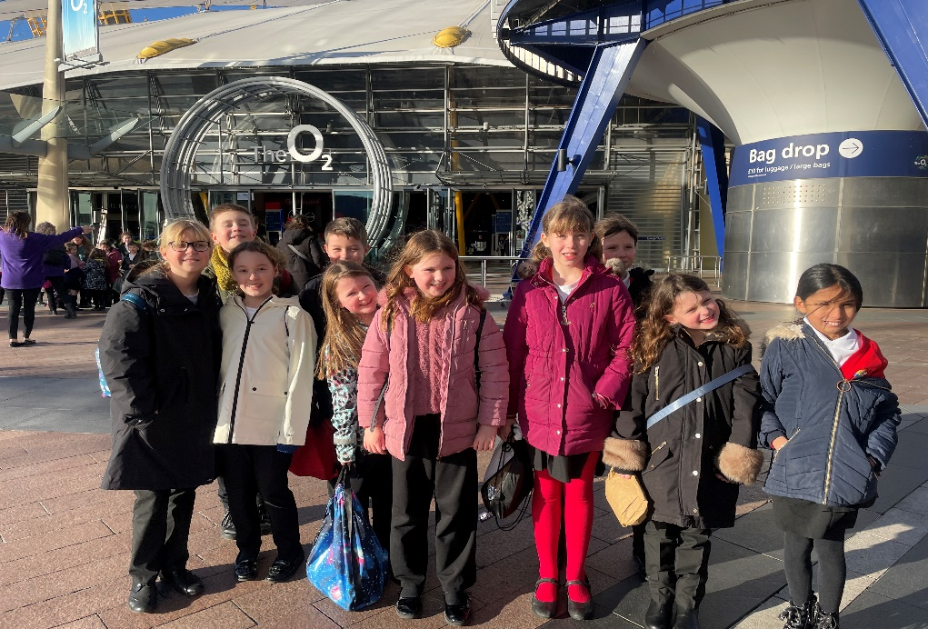

**HOLME READING ROOM TRUST**

The Holme Reading Room Trust is a charity which has been established to provide funds which are to be used exclusively for the benefit of the village. The trustees wish to maximise the benefit from the fund and welcome applications from those with ideas for new ventures, as well as from existing organisations. The trustees will encourage applicants to make a contribution towards funding ideally on a £ for £ basis according to individual circumstances. If you are interested in submitting an application please drop an email to [holmereadingroomtrust@gmail.com](mailto:holmereadingroomtrust@gmail.com). The next meeting to review applications will be held in March.

**HOLME PARISH NEWS**

Although we are now already a month into 2024 the Holme Parish News (HPN) wishes you all a Happy New Year. We have 10 editions of the HPN each year and it is a magazine for all the residents of the village so we want to make it work for you and include anything that may be happening in the village. If you have any articles or any ideas for the editions, please contact me at [louisersmith@hotmail.com](mailto:louisersmith@hotmail.com)

**HOLMEWOOD HALL**

**Quiz Night – Friday 9th February 2024**

After the success of our Christmas Quiz, we’re hosting another one to give you a second chance to test your knowledge and come out on top!

Our quiz will test your general knowledge, as well as your understanding of a selection of specialist topics, so be sure to have your thinking caps on. Teams of 2-6 people are welcome.

There will be a delicious hog roast dinner provided, as well as a welcome drink, with our bar open for you to retire to at the end of the quiz to toast your victory.

Hog Roast Menu

Hog Roast served in Soft Floured Baps

Sage & Onion Stuffing

Apple Sauce

Salt & Pepper Wedges,

Herb Coleslaw and

Tomato & Onion Salad

Veggie Burger available

Please let us know upon booking whether you have any allergies, intolerances or dietary requirements.

Tickets are priced at £25 per person, including entry to the Quiz, Hog Roast dinner and a welcome drink.

To book, please call 01487 829 555 or email [events@holmewood-hall.co.uk](mailto:events@holmewood-hall.co.uk).

*Yaxley Amateur Players*

*Present*

**ALI BABA**

**SATURDAY 3RD FEBRUARY 2.30PM & 7PM**

**SUNDAY 4TH FEBRUARY 2.30PM**

**SATURDAY 10TH FEBRUARY 2.30PM & 7PM**

See our website, yap.org.uk for details of our forthcoming shows for 2024

**Church & Parish Directory**

|  |  |  |
| --- | --- | --- |
| **St Giles Church** | **Name** | **Contact Details** |
| **Priest in charge** | Revd Becky Dyball | The Rectory, Church Causeway, Sawtry, PE28 5TD  T: 01487 506217  [revdyball@gmail.com](mailto:revdyball@gmail.com) |
| **Churchwarden** | Mrs Judith Osborne | 27 St Giles Close, Holme  01487 832023 |
| **Treasurer** | David Perry | astreasurer1880@gmail.com |
| **Website** |  | [www.holme-parish.org](http://www.holme-parish.org) |

|  |  |  |  |  |
| --- | --- | --- | --- | --- |
| **Parish Council** | **Name** | | **Contact Details** | |
| Chairman | Mr John Griffin, | | 11 Vicarage Close, Holme, PE7 3PQ  01487 831245 | |
| Clerk | Sarah Abbott | | [holmeparishclerk@gmail.com](mailto:holmeparishclerk@gmail.com)  07548 441977 | |
| **Parish Councillors – can be contacted via Clerk** | | | | |
| Cllr. W Aylesbury | | Cllr J Edwards | | Cllr D Neal, |
| Cllr C Reed | | Cllr L Roderick-Smith | | Cllr. P Sargent |
| Cllr H Watson | | Cllr E Whittaker | |  |

|  |  |  |
| --- | --- | --- |
|  | **Name** | **Contact Details** |
| **County Councillors** | Cllr. Simon Bywater | simon.bywater@cambridgeshire.gov.uk |
| **District Councillor** | Cllr Tim Alban | tim.alban@huntingdonshire.gov.uk |

|  |  |  |
| --- | --- | --- |
| **Village organisations** | **Name/website** | **Contact Details** |
| **Bowls Club** | Mr P Dickman | holmesmbc@gmail.com |
| **Holme Charity Lands** |  | holmecharitylands@gmail.com |
| **Holme Cricket Club** | Ian Kendall | [holmecricketclub@gmail.com](mailto:holmecricketclub@gmail.com)  07437 425107 |
| **Holme Reading Room Trust** |  | [holmereadingroomtrust@gmail.com](mailto:holmereadingroomtrust@gmail.com) |
| **Holme School** | Exec Head (Holme & Stilton)  Mrs C King  Head of School  Mrs C Ferrara |  |
| **www.holme.cambs.sch.uk** | [admin@holme.cambs.sch.uk](mailto:admin@holme.cambs.sch.uk) |
| **Friends of Holme School** | Amanda Rose | [Amanda.rose8@btinternet.com](mailto:Amanda.rose8@btinternet.com) |
| **Holme Pre-School** |  | manager[holmepreschool@yahoo.co.uk](mailto:holmepreschool@yahoo.co.uk) |
| **Holme Village Hall** | **www.holmecambsvillagehall.org.uk** | [bookings@holmecambsvillagehall.org.uk](mailto:bookings@holmecambsvillagehall.org.uk)  07714088691 |
| **Holme Youth Club** |  | holmeyouthclub@outlook.com |
| **Neighbourhood Watch** | David Neal | [davidneal994@gmail.com](mailto:davidneal994@gmail.com) |
| **Rainbows/Guides/Guides/ Rangers** | Val Aldridge, District Commissioner www.girlguiding.org.uk | [valaldridge@btinternet.com](mailto:valaldridge@btinternet.com) |
| **Sir John Cotton Educational Trust** |  | SJCEF1@outlook.com |
| **Speedwatch** |  | csw.holme@btinternet.com |

**HOLME PARISH NEWS EDITOR**

|  |  |
| --- | --- |
| **Name** | **Contact Details** |
| Louise Roderick-Smith | [Louisersmith@hotmail.com](mailto:Louisersmith@hotmail.com) 07971 955940 |

**Please send articles to the editor by the 23rd February 2024.**