#### **Holme**

#### **Parish News**

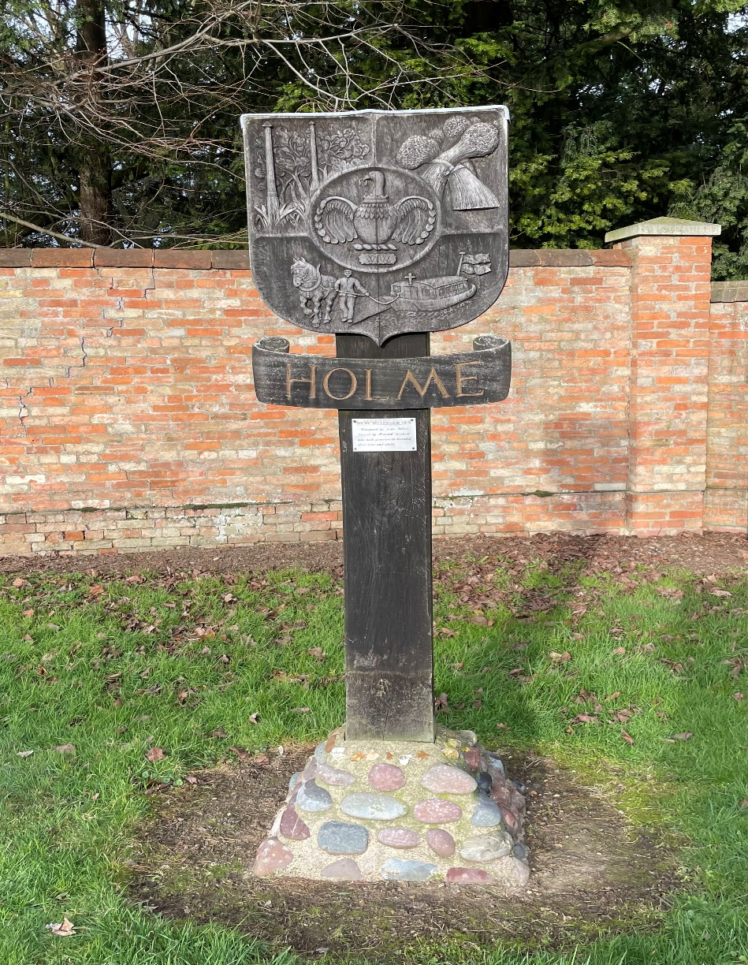

March 2024

Free to Holme residents

(thanks to the Reading Room Trust)

If you would like to advertise your business in the Holme Parish News please email louisersmith@hotmail.com

**HOLME PARISH COUNCIL**

A priority for your Parish Council this year is **beautification of the village**. Council were therefore pleased to hear that Cambridgeshire County Council have reversed their decision to stop spraying weeds. At a [meeting](https://cambridgeshire.cmis.uk.com/ccc_live/Meetings/tabid/70/ctl/ViewMeetingPublic/mid/397/Meeting/2110/Committee/62/SelectedTab/Documents/Default.aspx) on January 23, council officers apologised for the way the policy change was handled and admitted the county council did not engage effectively with other councils and people in the county.

**A village maintenance walk** was carried out on 23rd February on a lovely sunny if somewhat breezy morning. Thank you to residents who highlighted issues to be looked at. As a result, a dozen new issues have been logged with Cambridgeshire County Council. We know that County Council budgets are under pressure so we will prioritise following up issues that result in a risk of accidents, injury and/or damage to vehicles.

Ways in which you can help with improving the village are:

* Log issues with roads or paths with Cambridgeshire County Council by searching for “Cambridgeshire County Council – report a highways fault” even if you think someone else might have raised the issue. County Council do take into account number of complaints when prioritising work.
* Ensuring trees and hedges on your land are pruned so as not to obstruct paths, highways or overhead cables. I have spoken with Scottish and Southern Electricity Network who are responsible for overhead power cables in Holme and they tell me they will prune free of charge branches touching their cables. You can contact them on 0800 048 3516 or [emailge@ssen.co.uk](mailto:emailge@ssen.co.uk)
* Adhering to Huntingdon District Council regulations regarding bins which is that they should be removed from highway/footpath/grass verge and returned to premises by the resident as soon as reasonably possible after collections have been made.

A polite reminder too that if you laid a wreath at the cemetery over Christmas could you remove it? Thank you.

**Councillors regularly monitor the status of any developments** approved by HDC planning department to ensure they are in line with planning applications submitted. If they are not, these are escalated to the HDC enforcement team.

The **playground subcommittee** are exploring with providers of play equipment possible designs for a play area for Holme. They have also taken advice from the Huntingdon District Council and the Police on things to take into account when developing designs. Before making any decisions, Council will hold a public meeting to share ideas and get input. Decisions of this nature will always be made at a full meeting of the Council to which all members of the public are welcome to attend.

The next meeting of the Parish Council will be on Thursday 21st March at 7pm in the Village Hall. Members of the public are very welcome to attend. Looking ahead, the **Annual Parish Meeting** with be on **Thursday 2nd May.** All village organisations are encouraged to attend and share their updates.

Huntingdonshire has the scheduled Police and Crime Commissioner election on Thursday 2 May 2024. **Photo ID will be required**. If you don’t have such ID you can apply for free voter ID by calling 0800 328 0280 or visiting electoralcommission.org.uk/voterID.

**Can I help?**

If I can be of any help with Parish related matters please call or email me.

Sarah Abbott, Parish Clerk and Responsible Financial Officer

[holmeparishclerk@gmail.com](mailto:holmeparishclerk@gmail.com)

07548 441977

**HOLME YOUTH CLUB**

The second half of the spring term is very short with only four sessions and then three weeks off for Easter so come along and make the most of it.  As numbers are currently on the low side we can offer you the option to “BRING A FRIEND” who can try out our club and have the option to join as a “guest member”.   Again because of the short half term we won’t be having a night out so it is club nights only.

We will be seeking permission from the school to use the field once the clocks go forward and hopefully the weather improves so we will be able to add cricket and football etc to our usual activities.

Membership of Holme Youth Club is open to school years 5-10 who live in Holme or attend or have attended Holme (CofE) Primary Academy and at the moment their guests.  If you meet this criteria and want further information check us out on Facebook and our Web page, email us on [holmeyouthclub@outlook.com](mailto:holmeyouthclub@outlook.com)  or pop down to the village hall on a term time Friday evening between 6.30 and 8.30 pm and see us in action.

**ST GILES CHURCH**

It is with a slightly heavy heart I write this piece for this edition of Holme Parish News because time goes really quickly, and my curacy at All Saints’ Church ends on  
the 17th of March with a final service at All Saints’ Church. I have loved being part of the community in Sawtry, Glatton and Holme. I want to thank you so much for the welcome you have given me and all your support over the last two and a half years. I leave feeling very hopeful about the future. I am not going far – I am to be licensed as the Rector of the Stilton Group of churches, so hopefully, I will continue to bump into many of you going forward. This edition includes details of our services through to March, including Holy Week. These include our special Mother’s Day Runaways Service at 2 pm on Sunday, the 10th of March, a service for those who normally avoid church on Mothering Sunday and find that celebration difficult. I would also like to mention our regular Monday Evening open pub study group, meeting at  
the Greystones at 7 pm for those who like to order food 8 pm for conversation. This is open to anyone who would like to explore, question, and discover more about faith – no previous experience is required! Also, here's a quick update on the heating at St Giles: Work commenced on the 26th of February and should be completed very shortly. Please keep an eye on the church noticeboard and social media for services recommencing.

Every blessing,  
Rev Diane

**Service Rota March 2024**

For latest service information and online service links please visit www.allsaintssawtry.org.uk

|  |  |  |  |
| --- | --- | --- | --- |
|  | **All Saints’, Sawtry** | **St. Nicholas, Glatton** | **St. Giles, Holme\*\*** |
| Sunday 3rd March | 10.30am Holy Communion | 9.00am Morning Prayer |  |
| Sunday 10th  (Mothering Sunday) | 10.30 Morning Prayer  2pm Mother’s Day Runaways Service | 9.00am Holy Communion | -- |
| Saturday 16th | 4pm Messy Church | – | – |
| Sunday 17th | Benefice Holy Communion | – |  |
| Sunday 24th  (Palm Sunday & the start of Holy Week) | 8.00am BCP* Holy Communion  10.30am Morning Prayer | 9.00am Holy Communion |  |
| Monday 25th | 9pm Compline |  |  |
| Tuesday 26th | 9pm Compline |  |  |
| Wednesday 27th | 9pm Compline |  |  |
| Thursday 28th  (Maundy Thursday) |  | 7.30pm Maundy Thursday Service |  |
| Friday 29th  (Good Friday) | 10am Walk of Witness (Starting at All Saints Church walking to Sawtry Methodist Church) |  |  |
| Sunday 31st  (Easter Sunday) | 10.30am Holy Communion |  | 9.00am Holy Communion |

*BCP A much loved traditional service using the 1662 prayer book

**St Giles, Holme remains closed for the completion of a new heating system. We are expecting to return no later than Easter Sunday but hopefully earlier in March. Do watch out for notices on social media and the noticeboard outside St Giles.

**Diary Dates for March 2024**

|  |  |
| --- | --- |
| **Friday 1** | **St David’s Day**  **Green bin collection**  **Mobile Post Office** – 9.30-10.30am  **Youth Club –**Village Hall, 6.30pm-8.30pm |
| **Saturday 2** | **Fish’n’Chip van –** various stops in the village from 6.15pm  T: 07717 747772 for details or Howe Chippy on facebook. |
| **Monday 4** | **Grey bin collection** |
| **Tuesday 5** | **Short Mat Bowls –** Village Hall 7.30pm  **Quiz Night -** 8pm Admiral Wells |
| **Wednesday 6** | **415 Bus to Peterborough**  **Wet Fish van –** Station Rd, St Giles, Church St, Vicarage Cl.  T: 07894 495544  **Short Mat Bowls –** Village Hall 7.30pm |
| **Friday 8** | **Mobile Post Office –** 9.30-10.30am  **Mobile Library** – 12.05–12.30pm Holmewood  **Youth Club –**Village Hall, 6.30pm-8.30pm |
| **Saturday 9** | **Fish’n’Chip van –** various stops in the village from 6.15pm |
| **Sunday 10** | **Mothering Sunday** |
| **Monday 11** | **Blue bin collection** |
| **Tuesday 12** | **Short Mat Bowls –** Village Hall 7.30pm  **Quiz Night -** 8pm Admiral Wells |
| **Wednesday 13** | **415 Bus to Peterborough**  **Wet Fish van –** Station Rd, St Giles, Church St, Vicarage Cl.  T: 07894 495544  **Short Mat Bowls –** Village Hall 7.30pm |
| **Friday 15** | **Green bin collection**  **Mobile Post Office –** 9.30-10.30am  **Youth Club –**Village Hall, 6.30pm-8.30pm |
| **Saturday 16** | **Fish’n’Chip van –** various stops in the village from 6.15pm |
| **Sunday 17** | **St Patrick’s Day** |
| **Monday 18** | **Grey bin collection** |
| **Tuesday 19** | **Short Mat Bowls –** Village Hall 7.30pm  **Quiz Night -** 8pm Admiral Wells |
| **Wednesday 20** | **415 Bus to Peterborough**  **Wet Fish van –** Station Rd, St Giles, Church St, Vicarage Cl.  T: 07894 495544  **Short Mat Bowls –** Village Hall 7.30pm |
| **Thursday 21** | **Parish Council Mtg. Village Hall 7pm** |
| **Friday 22** | **Mobile Post Office –** 9.30-10.30am  **Youth Club –**Village Hall, 6.30pm-8.30pm  **Bingo at Yaxley Public Hall –** doors open 6.30pm, eyes down 7pm, £8 pp. Everyone welcome |
| **Saturday 23** | **Fish’n’Chip van –** various stops in the village from 6.15pm. |
| **Monday 25** | **Blue bin collection** |
| **Tuesday 26** | **Short Mat Bowls –** Village Hall 7.30pm  **Quiz Night -** 8pm Admiral Wells |
| **Wednesday 27** | **415 Bus to Peterborough**  **Wet Fish van –** Station Rd, St Giles, Church St, Vicarage Cl.  T: 07894 495544  **Short Mat Bowls –** Village Hall 7.30pm |
| **Thursday 28** | **Holme School and Pre-School start of Easter Holiday** |
| **Friday 29** | **Good Friday**  **Green bin collection** |
| **Saturday 30** | **Fish’n’Chip van –** various stops in the village from 6.15pm. |
| **Sunday 31** | **Easter Sunday**  **9am Communion at St Giles**  **British Summer Starts at 1am, clocks go forward 1 hour** |

**\*415 Bus to Peterborough** pick up from 10.15 am Pingle Bank then Station Road & Holmewood. Return at 1.30pm

**HACT Ring and Ride Tel: 01480 411114** – membership £15 per annum. http://www.hact-cambs.co.uk/home

**Community Car Scheme** **Tel:** **07795542084** between 9am -12noon to book

If you have an event you would like included please let us know by *15th of preceding month*, email wendyaylesbury@hotmail.com

**HOLME COMMUNITY SPEEDWATCH**

Well we did it!   We got a NIL RETURN!  So maybe our campaign is working and people are taking notice and slowing down through our village.

We will be continuing our efforts as this, so far, has been a one off and the percentage is back up to 15%.

If you have an hour or so to spare each month and would like to join us in educating drivers to adhere to the speed limit please contact [csw.holme@btinternet.com](mailto:csw.holme@btinternet.com) and we will send you the Guidance Notes, so you have a full view of what we do, and get Cambridgeshire Police to contact you and organise your training then you can come along and join our cheerful volunteers.

**HOLME VILLAGE PRE-SCHOOL**

We are welcoming the milder days and the lighter evenings as the days go by and this half term has flown by!

The children have been busy with many new resources which have captured their imaginations alongside our themes of people who help us and dinosaurs. After half term our theme will be colours where we will be colour mixing, colour sorting and taking part in lots of arts and crafts with our colour of the week.

We have lots of lovely activities planned and for Mother’s Day we are inviting our Mums in for afternoon tea to celebrate with their little ones.

Our new logo has gone live, with the staff and children all receiving new uniforms. Look out for new signage at the front of the hall soon!

We still have some spaces available for an immediate start on a Tuesday and a Thursday and a waiting list for 2-year-olds from April 2024 when the funding rules change.

The Pre-School team is supported by a voluntary committee but any donations or help is gratefully received.

For further information or to arrange a visit, please contact our manager Kelly at

[managerholmepreschool@yahoo.com](mailto:managerholmepreschool@yahoo.com) or call 07842 192052

[www.holmevillagepre-school.co.uk](http://www.holmevillagepre-school.co.uk/)

**HOLME C of E PRIMARY ACADEMDY**

The last half term has flown by and we have had such a great start to the new year.

The Squirrels class had an amazing trip to the Peterborough Museum where they were able to excavate a trench and reveal an Anglo-Saxon woman and the objects she was buried with. The children were able to use this evidence to find out about her real-life. The children were also able to make their own treasure crafts to take back to school – they loved making their Anglo-Saxon brooches.

Some of our children have been ‘getting their sport on’, with several of the year 3 and 4 children taking part in a football tournament. The boys did incredibly well scoring 22 goals over 6 games and they only conceded 1. They showed great teamwork, determination and passion for the game, all values we want to instil in our children.

We also had 6 children attend Huntingdon Gymnastics club, where they took part in an inter-school gymnastics competition. They competed in body management, floor routine and vault elements. They enjoyed the experience on the bouncy floor and were great representatives of the school. Well done to all involved in both competitions.

Also in school, we have considered what we would like to do during Lent this year and our lovely reverend delivered a special Ash Wednesday collective worship, where we were able to invite parents of our children into school to celebrate and reflect together. We thank Reverend Canon Becky and Reverend Diane for all they do with our school.

To end the half term off, our lovely Friends of Holme School organised another fantastic disco, which was enjoyed by all. The children looked incredible in their party outfits, enjoyed their hotdogs and were showing off their dance moves. Thank you FOHS for all you do for our small but mighty school too.

We are looking forward to the warmer weather and the many more exciting events and experiences we have planned.

Mrs King, Mrs Ferrara and the Small but Mighty Team.

**HOLME READING ROOM TRUST**

The Holme Reading Room Trust is a charity which has been established to provide funds which are to be used exclusively for the benefit of the village. The trustees wish to maximise the benefit from the fund and welcome applications from those with ideas for new ventures, as well as from existing organisations. The trustees will encourage applicants to make a contribution towards funding ideally on a £ for £ basis according to individual circumstances. If you are interested in submitting an application please drop an email to [holmereadingroomtrust@gmail.com](mailto:holmereadingroomtrust@gmail.com).



**Church & Parish Directory**

|  |  |  |
| --- | --- | --- |
| **St Giles Church** | **Name** | **Contact Details** |
| **Priest in charge** | Revd Becky Dyball | The Rectory, Church Causeway, Sawtry, PE28 5TD  T: 01487 506217  [revdyball@gmail.com](mailto:revdyball@gmail.com) |
| **Churchwarden** | Mrs Judith Osborne | 27 St Giles Close, Holme  01487 832023 |
| **Treasurer** | David Perry | astreasurer1880@gmail.com |
| **Website** |  | [www.holme-parish.org](http://www.holme-parish.org) |

|  |  |  |  |  |
| --- | --- | --- | --- | --- |
| **Parish Council** | **Name** | | **Contact Details** | |
| Chairman | Mr John Griffin, | | 11 Vicarage Close, Holme, PE7 3PQ  01487 831245 | |
| Clerk | Sarah Abbott | | [holmeparishclerk@gmail.com](mailto:holmeparishclerk@gmail.com)  07548 441977 | |
| **Parish Councillors – can be contacted via Clerk** | | | | |
| Cllr. W Aylesbury | | Cllr J Edwards | | Cllr D Neal, |
| Cllr C Reed | | Cllr L Roderick-Smith | | Cllr. P Sargent |
| Cllr H Watson | | Cllr E Whittaker | |  |

|  |  |  |
| --- | --- | --- |
|  | **Name** | **Contact Details** |
| **County Councillors** | Cllr. Simon Bywater | simon.bywater@cambridgeshire.gov.uk |
| **District Councillor** | Cllr Tim Alban | tim.alban@huntingdonshire.gov.uk |

|  |  |  |
| --- | --- | --- |
| **Village organisations** | **Name/website** | **Contact Details** |
| **Bowls Club** | Mr P Dickman | holmesmbc@gmail.com |
| **Holme Charity Lands** |  | holmecharitylands@gmail.com |
| **Holme Cricket Club** | Ian Kendall | [holmecricketclub@gmail.com](mailto:holmecricketclub@gmail.com)  07437 425107 |
| **Holme Reading Room Trust** |  | [holmereadingroomtrust@gmail.com](mailto:holmereadingroomtrust@gmail.com) |
| **Holme School** | Exec Head (Holme & Stilton)  Mrs C King  Head of School  Mrs C Ferrara |  |
| **www.holme.cambs.sch.uk** | [admin@holme.cambs.sch.uk](mailto:admin@holme.cambs.sch.uk) |
| **Friends of Holme School** | Amanda Rose | [Amanda.rose8@btinternet.com](mailto:Amanda.rose8@btinternet.com) |
| **Holme Pre-School** | Kelly Fox | [managerholmepreschool@yahoo.com](mailto:managerholmepreschool@yahoo.com) |
| **Holme Village Hall** | www.holmecambsvillagehall.org.uk | [bookings@holmecambsvillagehall.org.uk](mailto:bookings@holmecambsvillagehall.org.uk)  07714088691 |
| **Holme Youth Club** |  | holmeyouthclub@outlook.com |
| **Neighbourhood Watch** | David Neal | [davidneal994@gmail.com](mailto:davidneal994@gmail.com) |
| **Rainbows/Guides/Guides/ Rangers** | Val Aldridge, District Commissioner www.girlguiding.org.uk | [valaldridge@btinternet.com](mailto:valaldridge@btinternet.com) |
| **Sir John Cotton Educational Trust** |  | SJCEF1@outlook.com |
| **Speedwatch** |  | csw.holme@btinternet.com |

**HOLME PARISH NEWS EDITOR**

|  |  |
| --- | --- |
| **Name** | **Contact Details** |
| Louise Roderick-Smith | [Louisersmith@hotmail.com](mailto:Louisersmith@hotmail.com) 07971 955940 |

**Please send articles to the editor by the 15th March 2024.**