#### **Holme**

#### **Parish News**

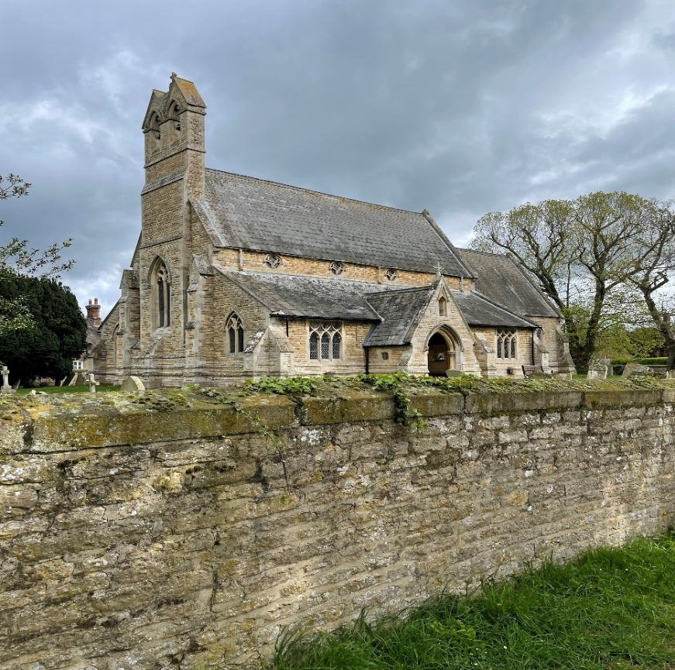

May 2024

Free to Holme residents

(thanks to the Reading Room Trust)

**HOLME ANNUAL PARISH MEETING**

**Thursday 2nd May @ 7pm**

**In the Village Hall**

If you would like to advertise your business in the Holme Parish News please email louisersmith@hotmail.com

**HOLME PARISH COUNCIL**

**ANNUAL PARISH MEETING**

At the time of writing, I am pulling together all the information that will shared at the **Annual Parish** **Meeting on Thursday 2nd May at 7pm in the village hall.** Thank you to everyone who sent in a report. The agenda for the meeting is as follows:

1. Welcome by Holme Parish Council
2. Apologies for absence
3. Minutes of the Annual Parish Meeting on 27th April 2023
4. Presentation by North Hunts Community Car Scheme
5. Annual Report of the Parish Council
6. Annual Report of County Councillor Simon Bywater
7. Annual Report by District Councillor Tim Alban
8. Reports from Village Organisations
9. Any resolutions submitted by an elector

**NOTICE OF A VACANCY ON THE PARISH COUNCIL**

Due to a resignation of one of the Parish Councillor’s, there is now a vacancy. Council are required to follow a formal process when it comes to appointing a replacement. Please see the notice included in this edition of HPN for further details.

**HANDY PERSON REQUIRED**

At the last meeting of the Parish Council a need for a “Handy Person” was identified for odd jobs around the village. Examples of such jobs include refurbishment of the noticeboards & fixing gates. If you are interested in this (paid) role please get in touch.

Sarah Abbott, Parish Clerk and Responsible Financial Officer

[holmeparishclerk@gmail.com](mailto:holmeparishclerk@gmail.com)

07548 441977

**Notice of Vacancy in office of Parish Councillor on the Holme Parish Council**

Notice is hereby given pursuant to section 87(2) of the Local Government Act 1972 that due to the resignation of Councillor Reed there is a vacancy on the Holme Parish Council.

If, within 14 statutory days after the date of this notice, a request for an election to fill the vacancy is made in writing to the Proper Officer, Huntingdonshire District Council, Pathfinder House, Huntingdon PE29 3TN by ten electors of the Parish an election will be held. If no such notice is given the Parish Council will fill the vacancy by co-option.

If any member of the Parish would like to be considered for co-option, please contact the Parish Clerk.

Dated: 22nd April 2024 Signed Signature redacted  *Parish Clerk*

Address: 38 Townsend Way, Folksworth, Peterborough, PE7 3TU __

Printed and Published by the Parish Clerk

*38 Townsend Way, Folksworth, Peterborough, PE7 3TU*

**DISTRICT COUNCILLOR**

I hope everyone had a Happy Easter and is looking forward to the two Bank Holiday weekends coming up in May.

Most, if not all district councillors might say the same but I really do think the Stilton, Folksworth & Washingley ward is one of the most special in the Huntingdonshire District.

There is a mix of villages with their own charm, as well as their own challenges but we also have areas and issues in common; it is with that in mind that, along with my fellow ward councillor, Marge Beuttell, I have organised joint meetings for the Chairs and Clerks from the various parish councils and parish meetings.

The first was held in Holme, with the most recent two being held in the Milestone Hotel at Norman Cross, where we have received presentations from Huntingdonshire District Council's Chief Planning Officer and representatives of Cambridgeshire Police.

Most importantly though, these meetings continue to provide an opportunity to meet with each other, to share common problems and exchange ideas; I am pleased that Marge and I have been supported in this by County Councillors Simon Bywater and Ian Gardener.  I am also pleased that Holme has been represented at each of these meetings.

Our next meeting will hopefully be in the autumn, where I intend to invite a representative from the district council's Operations team to discuss the changes in the garden waste collections.  Speaking of which...

I have received direct correspondence and seen comments on social media about the changes, most - although not all - have been negative.  Without being too political, I feel it appropriate to confirm that I remain unconvinced that there was a need to introduce a green bin charge and didn't vote in favour of it.  That said it was democratically voted for by the majority of elected district councillors and the changes have been made.

The new arrangements, including the introduction of a once a month Saturday Freighter service, have prompted further comments (particularly about communication) and I continue to follow these up with council officers.  
  
Anyone, whether they have paid the green bin charge or not, can take their garden bin to be emptied at a specified location, on a Saturday morning once a month; the nearest for Holme are Stilton, Yaxley and Sawtry.  Further information can be found via [https://www.huntingdonshire.gov.uk/bins-waste/garden-waste-subscription-service/garden-waste-initiatives/freighter-locations-and-schedule/](https://eur01.safelinks.protection.outlook.com/?url=https%3A%2F%2Fwww.huntingdonshire.gov.uk%2Fbins-waste%2Fgarden-waste-subscription-service%2Fgarden-waste-initiatives%2Ffreighter-locations-and-schedule%2F&data=05%7C02%7Cjon.collins%40mitie.com%7C333c046a1e014cc4ff4208dc608de003%7C9e66e0b4768c4506a1b67e44c80595f2%7C0%7C0%7C638491409664722501%7CUnknown%7CTWFpbGZsb3d8eyJWIjoiMC4wLjAwMDAiLCJQIjoiV2luMzIiLCJBTiI6Ik1haWwiLCJXVCI6Mn0%3D%7C0%7C%7C%7C&sdata=2VCiWlUlJbDFRSWnh6xNCW3KaTpJEnRlXH26lzUn5LQ%3D&reserved=0)

Planning issues, especially those relating to the development sites on Pingle Bank and Yaxley Road continue to keep me busy.  The latest news on these two sites is that it is hoped development work will start later this year.

On Thursday 2nd May there will be elections for the post of Police & Crime Commissioner and one change from the last time we voted is that, anyone voting in person (rather than by post) will need to show Photo ID.  Acceptable forms of ID can be found via [https://www.electoralcommission.org.uk/voting-and-elections/voter-id/accepted-forms-photo-id](https://eur01.safelinks.protection.outlook.com/?url=https%3A%2F%2Fwww.electoralcommission.org.uk%2Fvoting-and-elections%2Fvoter-id%2Faccepted-forms-photo-id&data=05%7C02%7Cjon.collins%40mitie.com%7C333c046a1e014cc4ff4208dc608de003%7C9e66e0b4768c4506a1b67e44c80595f2%7C0%7C0%7C638491409664727417%7CUnknown%7CTWFpbGZsb3d8eyJWIjoiMC4wLjAwMDAiLCJQIjoiV2luMzIiLCJBTiI6Ik1haWwiLCJXVCI6Mn0%3D%7C0%7C%7C%7C&sdata=f4p6Uz%2B%2BwEMFnWHSreAgeu4cPrNTsd33vMg7Wj3ycco%3D&reserved=0)

From the fens in the East to the Huntingdonshire Wolds in the West, and from Little Gidding in the South to the river Nene in the North, the Stilton, Folksworth & Washingley ward is one of the largest in the Huntingdonshire District and I continue to enjoy working with Marge to represent the people who live here.  With such a wide area, Marge focusses on the North and I focus on the South - including Holme; to contact me, please email me via [tim.alban@huntingdonshire.gov.uk](mailto:tim.alban@huntingdonshire.gov.uk) or call 07903 518967.

Councillor Tim Alban

**HOLME PARISH NEWS (HPN)**

If you have any feedback on the HPN please can you either email or call me as I will not see any posts on social media. My contact details are always in the directory.

If you would like to stop receiving the paper copy of the HPN as you would rather view it online please contact me directly to arrange this.

Thank you

Louise

**HOLME VILLAGE PRE-SCHOOL**

We have all settled back into the routines well after the Easter break and have enjoyed our first week back.

The children have loved exploring the new resources this week, including new building blocks and a wonderful new Rocket to go with our space themed resources. As well as this, the children have helped to spruce up the garden, planting flowers, sowing seeds and making sure the birds have food in our new feeder.

We have welcomed in some new children this term too with more to start before the summer.

So a reminder of what Holme Village Pre-school can offer:

*We accept all funded hours and take children from 2 years old

*We offer a breakfast club starting  at 8.15am

*We have a weekly sports session with Josh from Key Sports

*AND we are now pleased to welcome Rachel from Spanglish once a week too from the end of April

*We have a variety of different resources, so no 2 days are the same

and finally

*we have some wonderfully, fully trained, knowledgeable staff who go above and beyond to make the children smile!!

Don't delay, book your visit today!

For further information or to arrange a visit, please contact our manager Kelly at

[managerholmepreschool@yahoo.com](mailto:managerholmepreschool@yahoo.com) or call 07842 192052

[http://www.holmevillagepre-school.co.](https://eur01.safelinks.protection.outlook.com/?url=http%3A%2F%2Fwww.holmevillagepre-school.co.u%2F&data=05%7C02%7Cjon.collins%40mitie.com%7Cc667ded79e4542268dd108dc61463d1b%7C9e66e0b4768c4506a1b67e44c80595f2%7C0%7C0%7C638492201493786160%7CUnknown%7CTWFpbGZsb3d8eyJWIjoiMC4wLjAwMDAiLCJQIjoiV2luMzIiLCJBTiI6Ik1haWwiLCJXVCI6Mn0%3D%7C0%7C%7C%7C&sdata=UoTwngBMZchF7R2Fg%2Fp4Je7k5PTeiTJ09Ufj9mLs6AY%3D&reserved=0)uk

[The Pre-School team is supported by a voluntary committee but any donations or help is gratefully received](https://eur01.safelinks.protection.outlook.com/?url=http%3A%2F%2Fwww.holmevillagepre-school.co.uk%2F&data=05%7C02%7Cjon.collins%40mitie.com%7Cc667ded79e4542268dd108dc61463d1b%7C9e66e0b4768c4506a1b67e44c80595f2%7C0%7C0%7C638492201493794510%7CUnknown%7CTWFpbGZsb3d8eyJWIjoiMC4wLjAwMDAiLCJQIjoiV2luMzIiLCJBTiI6Ik1haWwiLCJXVCI6Mn0%3D%7C0%7C%7C%7C&sdata=p9L3Z%2FNW2YNer%2FkZa6GKhCp0D3k2QjmHOi6R2rPUylY%3D&reserved=0).

**HOLME COMMUNITY SPEEDWATCH**

Unscheduled road closures and bad weather has affected our sessions just lately but hopefully now that summer is almost here we will be able to continue with our endeavours to educate drivers to adhere to the designated speed limits.  We hope the letters received from the police encourage drivers to think about their speed in all locations as well as Holme.  Certainly our percentage of speeders is much lower now than when we first started about 15 years ago.

If you feel you could spare an hour or so each month and would like to support our campaign please contact [csw.holme@btinternet.com](mailto:csw.holme@btinternet.com) and we will send you the Guidance Notes so you get full details of what is involved, then if you are still interested we will arrange for your training with Cambridgeshire Police and get you out on the road with some of our friendly volunteers.

**ST GILES CHURCH**

After the Heating and lighting project services and activities in St. Giles resumed and I am pleased to confirm that… **Coffee and Cake is back on the 2nd Saturday of every month** and it's bringing a friend. Coffee Ark will now be joining as much as they can to serve brilliant barista coffee in the heart of Holme.

Coffee Ark ([www.coffeeark.org](http://www.coffeeark.org)) is a mobile coffee shop, in a converted Land Rover Defender, with a particular heart for reaching those who find themselves separated or isolated whether through loneliness, challenges around mental health or other social circumstances.

Coffee Ark exists to build community, resource positive mental health, offer radical hospitality and serve great coffee. We use income from public and private events to help fund our community action and enable us to be where we need to be.

Come along on Saturday 11th May 2:30 - 4:30, grab a coffee for your dog walk, rest a while, explore the church, enjoy a natter in a pew or new play space for younger ones, we look forward to seeing you.

Reverend Canon Becky Dyball

**Diary Dates for May 2024**

|  |  |
| --- | --- |
| **Wednesday 1** | **415 Bus to Peterborough**  **Wet Fish van –** Station Rd, St Giles, Church St, Vicarage Cl.  T: 07894 495544 |
| **Thursday 2** | **Annual Parish Mtg, Village Hall at 7pm** |
| **Friday 3** | **Youth Club –**Village Hall, 6.30pm-8.30pm |
| **Saturday 4** | **Fish’n’Chip van –** various stops in the village from 6.15pm  T: 07717 747772 for details or Howe Chippy on facebook |
| **Sunday 5** | **9am Holy Communion in St Giles Church** |
| **Monday 6** | **Blue bin collection**  **May Day Bank Holiday** |
| **Tuesday 7** | **Quiz Night -** 8pm Admiral Wells |
| **Wednesday 8** | **415 Bus to Peterborough**  **Wet Fish van –** Station Rd, St Giles, Church St, Vicarage Cl.  T: 07894 495544 |
| **Friday 10** | **Green bin collection**  **Mobile Library** – 12.05–12.30pm Holmewood  **Youth Club –**Village Hall, 6.30pm-8.30pm |
| **Saturday 11** | **St Giles 2.30-4.30pm** coffee and cake followed by a short service  **Fish’n’Chip van –** various stops in the village from 6.15pm |
| **Monday 13** | **Grey bin collection** |
| **Tuesday 14** | **Quiz Night -** 8pm Admiral Wells |
| **Wednesday 15** | **415 Bus to Peterborough**  **Wet Fish van –** Station Rd, St Giles, Church St, Vicarage Cl.  T: 07894 495544 |
| **Thursday 16** | **Annual Mtg of the Parish Council, Village Hall at 7pm** |
| **Friday 17** | **Mobile Post Office –** 9.30-10.30am  **Youth Club –**Village Hall, 6.30pm-8.30pm |
| **Saturday 18** | **Fish’n’Chip van –** various stops in the village from 6.15pm. |
| **Sunday 19** | **9am Holy Communion in St Giles Church** |
| **Monday 20** | **Blue bin collection** |
| **Tuesday 21** | **Quiz Night -** 8pm Admiral Wells |
| **Wednesday 22** | **415 Bus to Peterborough**  **Wet Fish van –** Station Rd, St Giles, Church St, Vicarage Cl.  T: 07894 495544 |
| **Friday 24** | **Green bin collection**  **Mobile Post Office –** 9.30-10.30am  **Youth Club –**Village Hall, 6.30pm-8.30pm  **Bingo at Yaxley Public Hall –** doors open 6.30pm, eyes down 7pm, £8 pp. Everyone welcome |
| **Saturday 25** | **Aerobatic Competition at Conington Airfield**  **Fish’n’Chip van –** various stops in the village from 6.15pm. |
| **Monday 27** | **Spring Bank Holiday**  **Grey bin collection**  **Holme School and Pre-School Half Term until 31 May** |
| **Tuesday 28** | **Quiz Night -** 8pm Admiral Wells |
| **Wednesday 29** | **415 Bus to Peterborough**  **Wet Fish van –** Station Rd, St Giles, Church St, Vicarage Cl.  T: 07894 495544 |
| **Friday 31** | **Mobile Post Office –** 9.30-10.30am |

**\*415 Bus to Peterborough** pick up from 10.15 am Pingle Bank then Station Road & Holmewood. Return at 1.30pm

**HACT Ring and Ride Tel: 01480 411114** – membership £15 per annum. http://www.hact-cambs.co.uk/home

**Community Car Scheme** **Tel:** **07795542084** between 9am -12noon to book

If you have an event you would like included please let us know by *15th of preceding month*, email wendyaylesbury@hotmail.com

**HOLME C of E PRIMARY ACADEMDY**

We have already had a busy few weeks back in school. The oldest children in school have visited Leicester Space Centre and thoroughly enjoyed exploring what it had to offer. The planetarium show provided an immersive experience into space and the children were able to extend their knowledge of planets in our solar system and the constellations too. They were able to explore the artefacts on show and ask questions to the experts who work there.

We were also lucky enough to have the scholastic travelling book fair in school. The children were excited to explore the wonderful books on offer and they really demonstrated their love of reading, with conversations of the books they had seen and bought on the playground at break and lunch times. Our outdoor reading space has definitely become the place to be at lunchtimes!

We have many exciting things planned for the Summer Term, including our May Day celebrations at the end of May which will include maypole dancing and country dancing, we have sports day to look forward to, the youngest children in school will have their class trip to go on, more sporting fixtures scheduled in and the Foxes class have their residential stay in just a few months.

We look forward to welcoming our next intake of children and their families for our EYFS Open Evening this term too. We can’t wait to meet you!

Mrs King, Mrs Ferrara and the Small but Mighty Team.

**HOLME READING ROOM TRUST**

The Holme Reading Room Trust is a charity which has been established to provide funds which are to be used exclusively for the benefit of the village. The trustees wish to maximise the benefit from the fund and welcome applications from those with ideas for new ventures, as well as from existing organisations. The trustees will encourage applicants to make a contribution towards funding ideally on a £ for £ basis according to individual circumstances. If you are interested in submitting an application please drop an email to [holmereadingroomtrust@gmail.com](mailto:holmereadingroomtrust@gmail.com).

**HOLME YOUTH CLUB**

During most of April Youth Club was closed because of the Easter break but we are now up and running again and using the school field when weather permits.

Hopefully numbers will pick up a little and members are invited to bring along a friend (who does not qualify for full membership) if they wish.

We will be holding our taster sessions for the current year 4s on 21st June and 6th July so make a note in your diary to come along and try it out- you will be made most welcome.  Keep an eye on Facebook (both village and youth club sites) to see if there are any changes and what’s going on otherwise.

Membership of Holme Youth Club is open to school years 5-10 who live in Holme village or attend or have attended Holme CofE Primary Academy.

**CONINGTON AIRFIELD**

On Saturday May 25th we have a one day Aerobatics Competition organised & run by the RAF for their Pilots.

The Pilots will be competing for the Tony Air Blade and it will commence about 9am, weather permitting.

We are open to visitors and hope they will come to watch. Bacon Rolls are available as normal, as are ice creams, hot and cold refreshments etc.

More information can be given by The Airfield if required.

Peterborough Business Airfield, Holme, PE7 3PX

Tel: 01487 834161

**Church & Parish Directory**

|  |  |  |
| --- | --- | --- |
| **St Giles Church** | **Name** | **Contact Details** |
| **Priest in charge** | Revd Becky Dyball | The Rectory, Church Causeway, Sawtry, PE28 5TD  T: 01487 506217  [revdyball@gmail.com](mailto:revdyball@gmail.com) |
| **Churchwarden** | Mrs Judith Osborne | 27 St Giles Close, Holme  01487 832023 |
| **Treasurer** | David Perry | astreasurer1880@gmail.com |
| **Website** |  | [www.holme-parish.org](http://www.holme-parish.org) |

|  |  |  |  |  |
| --- | --- | --- | --- | --- |
| **Parish Council** | **Name** | | **Contact Details** | |
| Chairman | Mr John Griffin, | | 11 Vicarage Close, Holme, PE7 3PQ  01487 831245 | |
| Clerk | Sarah Abbott | | [holmeparishclerk@gmail.com](mailto:holmeparishclerk@gmail.com)  07548 441977 | |
| **Parish Councillors – can be contacted via Clerk** | | | | |
| Cllr. W Aylesbury | | Cllr J Edwards | | Cllr D Neal, |
| Cllr C Reed | | Cllr L Roderick-Smith | | Cllr. P Sargent |
| Cllr H Watson | | Cllr E Whittaker | |  |

|  |  |  |
| --- | --- | --- |
|  | **Name** | **Contact Details** |
| **County Councillors** | Cllr. Simon Bywater | simon.bywater@cambridgeshire.gov.uk |
| **District Councillor** | Cllr Tim Alban | tim.alban@huntingdonshire.gov.uk |

|  |  |  |
| --- | --- | --- |
| **Village organisations** | **Name/website** | **Contact Details** |
| **Bowls Club** | Mr P Dickman | holmesmbc@gmail.com |
| **Holme Charity Lands** |  | holmecharitylands@gmail.com |
| **Holme Cricket Club** | Ian Kendall | [holmecricketclub@gmail.com](mailto:holmecricketclub@gmail.com)  07437 425107 |
| **Holme Reading Room Trust** |  | [holmereadingroomtrust@gmail.com](mailto:holmereadingroomtrust@gmail.com) |
| **Holme School** | Exec Head (Holme & Stilton)  Mrs C King  Head of School  Mrs C Ferrara |  |
| **www.holme.cambs.sch.uk** | [admin@holme.cambs.sch.uk](mailto:admin@holme.cambs.sch.uk) |
| **Friends of Holme School** | Amanda Rose | [Amanda.rose8@btinternet.com](mailto:Amanda.rose8@btinternet.com) |
| **Holme Pre-School** | Kelly Fox | [managerholmepreschool@yahoo.com](mailto:managerholmepreschool@yahoo.com) |
| **Holme Village Hall** | www.holmecambsvillagehall.org.uk | [bookings@holmecambsvillagehall.org.uk](mailto:bookings@holmecambsvillagehall.org.uk)  07714088691 |
| **Holme Youth Club** |  | holmeyouthclub@outlook.com |
| **Neighbourhood Watch** | David Neal | [davidneal994@gmail.com](mailto:davidneal994@gmail.com) |
| **Rainbows/Guides/Guides/ Rangers** | Val Aldridge, District Commissioner www.girlguiding.org.uk | [valaldridge@btinternet.com](mailto:valaldridge@btinternet.com) |
| **Sir John Cotton Educational Trust** |  | SJCEF1@outlook.com |
| **Speedwatch** |  | csw.holme@btinternet.com |

**HOLME PARISH NEWS EDITOR**

|  |  |
| --- | --- |
| **Name** | **Contact Details** |
| Louise Roderick-Smith | [Louisersmith@hotmail.com](mailto:Louisersmith@hotmail.com) 07971 955940 |

**Please send articles to the editor by the 17th May 2024.**